For Official Use Only
Shortlisting Codes
A
B
C
D
E
F
G
H
I
J
K
L

CONFIDENTIAL
APPLICATION NUMBER

T
e
a
c
h
i
n
g
S
t
a
f
f
A
p
p
l
i
c
a
t
i
o
n
F
o
r
m

Sandwell Metropolitan Borough Council

Please note that CVs cannot be accepted

Please complete
All Sections
of this form as appropriate, and for ease of
photocopying, complete in
Type
or
Black Ink.

Please note sections 1, 2 & 3 of this application form will be removed prior to
shortlisting.

Post Applied For

School / Unit

SECTION 1. PERSONAL DETAILS

Title:

Last name:

First name(s):

Former name(s):

Home address:

Post Code:

Term address:
(
if different
)

Post Code:

Day/Work Telephone:

Mobile Telephone:

E-mail address:

Home Telephone:

GTC Registration Date:

DfE number:

Date of birth:

NI number:

Rev. 04/11
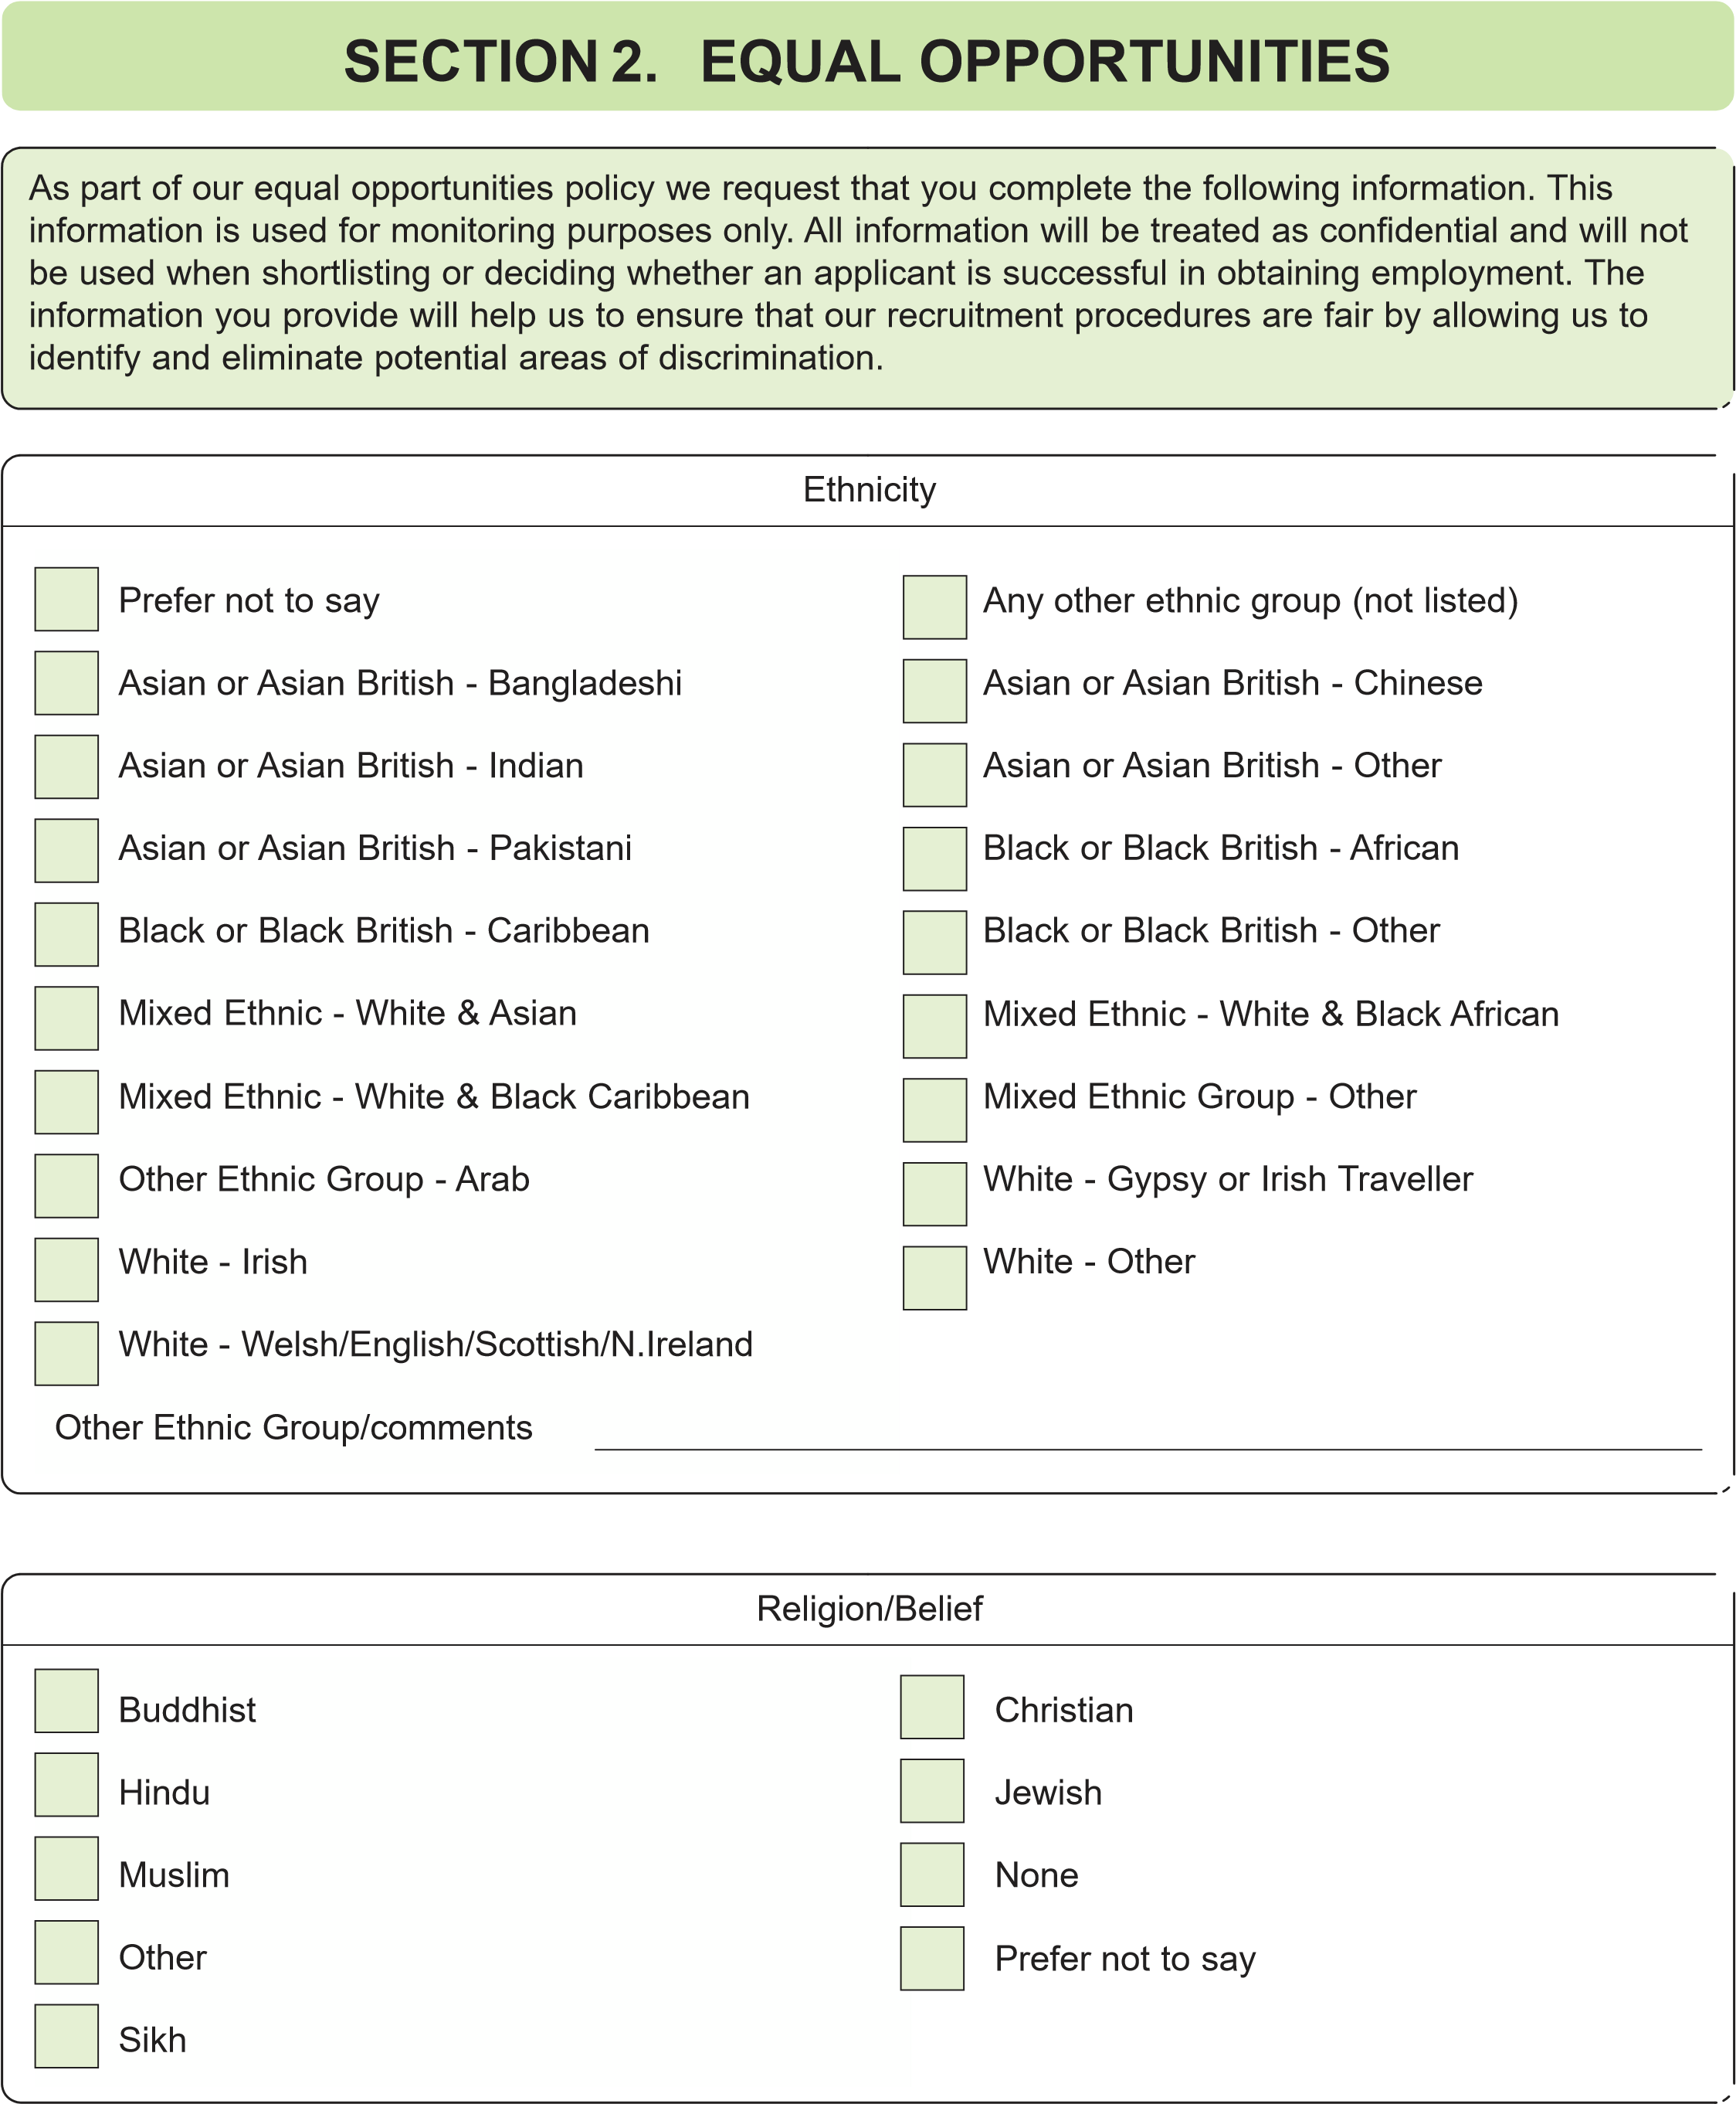
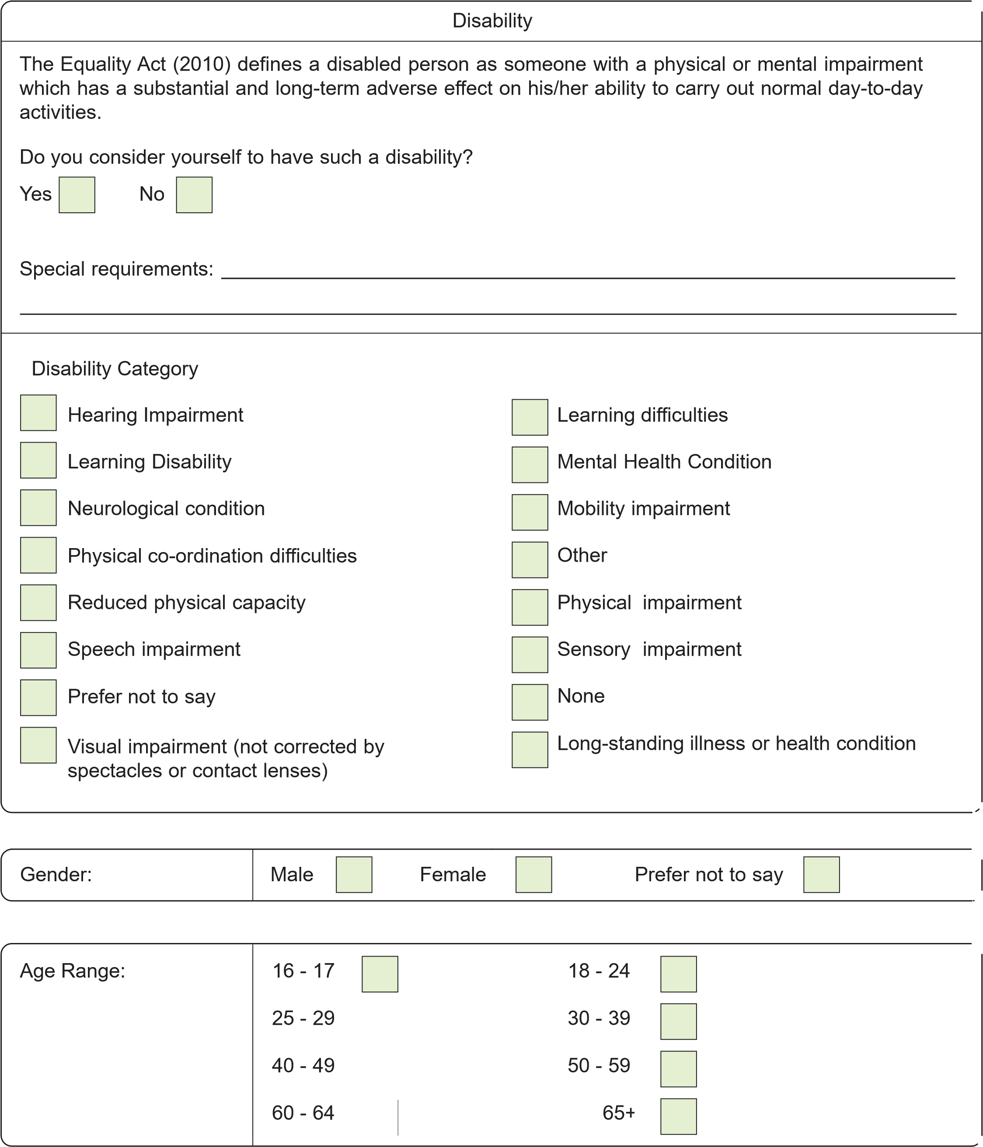
I certify that, to the best of my knowledge and belief, the information I have provided is true. I understand that any false information or failure to disclose any criminal convictions will result, in the event of employment, in a disciplinary investigation, and may result in dismissal.

Signed ............................................................................ Date ...................................................................

If I am appointed, I give my permission for my name and contact details to be provided to the recognised Trade ^{YES} ^{NO} Unions in Sandwell (please tick as applicable)

Sexual Orientation:

Bisexual

Gay man

Hetrosexual/straight

Prefer not to say

Lesbian/Gay woman

Do you have a legal right to live and work in the UK?

How did you learn about the vacancy, please state

NO
YES

SECTION 3. CERTIFICATION

If I am appointed, I give my permission for my service and
salary details to be accessed by other local authorities YES NO
(please tick as applicable)

N.B. Canvassing for this appointment will disqualify.
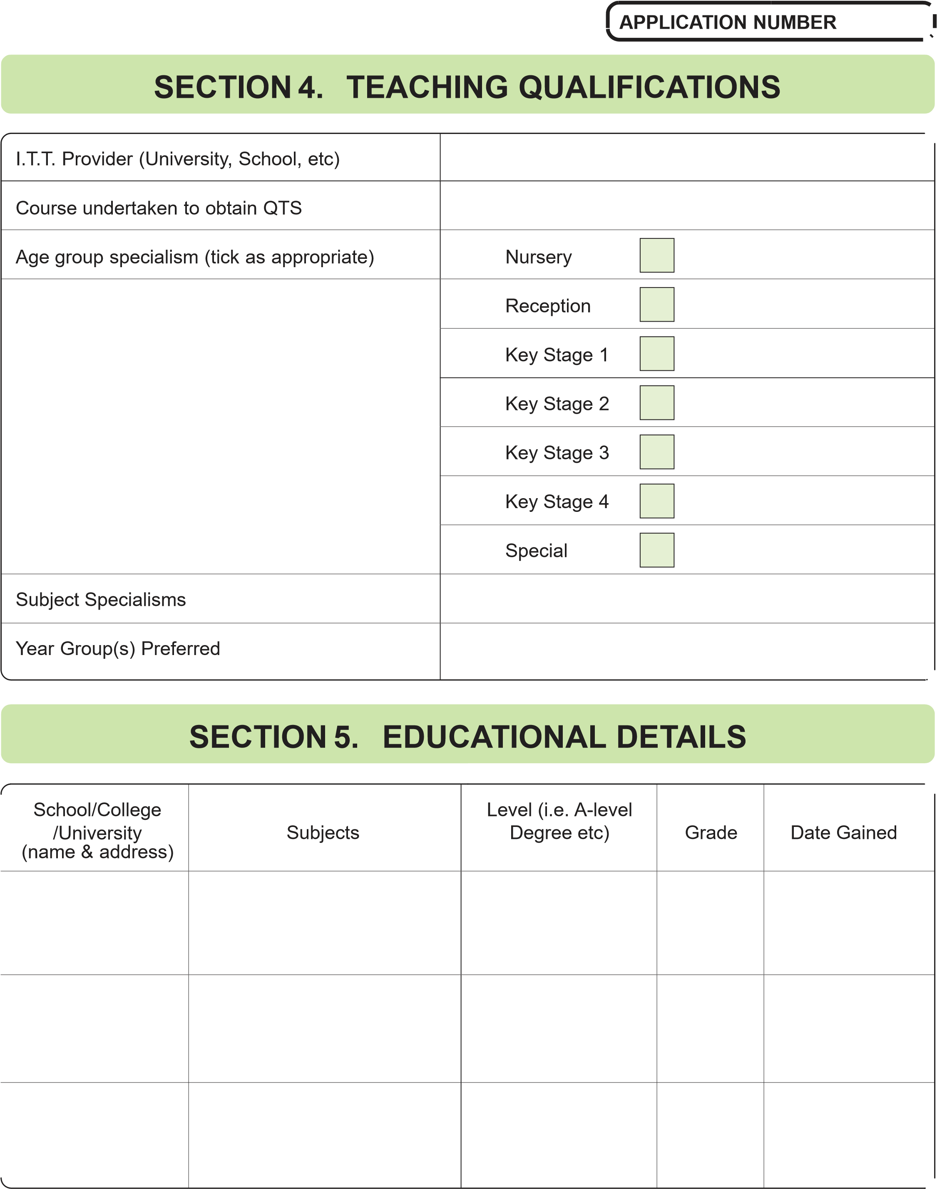
SECTION 6. DETAILS OF FURTHER EDUCATION

(
Please list any training you have received
)

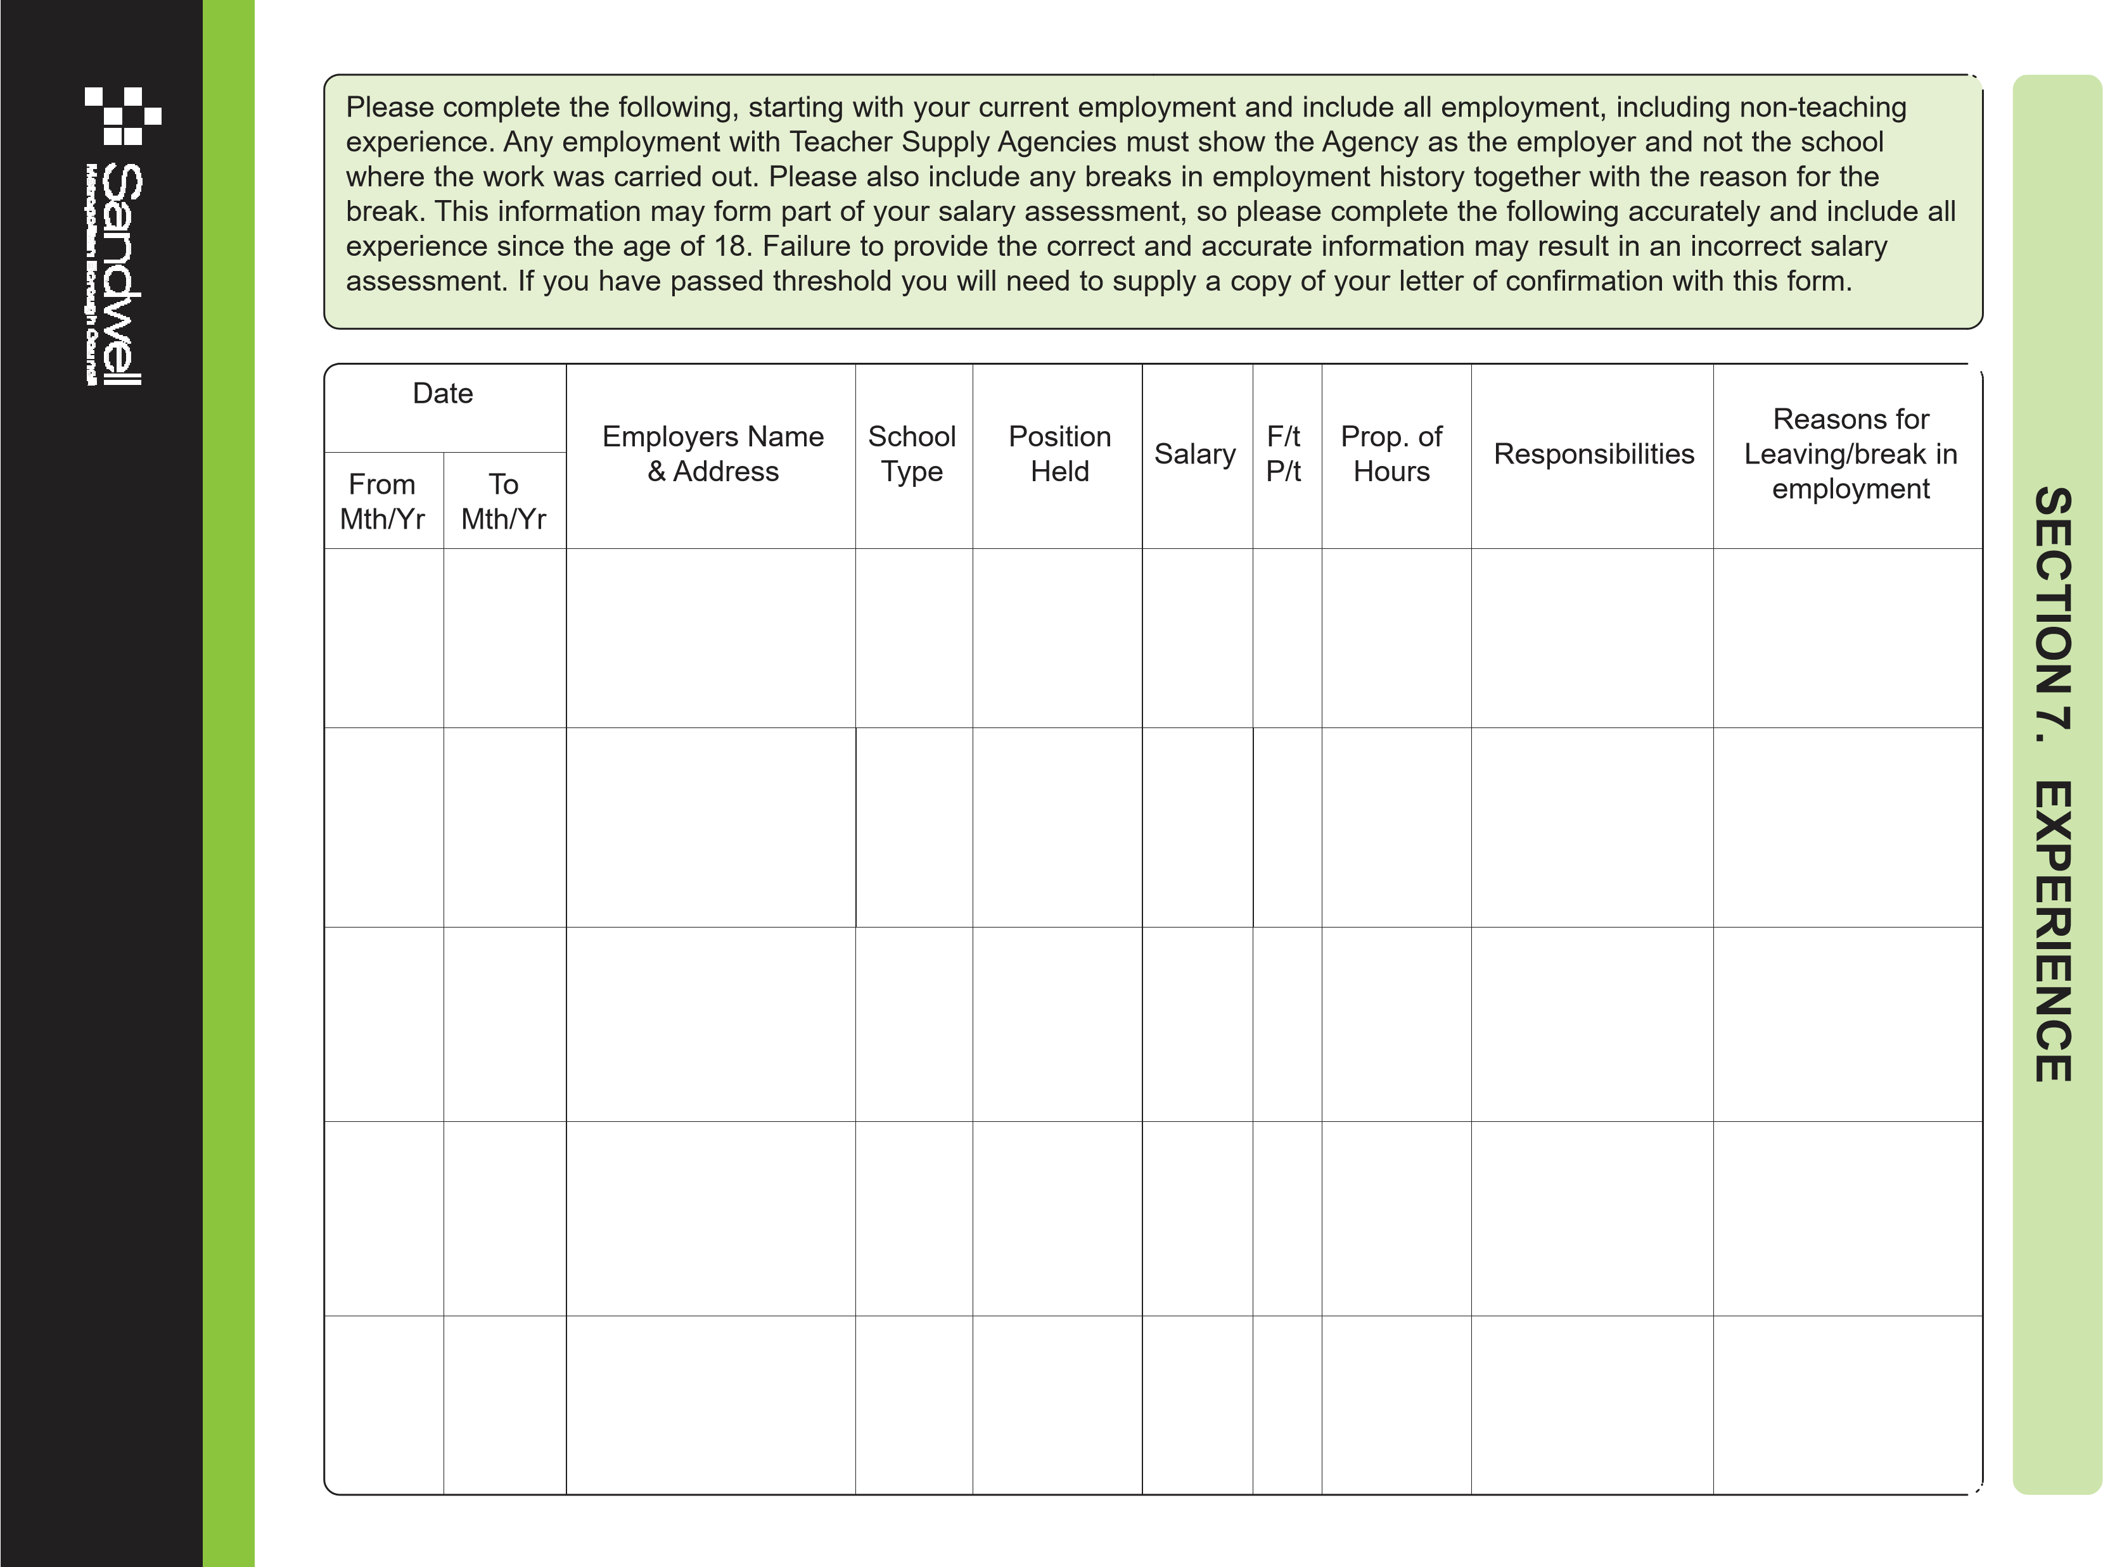

SECTION 8. OTHER INFORMATION IN SUPPORT OF YOUR APPLICATION

Please continue on blank pages at the end of this application form if necessary

SECTION 9. CONVICTIONS

Rehabilitation of Offenders Act 1974 (exceptions) Order 1975
IMPORTANT NOTE FOR ALL PERSONS APPLYING FOR POSITIONS IN SCHOOLS AND COLLEGES, AND OTHERS WHO WILL WORK WITH YOUNG PERSONS UNDER AGE 18.
The Rehabilitation of Offenders Act 1974 (exceptions) Order 1975 does not allow employees with access to children and young persons under the age of 18 years the right to withhold information regarding previous criminal convictions, including cautions,reprimands and formal warnings, for any offence (not just those involving children) which for other purposes are ‘spent’ under the provisions of the Act. You must disclose in this section any previous convictions, cautions, reprimands and formal warnings.
Failure to disclose any previous convictions (including cautions, reprimands and formal warnings) could result in dismissal should it be subsequently discovered. Any information given, either when returning this application form or at interview, will be entirely confidential and will be considered only in relation to this application.

Date Type of Offence Sentence / Fine Imposed Comments

SECTION 10. REFERENCES

Please provide the names, addresses and occupations of two referees (one of whom must be your present or most recent employer) who are willing to support your application:

Name Name

Address Address

Postcode Postcode
Telephone No. Telephone No.
E-mail Address E-mail Address
Occupation Occupation

May we contact your referees at this stage without further reference to you? YES NO

SECTION 11. DATA PROTECTION ACT

The information collected in the form will be used in compliance with the provisions of the Data Protection Act 1998. The information is being collected by the Recruitment Team for the purpose of administering the employment and training of employees of the Learning and Culture Service. The information may be disclosed, as appropriate, within the Learning and Culture Service, to School Governors, to Occupational Health, to the General Teaching Council, to the Teachers Pensions Agency, to the Department for Education, pension providers and relevant statutory bodies. You may also note that because we have a duty to protect public funds we handle, we might need to use the information you have provided on this form to prevent and detect fraud. We may also share this information for the same purposes with other organisations, which handle public funds.
This page is deliberately left blank.
This page is deliberately left blank.

