INFORMATION PACK
CLASS TEACHER KS1/KS2
NQTs welcome to apply
Bright Futures Educational Trust
Bright Futures Educational Trust (The Trust) is a multi-academy trust set up in 2011. The Trust is made up of a richly diverse group of schools in Greater Manchester and Blackpool. We are passionate about working together within and beyond the Trust to achieve our aspirational vision: the best for everyone, the best from everyone. We are an organisation that is underpinned by values of: community, integrity and passion. In everything we do, we remember that we are accountable to the children, families and communities that we serve.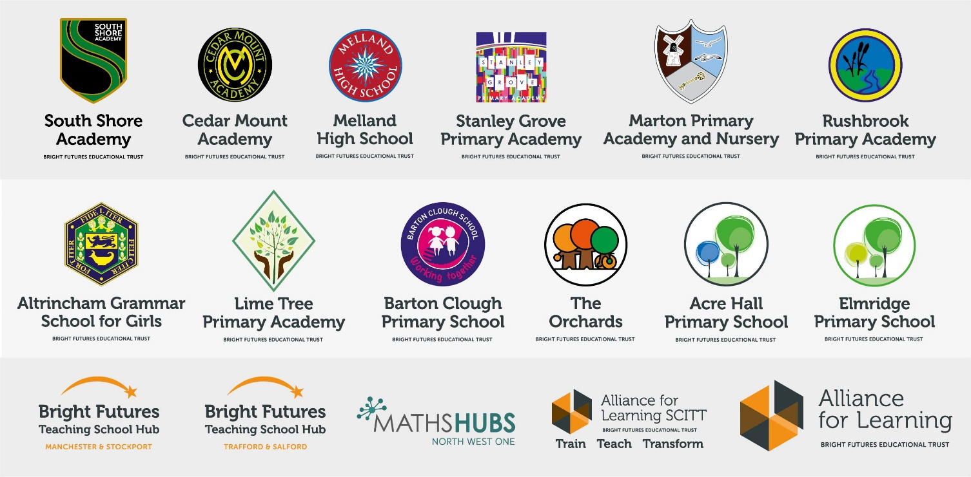
Our schools have their own identities and form one organisation and one employer, Bright Futures Educational Trust. Bright Futures’ Board of Trustees maintains strategic oversight of the Trust and delegates some of its responsibilities to the Executive Team, Principals and local governing bodies. We place a high value on integrity and probity and take seriously our accountabilities for making the best use of public money. How decisions are made is described in our delegation framework. You can find out more about the Trustees and the Executive Team on our website: http://bfet.co.uk/about-us/.

The central team, comprises the Executive Team: John Stephens, CEO; Edward Vitalis, Chief Operating Officer; Gary Handforth, Director of Education; Lisa Fathers, Director of Teaching School and Partnerships and Lynette Beckett, Director of HR & Strategy. The focus of these roles is to work with schools, providing high quality and timely guidance, leadership, challenge and support. In addition to the executive team, we have central operations for finance, HR, educational psychology and Digital Technologies. Please see our website brochure which explains our central operations: Working together for a Bright Future.
Bright Futures Development Network is another important outward facing component of our organisation. Underneath this umbrella we have 5 network hubs. ‘The Alliance for Learning’ (AFL) which provides school improvement services and CPD to over 700 schools (http://allianceforlearning.co.uk/); a North West Maths’ hub providing mathematics training and coaching to 500 schools: a SCITT (School Centered Initial Teacher Training) which is the largest in the North West. After significant national reforms to the teaching school policy, Bright Futures was designated with two new large-scale Teaching School Hubs in 2021. The areas we serve are Manchester, Stockport, Salford and Trafford.

Collaboration and strong relationships form one of the ‘commitments’ in our Strategy and all components of the Bright Futures’ family work closely together. Our Strategy was developed collaboratively and can be found on our website: Our Strategy.

About Lime Tree

Lime Tree Primary Academy is an Ofsted outstanding, nationally designated Teaching School that educates children aged from 2 to 11 years old.
Situated in the Borough of Trafford, our facility benefits from extensive grounds incorporating a working farm and several dedicated Forest School areas. The school building boasts spacious, light filled learning spaces and state of the art technology and resources.
At Lime Tree Primary Academy, we offer our pupils the very best start in their education through the careful nurturing of individuals via ingredients of creativity, innovation and academic challenge. We passionately believe that it is every child’s right to receive an education that fosters a lifelong love of learning.

Lime Tree’s Values
We believe in and strive for…
Skilled knowledgeable, independent and resilient
Learners
Creative, imaginative, structured and adaptable
Thinkers
World aware, community spirited, caring and healthy
Individuals
A place where everyone loves to learn.
Lime Tree exists, to push the boundaries, remove the barriers and challenge the ordinary, enabling learning construction that is truly accessible for all. Through research, innovation and creativity we champion education as the vehicle to ignite passions, discover talent, nurture self-belief and become the very heart of our community

Why work for us?

We offer a great opportunity to join an organisation which really lives its values. Our working environment is very inclusive and whilst you can expect to be challenged in your role, you will be supported through professional learning, treated fairly and with dignity and respect. Please see the Equality, diversity and inclusion statement on our website: http://bfet.co.uk/vacancies/.

Terms and Conditions
Salary: MPR/UPR (School Teachers Terms and Conditions)dependent upon experience
Pension: Teachers Pension Scheme: https://www.teacherspensions.co.uk/

Other: We offer salary sacrifice schemes for purchasing cycles and technology, through monthly interest free salary deductions.
How to Apply

We can only accept completed application forms, rather than CVs. This is because the regulatory guidelines of Keeping Children Safe in Education, require us to check various details of job applicants and an identical application format for each candidate enables us to do this.
Our website contains our application form and disclosure of criminal background form. Both completed forms should be emailed to jobs@limetree.trafford.sch.uk by 5pm on Friday 21st May 2021 at 12 Noon.

The selection process will in all likelihood be conducted virtually, so candidates will need access to a device with a camera and a microphone to participate. The shortlisting will take place on Monday 24th May with the selection process on Thursday 27th May 2021

Keeping Children Safe in Education

Bright Futures Educational Trust is committed to safeguarding and promoting the welfare of children and young people and we expect all staff and volunteers to share this commitment. This post is exempt from the Rehabilitation of Offenders Act 1974; pre-employment checks will be carried out and references will be sought for shortlisted candidates and successful candidates will be subject to an enhanced DBS check and other relevant checks with statutory bodies.
Data Privacy
You can the details of how we use the personal data that you provide us with in our Job Applicants’ privacy notice on our website: http://bfet.co.uk/wp-content/uploads/2018/07/BFET-Applicant-privacy-notice-002.pdf

JOB DESCRIPTION

KEY PURPOSE OF THE JOB
To take responsibility for the education and welfare of a designated class of children in accordance with the current Academy Teachers’ Pay and Conditions document, having due regard to the requirements of the National Curriculum and Trust/Academy policies.

MAIN ACTIVITIES

- To take responsibility for planning and implementing appropriate work programmes for all children in the designated class, within the framework of national and academy policies.

- To maintain assessment records and report on pupils’ progress to senior staff and to parents and carers, in accordance with academy policy.

PRINCIPAL ACCOUNTABILITIES

- To plan work for the class in accordance with national, trust and academy curriculum policies and in co-operation with subject and phase leaders to ensure that the children experience a broad, balanced, relevant and stimulating curriculum.

- To ensure a close match between the learning experience offered, and the individual needs of the children in the class, so as to give each child an opportunity to achieve to the maximum of his/her capability.

- To make appropriate educational provision for children with SEN and those learning EAL, with support from the SENCo

- Where possible, to make sure that the majority of the children’s work is closely linked to first-hand practical experience.

- To provide children with opportunities to manage their own learning and become independent learners.

- To create a secure, happy and stimulating classroom environment, maintaining the highest standards of organisation, and discipline.

- To foster each child’s self-image and esteem and establish relationships which are based on mutual respect.

- To maintain a high standard of display both in the classroom and in other areas of the academy.

- To arrange for resources, equipment and materials to be available in such a way that they are properly cared for, easily accessible and will encourage the children to become more responsible for their own learning.

- To work closely with colleagues to undertake medium and short term planning and the implementation of agreed schemes of work.

- To assess children’s progress, maintain records and provide written reports to parents and carers in accordance with academy policies.

- To communicate and consult with parents and carers and with outside agencies, as necessary, about children’s progress and attainment.

- To ensure that the academy’s aims and objectives in relation to the curriculum, equal opportunities and discipline are promoted in every day classroom organisation and practice.

- To liase with support staff both academy based, from the Trust & from other external bodies as required.

- To take responsibility for the management of other adults in the classroom.

- To take up the opportunity for continuous professional development through self-directed reading, courses and in-service training.

- To undertake any other reasonable and relevant duties in accordance with the changing needs of the academy.

- To take responsibility for a curriculum subject area as agreed with the headteacher as detailed below:

- Promote the teaching of the agreed subject throughout the academy, according to the requirements of the National Curriculum and the academy’s agreed structures and frameworks.

- In conjunction with the head teacher or other senior staff, be responsible for the implementation and management of the academy’s policy for the agreed subject area

- Review the policy and adapt it as appropriate

- Develop a scheme of work for the subject suitable to the needs of a primary academy catering for 3 – 11 year olds that embraces the academy’s vision of teaching and learning

- Take responsibility for maintaining and evaluating all material resources with a system of easy accessibility. To consult colleagues and be responsible for ordering resources within an agreed budget in full consultation with the head teacher

- Offer support and advice to colleagues.

KEY ORGANISATIONAL OBJECTIVES

The Post holder will contribute to the academy’s objectives in service delivery by:

- Enactment of Health and Safety requirements and initiatives as directed
- Ensuring compliance with Data Protection legislation
- At all times operating within the academy’s Equal Opportunities framework
- Commitment and contribution to improving standards for pupils as appropriate
- Acknowledging Customer Care and Quality initiatives
- Contributing to the maintenance of a caring and stimulating environment for pupils

PERSON SPECIFICATION

 | ESSENTIAL | DESIRABLE
QUALIFICATIONS | - Educated to degree level  - Qualified Teacher Status | 2:1 Degree or above
EXPERIENCE | - Successful experience on teaching practices  - Teaching practices across two key stages as part of training | - OFSTED grade 1 lessons observed  - Range of additional experiences with primary age children  - Experience of children with SEN
KNOWLEDGE  AND  UNDERSTANDING | - A sound knowledge of the National  Curriculum  An awareness and understanding of child protection issues  - Good understanding of the principles of Assessment for Learning | - Familiarity with End of Key Stage Assessment  - procedures
SKILLS AND ABILITIES | - The ability to plan, monitor, evaluate and review pupils progress  - Sensitivity towards the requirements of children with Special Educational Needs  - The ability to use ICT effectively in the classroom  - The ability to work collaboratively and effectively in a team with staff, governors and parents  - A high level of written and oral communication skills  - Promotion of positive behaviour strategies | - Additional knowledge and understanding of a specialist curriculum area(s)  - Ability to offer extra-curricular’ activities
OTHER | - A commitment to involve parents, governors and the community in the work of the school  - An awareness, understanding and commitment to equal opportunities

C

