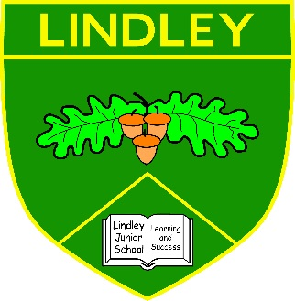

Lindley Junior School

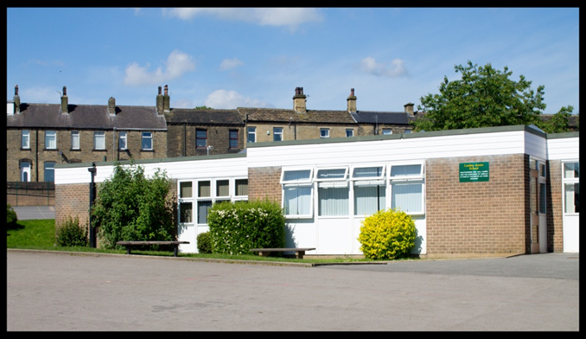

Class Teacher Full Time, Fixed Term
Information Pack
March 2024

Lindley Junior School, George Street, Lindley, Huddersfield HD3 3LY

Dear Applicant

Thank you for your interest in our Class Teacher post. We hope that this information pack, containing details of the post and the school, is helpful.

To assist you in making a successful application, the points below are given for your guidance:

- Please complete the application form by hand.

- Unfortunately, the standard application form does not provide all the information we require, therefore, a separate supporting letter (which may be typed). The letter in support of your application is a vital part of the process; please ensure that you address each of the essential and desirable criteria listed on pages 7-9.

- Completed applications should be returned to the Head Teacher at the school;

- The closing date 12 noon Monday 8th April 2024.

- Please prepare your referees for our request for your references at short notice and ensure that you provide us with their current e-mail addresses.

We look forward to receiving your application. Thank you for your interest in the school.

Good luck!

Yours sincerely

Emma McKenna Sharon Farr
Head Teacher Chair of Governing Body

General information
Lindley Junior School is an oversubscribed junior school, which converted to academy status in October 2011, for children in the age range 7-11 years. The school is close to the centre of Lindley - an attractive and thriving village only three miles from the centre of Huddersfield.
We work closely with Lindley Church of England Infant School from which most of our intake transfer. The Lindley schools are two of the six schools in the Salendine Nook pyramid of schools; relationships within the pyramid are supportive. Most pupils transfer to Salendine Nook High School Academy, others to the grammar schools in Halifax and Heckmondwike or to independent schools in Bradford, Wakefield, Leeds and Huddersfield.

The admission area of the school has a fairly diverse socio-economic mix including nearby residential estates, private and local authority housing and short term rental properties. A broad range of social and economic backgrounds is reflected in the current school roll of 498 pupils with 81 (16%) pupils entitled to FSM and 82 (16.2%) pupils entitled to the Pupil Premium. There are 42% of pupils from ethnic minority heritage backgrounds. There are currently 24 pupils with an Educational, Health and Care Plan in place. We have strong and effective relationships with parents/carers, supported by regular consultation.

Lindley Junior School has a strong commitment to the clear vision set out in its ethos and values statement, which is evident in the pupils’ achievements and sheer enjoyment of teaching and learning shown by staff and pupils alike.

Vision and values
At Lindley Junior School, we offer a learning community, where we strive for quality, enjoyment and success for all, by fostering enquiring minds in a stimulating, caring environment, where everyone is valued.
We encourage the development of mutual respect and tolerance within a happy, hardworking atmosphere. We prepare pupils for the challenges, opportunities and responsibilities of life.
Our intention is for all pupils to achieve their full potential - we strive for excellence. We recognise and are constantly aware of the needs of each individual.

All members of the school community work towards the school's aims of:
- valuing everyone as individuals and respecting their rights, values and beliefs
- providing a well ordered school in which everyone understands appropriate behaviour
- encouraging mutual respect
- fostering and promoting good relationships
- providing a safe, secure and caring environment
- offering equal opportunities for everyone, in all aspects of school life and recognising the importance of different cultures
- encouraging, praising and positively reinforcing good relationships, behaviours and work
- working as a team, supporting and encouraging each other
- striving for excellence

The pupils are encouraged to:
- respect adults, children and property
- work hard during every lesson, listen, question, reason, reflect and respond appropriately
- have high expectations for themselves
- take increasing responsibility for their own learning, behaviour and attitudes
- listen thoughtfully to the views of others
- express their views with clarity and confidence
- be organised and self-disciplined with personal belongings and the daily routine of school
- attend school regularly and punctually
- take home letters, notes and reports and give them to their parents
- talk to parents and teachers about any worries or concerns
- accept and conform to the uniform code

We ask parents to:
- ensure that their children attend school in good health, regularly and punctually
- provide support for the discipline within the school and for the teacher's role
- take an interest in what their child is learning
- be realistic about their children's abilities and to offer encouragement and praise
- participate in discussions concerning their child's progress and attainments
- ensure early contact with school to discuss matters which affect a child's happiness, progress and behaviour
- value homework
- allow their children to take increasing responsibilities as they progress through the school
- encourage their children to take part in after school activities by supporting their attendance
- inform the school, as soon as possible, about any absence and the reason for it
- avoid taking children away from school for term time holidays

Learning
At Lindley Junior School, we offer a broad curriculum which is conceptually rich, relevant, and balanced providing a challenging educational journey. We believe in supporting the emotional and social growth of our children and developing the intellectual, expressive, physical, moral, cultural and social skills of pupils of all abilities, within a safe and inclusive environment.

We seek to develop lively, enquiring minds; to prepare pupils for the challenges, opportunities and responsibilities of life through a high standard of education. Our curriculum is designed to give all pupils the knowledge and cultural capital they need to succeed in life. We encourage all pupils to reach the highest standards of personal achievement by recognising, and valuing each child as an individual with their own unique strengths.

We offer creative, enquiry led learning experiences, with enrichment and enterprise opportunities to engage learning. We believe that childhood should be a happy, investigative and enquiring time in our lives, where there is a thirst for knowledge and new experiences.

Our curriculum encourages achievement and develops caring and positive attitudes which extend the children's knowledge of themselves and of the world in which they live. We intend that pupils will develop tolerance, understanding, and respect for the rights and views of others.

Pupils will leave Lindley Junior School with a sense of belonging to their community; have the confidence and skills to make informed choices, through self-evaluation and making connections and, ultimately become life-long learners.
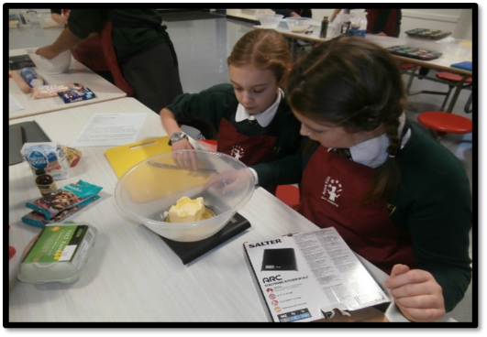
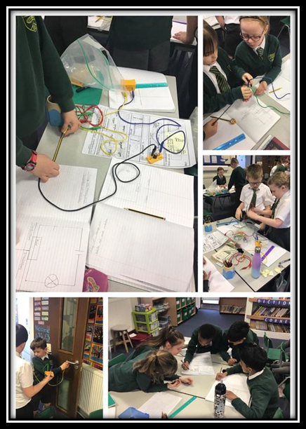

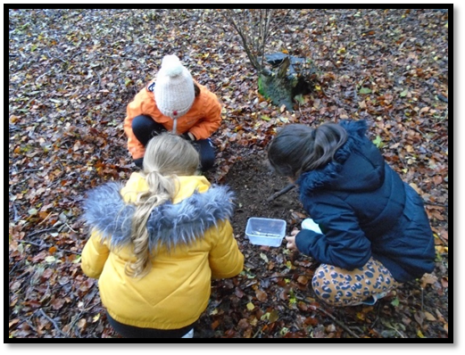

Teaching
Teaching and learning is the key focus of Lindley Junior School; its leadership sets the highest expectations for both teachers and pupils.
- Lessons are characterised by high levels of engagement, concentration, progress and achievement.
- The monitoring of teaching and learning is of prime importance – regular scrutiny of pupils’ books and paired and peer observations mean that effective practice can be celebrated and shared as well as weaknesses addressed.
- Members of staff are supported, valued and encouraged to maintain continuous professional development.
- There are sixteen classes, four in each year group; pupils are set for maths and there is some specialist teaching.
Academic performance
At the end of Key Stage 2, the 2022/23 cohort achieved successes as follows:
Average scaled score per pupil
Reading Maths
Lindley Junior School 108 107
National 105 104
% of pupils achieving at the expected standard or higher
Reading Writing Maths R, W & M G, P & S
Lindley Junior School 91% 82% 90% 77% 91%
National 73% 71% 73% 59% 72%
% of pupils achieving at the higher standard
Reading Writing Maths R, W & M G, P & S
Lindley Junior School 36% 10% 34% 7% 36%
National 29% 12% 23% 7% 30%

Average progress score
Reading Writing Maths
Lindley Junior School +1.1 -0.3 +1.1
National 0.0 0.0 0.0

There were 124 pupils in Year 6. 15% of the cohort had Special Educational Needs and 14.5% spoke English as a second language.
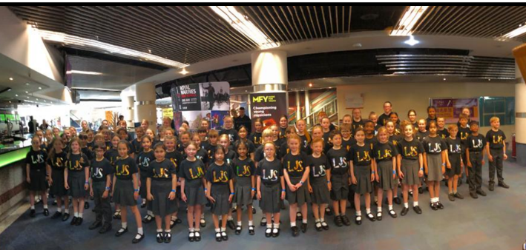

Leadership and management
In addition to the Head Teacher who is also a SENCo, the senior team comprises a Deputy Head Teacher who is not class based and an Assistant Head Teacher who is part class based. There are five TLR post holders and an Assistant SENCo.

The 2023-2024 school budget is £2.184million. The school receives approximately £10,000 annually from fundraising (reflecting strong parental support). Much of the school building has been renewed in recent years with significant refurbishment of the building. The school was a Converter Academy in 2011; and successfully took catering in-house on 1st September 2019.

Lindley Junior School has strong links to, and cooperates with other local schools and continues to buy some services from Kirklees Local Authority. The school has a strong and supportive Governing Body.

There are 25 teaching staff (22.77fte) and 37 support staff (25.23fte) who are dedicated, professional and hardworking. Many members of staff have been with, and advanced within, the school over a long period. The school is committed to the continued professional development of all its staff, both teaching and non-teaching and values them as people.
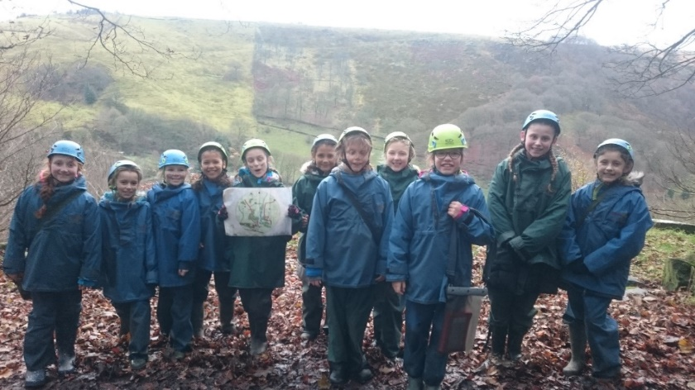

Job description
The Post
The Governors are keen to appoint a highly motivated and talented primary teacher with energy, vision and a passionate commitment to learning. The school is a happy and exciting place to work, where the pupils enjoy learning!
Salary will be paid on MPS/UPR depending on experience. This post is suitable for an ECT or an experienced teacher.
The post is a full time, fixed term for one year for a class teacher, starting on 1st September 2024.

Main purpose
The teacher will:
Fulfil the professional responsibilities of a teacher, as set out in the School Teachers’ Pay and Conditions Document
Meet the expectations set out in the Teachers’ Standards

Duties and responsibilities
Teaching
- Plan and teach well-structured lessons to assigned classes, following the school’s plans, curriculum and schemes of work
- Assess, monitor, record and report on the learning needs, progress and achievements of assigned pupils, making accurate and productive use of assessment
- Adapt teaching to respond to the strengths and needs of pupils
- Set high expectations which inspire, motivate and challenge pupils
- Promote good progress and outcomes by pupils
- Demonstrate good subject and curriculum knowledge
- Participate in arrangements for preparing pupils for external tests

Whole-school organisation, strategy and development
- Contribute to the development, implementation and evaluation of the school’s policies, practices and procedures, so as to support the school’s vision and values
- Make a positive contribution to the wider life and ethos of the school
- Work with others on curriculum and pupil development to secure co-ordinated outcomes
- Provide cover, in the unforeseen circumstance that another teacher is unable to teach

Health, safety and discipline
- Promote the safety and wellbeing of pupils
- Maintain good order and discipline among pupils, managing behaviour effectively and positively to ensure a good and safe learning environment

Professional development
- Take part in the school’s appraisal procedures
- Take part in further training and development in order to improve own teaching
- Where appropriate, take part in the appraisal and professional development of others

Communication
- Communicate effectively with pupils, parents and carers

Working with colleagues and other relevant professionals
- Collaborate and work with colleagues and other relevant professionals within and beyond the school
- Develop effective professional relationships with colleagues

Personal and professional conduct
- Uphold public trust in the profession and maintain high standards of ethics and behaviour, within and outside school
- Have proper and professional regard for the ethos, policies and practices of the school, and maintain high standards of attendance and punctuality
- Understand and act within the statutory frameworks setting out their professional duties and responsibilities

Relevant to teachers on Upper Pay Range below:
Management of staff and resources
- Direct and supervise support staff assigned to them, and where appropriate, other teachers
- Contribute to the recruitment and professional development of other teachers and support staff
- Deploy resources delegated to them

The Teacher will be required to safeguard and promote the welfare of children and young people, and follow school policies and the staff code of conduct.
Please note that this is illustrative of the general nature and level of responsibility of the role. It is not a comprehensive list of all tasks that the teacher will carry out. The post holder may be required to do other duties appropriate to the level of the role, as directed by the Head Teacher or Line Manager.

The successful candidate will be able:

Person specification
Qualifications and experience
- Qualified Teacher Status
- Degree
- Successful Primary teaching and experience
Skills and knowledge
- Knowledge of the National Curriculum
- Knowledge of effective teaching and learning strategies
- A good understanding of how children learn
- Ability to adapt teaching to meet pupils’ needs
- Ability to build effective working relationships with pupils
- Knowledge of guidance and requirements around safeguarding children
- Knowledge of effective positive behaviour management strategies
- Good ICT skills, particularly using ICT to support learning
Personal Qualities
- A commitment to getting the best outcomes for all pupils and promoting the ethos and values of the school
- High expectations for pupils’ attainment and progress
- Ability to work under pressure and prioritise effectively
- Commitment to maintaining confidentiality at all times
- Commitment to safeguarding and equality
The job description may be amended at any time in consultation with the post holder
The appointment
Lindley Junior School is committed to safeguarding and promoting the welfare of children and young people and expects all staff and volunteers to share in this commitment. Therefore, this position will be subject to the appropriate clearance checks including an Enhanced DBS check with the Disclosure & Barring Services (previously known as the Criminal Records Bureau). Lindley Junior School is an equal opportunities employer.
Pay
MPS/UPR.
Please find the following documents included in this candidate pack:
- Letter from the Head Teacher
- Job Description
- Personal Specification
- Application process
All appointments will be subject to receipt of satisfactory Enhanced DBS check, pre-employment checks and satisfactory references.
You are welcome, and encouraged, to visit the school in advance of your application. Please book your visit with Mrs Lawler, the School Business Manager:
Email: bursar@lindleyjunior.org.uk; telephone 01484 654650

Application process
Application must be made on the form provided; it must be hand-written and accompanied by a supporting letter (which may be typed). The application form and letter will be used as a basis for shortlisting candidates and candidates need to demonstrate how they meet the requirements of the post.
The application form can be downloaded from the school website, under the vacancies section; www.lindleyjun.org.uk
Applications should be addressed to the Head Teacher and posted to Lindley Junior School, George Street, Lindley, Huddersfield, HD3 3LY. The closing date for such applications 12 noon Monday 8th April 2024.
Interview Date: Wednesday 17th April 2024.

