Class Teacher
Application Pack
Main Scale
(Maternity Cover – January 2022 – July 2022)

Self-worth Engagement Purpose
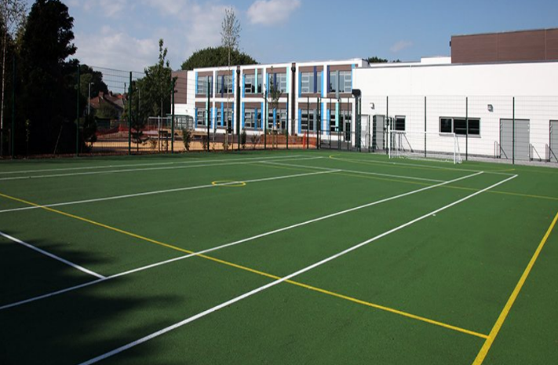
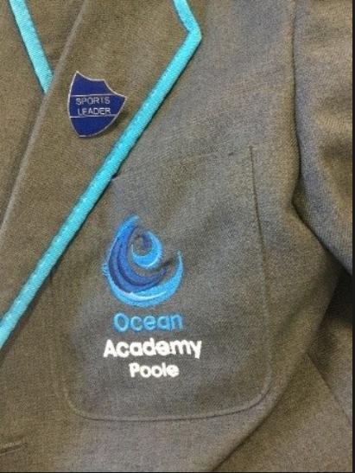
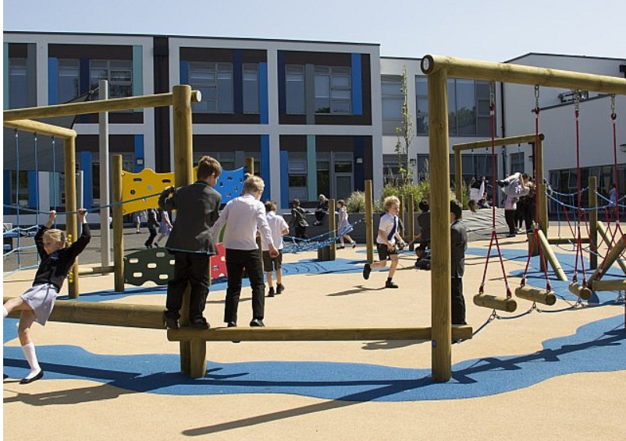
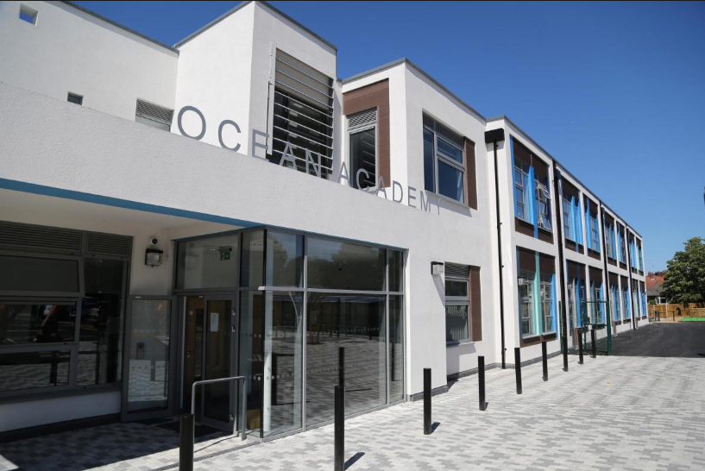

Welcome to Ocean Academy

Ocean Academy is a ‘GOOD’ school with OUTSTANDING behavior and personal development.

Thank you for considering Ocean Academy for the next step in your professional journey. Our Academy is a forward thinking, vibrant and exciting place to work. Ocean Academy has PAN of 360 children and serves a diverse community. We are a successful academy with a real energy and excitement about the future.
We are passionate about excellence in education, giving pupils the very best start in life with a firm belief that aspirational teaching transforms lives. Our core belief is that for all students to have high aspirations they must believe in themselves (SELF WORTH), be actively engaged in their learning (ENGAGEMENT) and see the connection between what they learn today and who they want to become tomorrow (PURPOSE).
We are looking for an outstanding class teacher who is passionate about being a leader of learning and who has children at the heart of all they do. We are looking for someone who is a highly motivated, enthusiastic professional who is passionately interested in teaching and learning, with a drive to achieve the very best education for our students.

We believe in the Growth Mindset approach to developing learning and resilience as we want our children to be confident to tackle all new experiences, safe in the knowledge that success and failure are learning opportunities and that thinking about tasks and problems in different ways, trying again and recognizing effort is positive.
In return we can offer a strong team of enthusiastic and dedicated staff, engaged children who are keen to learn, a supportive wider school community and parents who would overwhelmingly recommend Ocean Academy to other parents.
Ocean Academy is on a journey towards outstanding status and we are looking for a class teacher who wants to be part of making this happen. Excellent further professional development is offered by Ocean Academy, supported by the innovative and unique Aspirations training programmes. You will join a school that enables all pupils to access a broad and balanced ‘No Limits’ curriculum and develops their abilities and personalities, irrespective of race, gender, ethnic origin or disability.

Visits to our academy are welcomed and encouraged and we look forward to meeting you. Please contact the school office (details below) to arrange a suitable time.

Best wishes

Mrs J Quarrie
Executive Principal – Ocean Academy /Jewell Academy

School Office : Mrs Jane Burry (Office Manager) 01202 606888 office@aatocean.org

Closing date for applications: 18 October 2021 12 noon
Interviews will be held on: 22 October 2021
Start date: 4th Jan 2022-15th July 2022
Applications to be made on E Teach
https://ocean-aspirations.schoolrecruiter.com/application-register?vacancyId=1178733&lang=en-GB&src=BCP

For more information please visit: www.aatocean.org or www.aspirationsacademies.org

Class Teacher (maternity cover) at Ocean Academy
Job Description

Main Duties & Responsibilities
Classroom teaching responsibilities :
1.Teach in accordance with the requirements of the School Teachers’ Pay and Conditions doc, in line with the National Curriculum, school policies and schemes of work.
2. Set a high standard of professional example, ensuring that the classroom is well planned, tidy and provides a bright and stimulating environment in which children can learn.
3. Manage the classroom in such a way so as to provide a variety of teaching and learning styles as appropriate
4. Maintain discipline and acceptable standards of conduct and appearance of pupils.
5, Marking the class register, ensuring absences and lateness are accounted for and taking appropriate action where they are not.
6. Establish a rapport with pupils to develop their social and academic potential, nurturing children and communicating effectively with their families.
7.Consistently and effectively use information about children’s prior attainment and skill to focus on the next step in their learning.
8.Assess, record and report on the development, progress and attainment of pupils using agreed assessment for learning and summative strategies.
9.Monitoring homework of pupils.
10. Plan and review the year group curricula on a regular, weekly basis with the year team and be an active part of the team.
11.Respond to pupils’ work in accordance with the school assessment and feedback policy.
12. Know and understand the health and safety requirements, including where to obtain expert advice, and ensure there is a safe working environment in which risks are properly assessed and risk assessments are completed.
13. Participate, as directed, in meetings with colleagues and parents in respect of the duties of the post.
14. Attend staff meetings , INSET and other training events as directed by Ocean Academy or Aspirations.
15. Participate, as directed, in in-service training in order to keep abreast of trends and developments in education, especially those relevant to the duties and responsibilities of the post.
16. Participate in the performance management programme operated by the school.
17. Deal with all administrative, organisational and supervisory tasks

Teaching and Learning
1.Be clear about teaching objectives and learning outcomes in lessons, understand the sequence of teaching and learning and communicate this to pupils.
2.Provide guidance on appropriate teaching and learning methods to suit differing pupil needs, focusing on quality differentiation and providing a fully inclusive classroom.
3.Ensure curriculum coverage, continuity and progression for all pupils, from the most able through to those with special educational needs.
4.Gather, analysing and using data to inform planning and reporting.
5.Set expectations and targets for pupils that are realistic yet aspirational and challenging and bring about improvement in pupil performance.
6.Evaluate the quality of teaching and standards of pupils’ achievements, using the analysis to identify effective practice and areas for improvement.
16. Mirror the school’s practice in school-home links, develop a partnership with parents that involves them in their child’s learning of these subjects and informs them about pupil achievement through effective reporting procedures.
17. Where appropriate, develop effective links with the local community, including business and industry, so as to extend both the curriculum and pupils’ wider understanding.
18. Demonstrate a lively and informed interest in current trends in Primary Education.
19. Contribute to the overall aims and objectives of this school and its commitment to high standards and securing school improvement.
20. Promote the school’s Growth Mindset ethos and develop the values of Self Worth, Engagement and Purpose.

Career/Salary Progression
Teachers pay progression will be subject to the successful completion of the performance management procedures as directed by Ocean Academy Poole and Aspirations Academy Trust.

Personal Specification

CRITERIA | ESSENTIAL | DESIRABLE
Qualifications and Professional Development
• Qualified teacher  • Degree or relevant professional qualification  • Evidence of relevant continuous professional development | Yes  Yes | Yes
Experience
• Key Stage 2 age range curriculum experience  • Using a range of teaching strategies  • Ability to use IT and other new technologies to raise standards and motivate learners  • Successful parental liaison  • Managing behaviour for effective learning  • Making effective use of Assessment for Learning strategies  • Using data and assessment information to inform planning  • Being a reflective practitioner | Yes  Yes  Yes  Yes  Yes  Yes  Yes | Yes
Knowledge
Have a sound understanding of :  • Current educational developments and their impact on learning  • Assessment, recording and reporting and its use in accelerating pupil progress  • How to make effective use of performance data and other evidence to support, monitor, evaluate and track improvements in pupil’s learning  • Effective Safeguarding practices | Yes  Yes  Yes | Yes
Qualities and Aptitudes
• Possess integrity and is consistent, fair, open and honest  • Treats all individuals with respect and maintains professional confidentiality  • Confident, enthusiastic and excited by challenge and innovation  • Passionate about teaching, learning and caring for all pupils  • Approachable and positive  • Able to embrace the Growth Mindset culture of the school  • Able to be reflective and to recognise when own skills and experience need support to meet the needs of the school  • Motivated and committed to making a difference to the lives of children | Yes  Yes  Yes  Yes  Yes  Yes  Yes  Yes
Skills
• Effective communication and interpersonal skills  • Ability to maintain and develop good sensitive personal relationships with children, staff, governors, parents and the community  • Ability to interpret data and use it to inform actions for maximising pupil progress  • Ability to lead and manage effective strategies for behaviour management  • Ability to work collaboratively and as part of a team  • Make an effective contribution to the inclusive school ethos  • Ability to prioritise to meet deadlines  • Be or strive to be, an outstanding classroom practitioner | Yes  Yes  Yes  Yes  Yes  Yes  Yes  Yes

The aim of the job description and personal specification is to indicate the general purpose and level of responsibility of the post. Please be aware that duties may vary from time to time without changing their character or general level of responsibility. Duties may be subject to periodic review by the Principal. This is an outline job description only and the post holder will be expected to undertake the duties commensurate within the range and grade of the post or any lesser duties as directed by the Principal.

Aspirations Academies

Aspirations is a successful and rapidly growing sponsor of primary and secondary academies in southern England and is committed to raising students’ aspirations so that all young people reach their fullest potential and achieve the success they want for themselves in an ever changing world. We educate over 7,000 young people from ages 4 to 18.

Our academies are located within three geographical regions, or districts: West London, South Coast (Bournemouth, Poole and Dorset) and Banbury (Oxfordshire). We operate primary, junior, secondary and studio schools and one post-16 college.

In 2020, we will open two all-through academies in partnership with Ian Livingstone OBE, a pioneer in the UK games industry and the Government’s Creative Industries Champion.

The vision of Aspirations is that there is equality of opportunity for all and a recognition that as well as knowledge, students need to develop their ability and skills to apply and repurpose knowledge in order to survive in a rapidly changing world. In applying knowledge to real-world contexts and allowing young learners to take the lead in using this knowledge to find solutions and answers, learning is deepened. The ability to dream about the future while being inspired in the present to reach those dreams is paramount for all Aspirations learners.

The ‘NO LIMITS’ curriculum framework is based around INTENT, IMPLEMENTATION and IMPACT alongside the expectation that the curriculum in each academy additionally values ingenuity, creativity and risk-taking. Accelerated progress will come through the development of CORE and APPLIED learning whereby individual subject and trans discipline learning will unify knowledge, skill development and application. The drivers for change are encompassed in the Guiding Principles of Self – Worth, Engagement and Purpose. Our children need to be engaged in their learning, understand the purpose and subsequently have a high level of self-worth that will be resilient throughout their school life and beyond.

The Aspirations Academies Trust considers that its beliefs and principles are applicable and effective with students from age 3 to 18. Each stage of a child’s education is extremely important ‐ pre‐school, primary and secondary ‐ and should, where possible be coherent across the phases of education in the practice of developing the principles, beliefs and aims of Aspirations . For this reason, we support primary, secondary and, where possible, all through (Ages 3‐18) academies.

At whatever stage a child joins an Aspirations Academy, the aim is to provide each individual child with the best possible life chance. This is done through the achievement of the highest level of qualifications, the development of skills essential to success in an interconnected and highly competitive world, as well as encouraging the highest aspirations, expecting every student to gain a place at university or enter skilled employment.

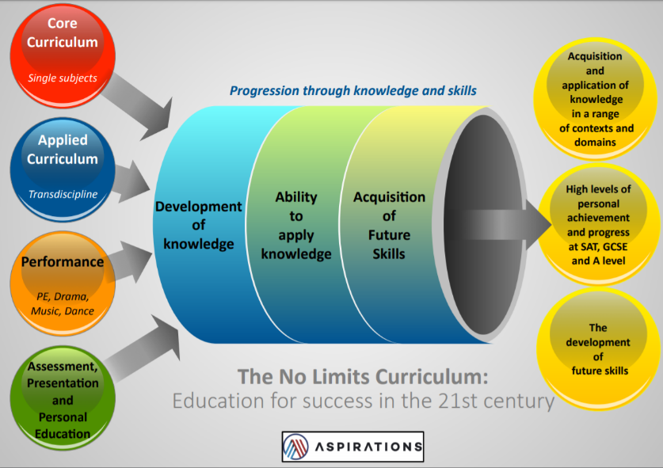

Safe Recruitment Procedure

Aspirations and Ocean Academy Poole are committed to safeguarding and promoting the welfare of all children, young people and staff. In order to meet this responsibility, we follow a rigorous selection process to discourage and screen out unsuitable applicants. This process is outlined below, but can be provided in more detail if requested.

Disclosure
This post is classified as having substantial access to children, and appointment is subject to an enhanced police check of previous criminal convictions (DBS). Applicants are required, before appointment, to disclose any conviction, caution or binding over including ‘spent convictions’ under the Rehabilitation of Offenders Act 1974 (Exemptions) Order 1975. Non-disclosure may lead to termination of employment. However, disclosure of a criminal background will not necessarily debar individuals from employment – this will depend upon the nature of the offence(s) and when they occurred.

Shortlisting
Where necessary, candidates will be asked to address any discrepancies, anomalies or gaps in their application form. Only those candidates meeting the relevant criteria indicated in the personal specification will be taken forward from application. Observations for longlisted candidates may take place before a shortlist is drawn up.

Interview
Those shortlisted will then take part in an interview with questions relating to the job description and person specification. There will also be a presentation and specific tasks relevant to the role.

Reference checking
At least two references will be requested, normally from the previous and current employers. These may be contacted before the interview and in all case before an offer of appointment is confirmed.

Please do not hesitate to contact us should you have any further questions.

