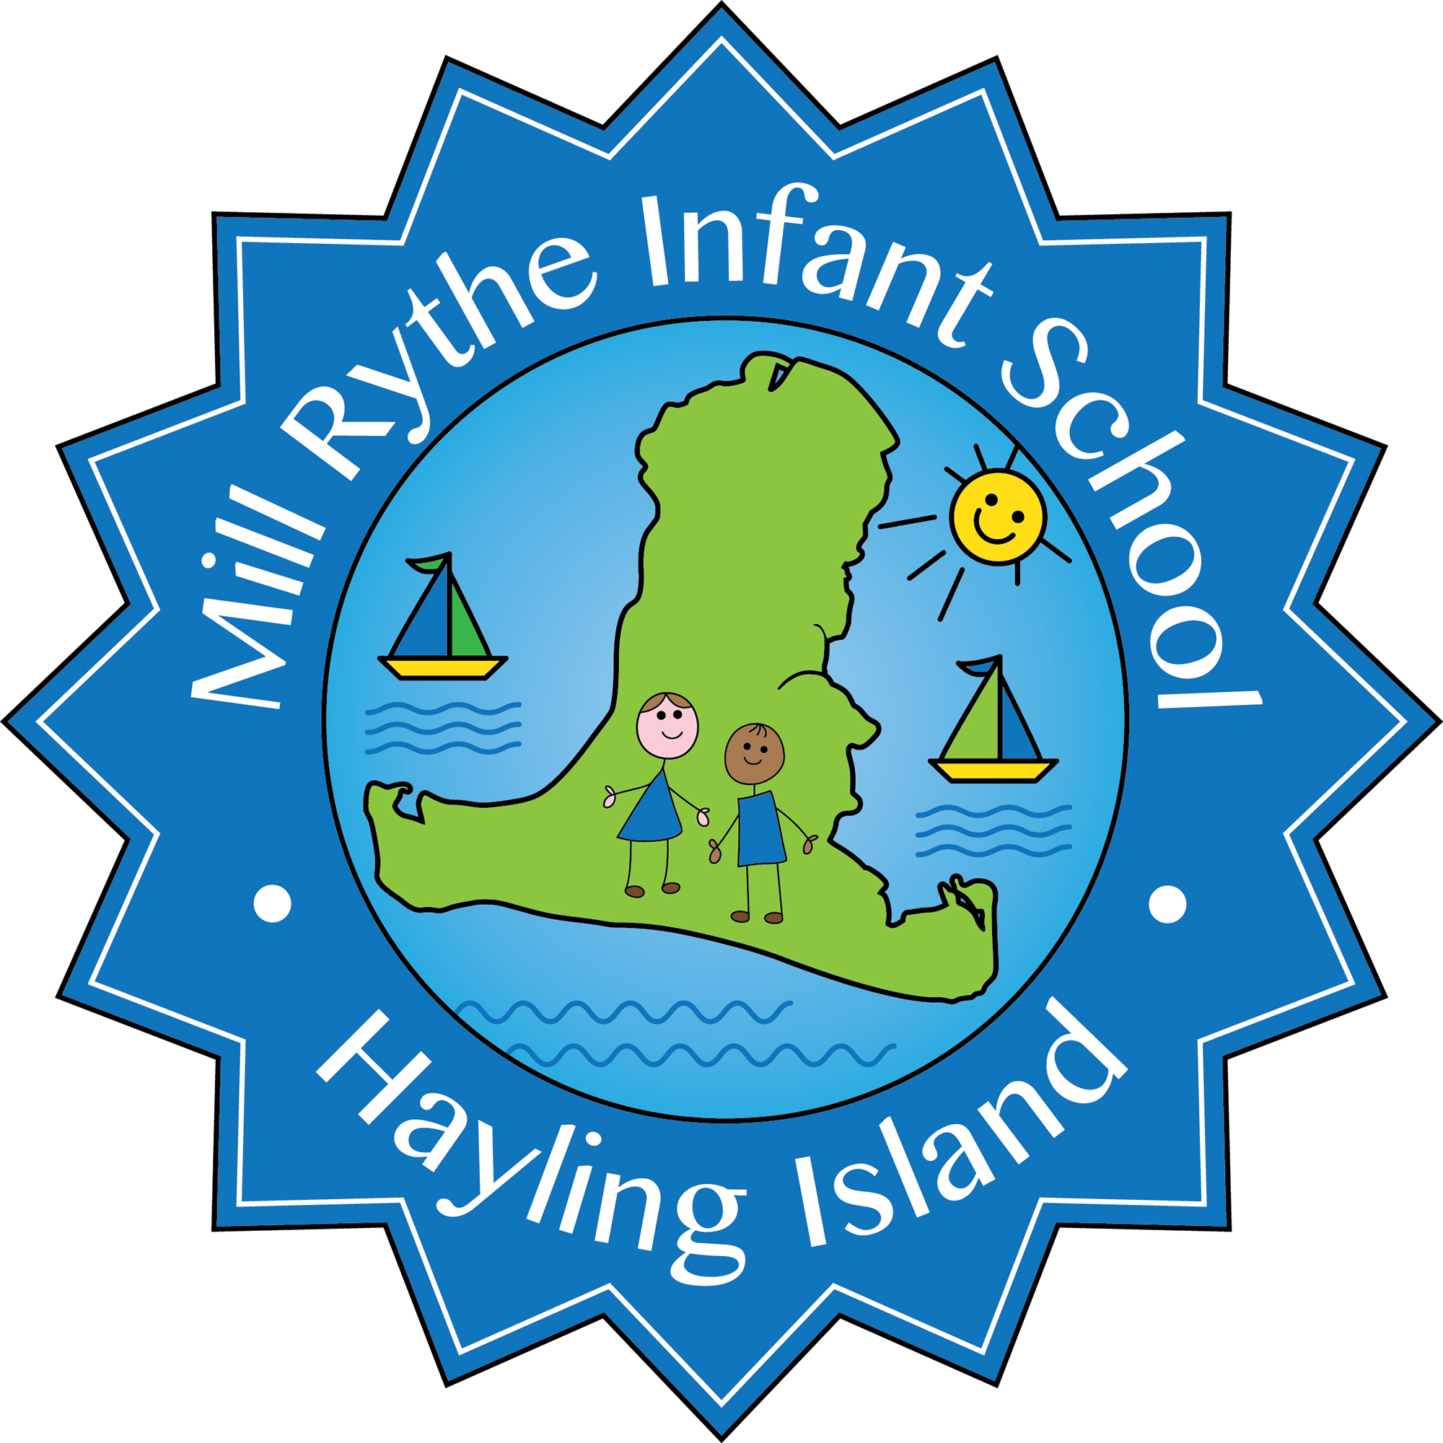

Job description for Class Teacher at Mill Rythe Infant School

The class teacher will:
- Take responsibility for planning and implementing appropriate learning opportunities for all children in the designated class, within the framework of national and school policies.

- Maintain assessment records and report on pupils’ progress to senior staff and to parents and carers, in accordance with school policy.

- Uphold the values and ethos of the school at all times.
Knowledge and Understanding:
The class teacher will demonstrate that he/she:
- understands the purpose, scope, structure and balance of the National Curriculum
- is aware of the breadth of content of the National Curriculum
Planning, Teaching and Class Management:
The class teacher will :
- Plan work for the class in accordance with national, LA and school curriculum policies and in co-operation with subject and phase leaders to ensure that the children experience a broad, balanced, relevant and stimulating curriculum.

- Ensure a close match between the learning experience offered, and the individual needs of the children in the class, so as to give each child an opportunity to achieve to the maximum of his/her capability.

- Make appropriate educational provision for children with SEND and those learning EAL, with support from the SENCo.

- Provide children with opportunities to manage their own learning and become independent learners.

- Create a secure, happy and stimulating classroom environment, maintaining the highest standards of organisation and discipline.

- Foster each child’s self-image and esteem and establish relationships which are based on mutual respect.

- Maintain a high standard of display both in the classroom and in other areas of the school.

- Arrange for resources, equipment and materials to be available in such a way that they are properly cared for, easily accessible and will encourage the children to become more responsible for their own learning.

- Work closely with colleagues to undertake medium and short term planning and the implementation of agreed schemes of work.

- Assess children’s progress, maintain records and provide written reports to parents and carers in accordance with school policies.

- Communicate and consult with parents and carers and with outside agencies, as necessary, about children’s progress and attainment.

- Ensure that the school’s aims and objectives in relation to the curriculum, equal opportunities and discipline are promoted in every day classroom organisation and practice.

- Liaise with support staff both school based, from the LA & from other external bodies as required.

- Take responsibility for the management of other adults in the classroom.

- Take up the opportunity for continuous professional development through self-directed reading, courses and in-service training.

- Undertake any other reasonable and relevant duties in accordance with the changing needs of the school.

- Take responsibility for a curriculum subject area as agreed with the Head Teacher to ensure the curriculum is fully delivered.

