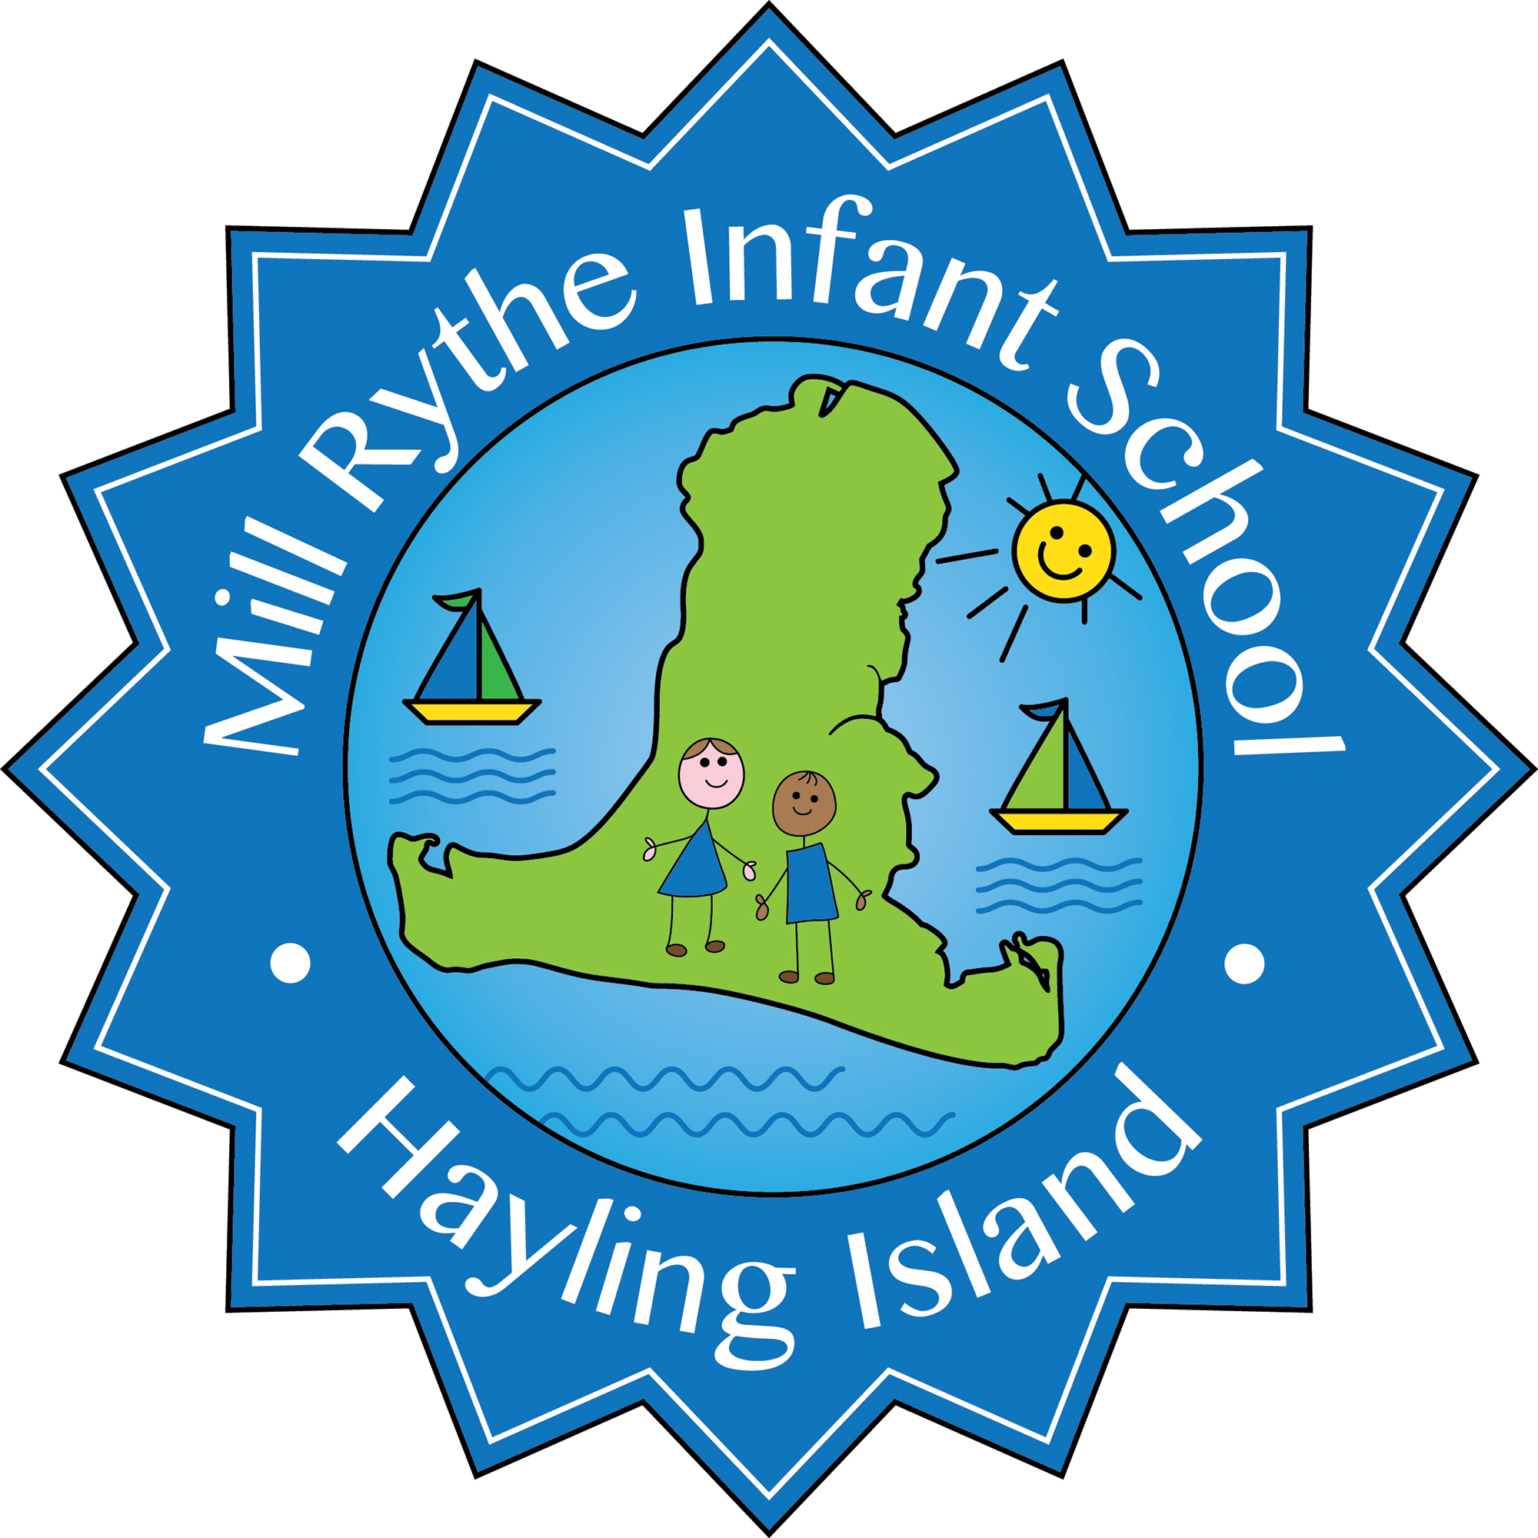
MILL RYTHE INFANT SCHOOL
Person Specification

Post Title: Class Teacher (fixed term)
Hours: Full time

 | Essential | Desirable | Source of Evidence
Education and Training  - Qualified Teacher Status at degree level  - Training as a Primary Teacher | *  * |  | A  A
Experience  - Successful experience as a good teacher  - Experience of successful leadership in an area of development across a school | * | * | A  A
Knowledge and Understanding of:  - The Early Years Foundation Stage Curriculum  - The National Curriculum  - Promoting the safeguarding of all pupils  - Recent changes and developments in best practice for infant pupils  - High Quality Inclusive teaching  - Assessment for learning  - Using the environment and planning to engage and enthuse learners  - The implementation of the wider curriculum | *  *  *  *  *  *  * | * | A/I  A/I  I  A/I  A/I  A/I  A/I  A/I
Skills  - The ability to plan, deliver and assess an effective and stimulating curriculum  - The ability to support pupils with SEN and a commitment to inclusion and equality of opportunity for all pupils  - The ability to work successfully in a team  - The ability to evaluate and adapt provision to meet the needs of children  - Good organisational skills  - Good interpersonal skills with adults and children  - Consistently good teaching  - Ability to establish effective relationships with parents | *  *  *  *  *  *  *  * |  | A/I  A/R/I  A/R/I  A/R/I  A/R/I  A/R/I  A/R/I  A/R/I
Personal Qualities  - Positive and enthusiastic  - Sense of humour  - Motivated and committed  - Proactive | *  *  *  * |  | I/R  I  I/R

Sources of evidence: A= Application R=Reference I=Interview

