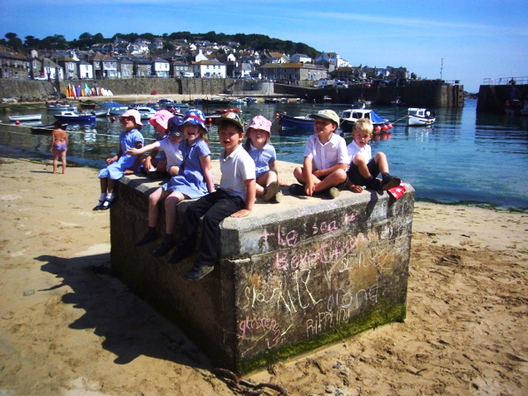
MOUSEHOLE School

teacher’s RECRUITMENT PACK

Truro and Penwith Academy Trust is a charitable Company registered in England and Wales, Company number 08880841. Registered office: College Road, Truro, TR1 3XX

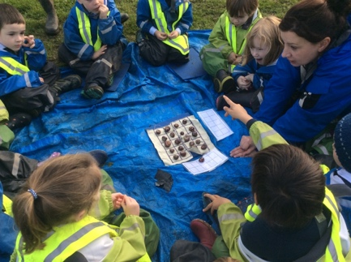
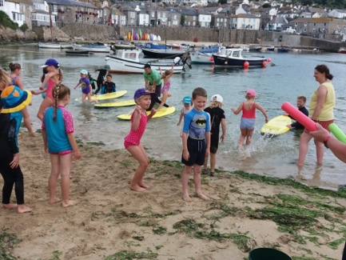
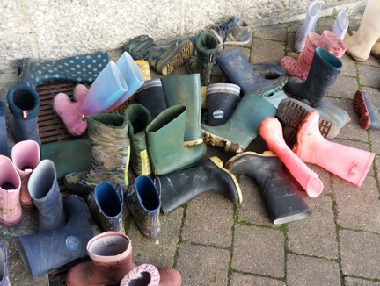
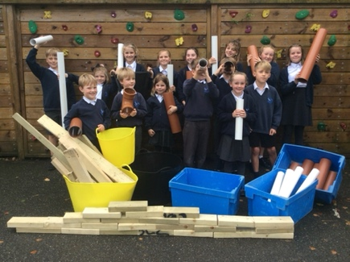
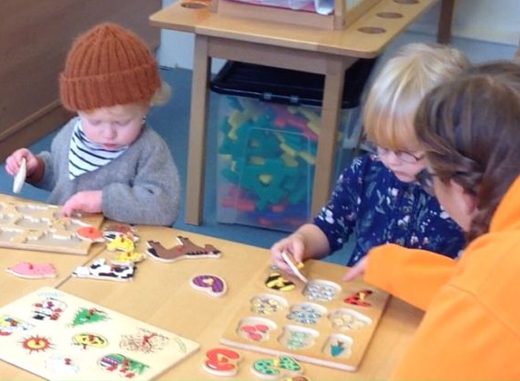
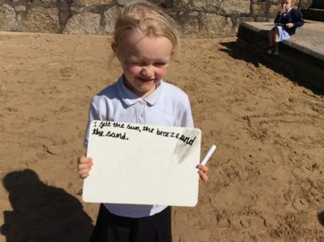
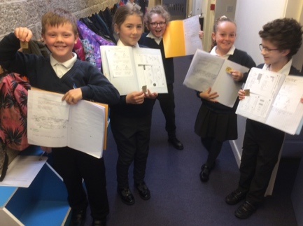
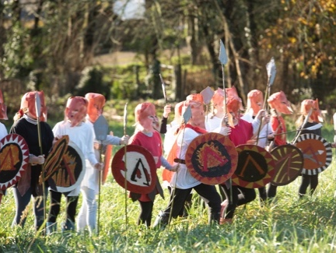
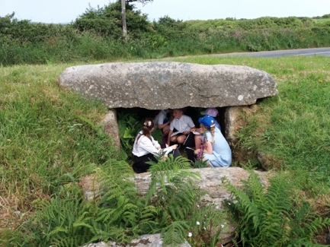
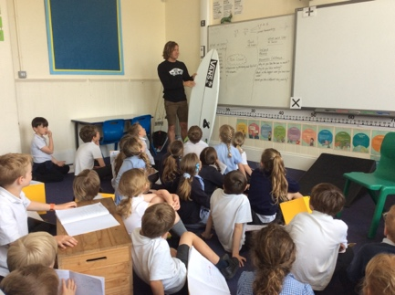

Welcome to Mousehole School
This information pack will provide you with an insight into our school and offer some practical information which will be of use to you as a prospective member of our school community.
Mousehole School is in a fabulous setting with excellent facilities and easy access to the most wonderful outdoor learning environments but what really makes it a great place to work is the people. The children are committed to learning and bring the most positive and enthusiastic attitudes to school with them. We have a very talented and conscientious staff team; we also have a supportive parent body and great links with the community.
We know that successful partnerships between home and school really help the children so we encourage parents and carers to play an active role supporting the school. We have always tried hard to welcome parents into the school for various events and are proud of our efforts to maintain these positive relationships through recent lockdowns and periods of home learning.
We look forward to meeting you and ideally showing you around our school. If this is not practical, our current head teacher is happy to meet remotely or answer any questions you have over the phone.

Our Vision and Aims
We aim to create an exceptional school that harbours confidence, respect and a love of learning and prepares children for the challenges and adventures of life.
At Mousehole School we work hard to achieve a successful, happy, caring and stimulating environment where children are given the opportunity to reach their potential in all aspects of school life. We are very proud of our record for good academic achievement in the core subjects of English and maths and for our passion for creating an interesting and challenging wider curriculum offer. We believe that academic success begins with a safe, stimulating and varied school experience. We offer opportunities and learning experiences beyond the National Curriculum and beyond the classroom and belief that recent global events mean that our role in promoting a positive, caring community and good physical and mental health has never been more important.
We define our aims thus:
- To pursue a creative, adaptable and forward-thinking approach to education which fosters a love of learning, a thirst for knowledge and is focussed on the best outcomes for children.
- To nurture children’s confidence by promoting their independence. Children must believe they can achieve with and without support. They must be empowered and inspired to widen their educational opportunities and improve their life chances.
- To communicate shared values based on mutual respect in the interest of the whole community.
- To ensure an education of such high calibre and clear identity that all members of the community can feel pride in their school.
- To establish a detailed understanding of the talents, needs and personalities of all our children, ensuring our capacity to nurture and challenge every individual.
- Pursue collaborative opportunities and external support for families to improve the quality of education for the children of Mousehole School and beyond.

Background information
Location: The school is in the village of Mousehole, in West Cornwall only a short distance from the picturesque harbour. The area is well connected by good road, rail and air links and offers a variety of amenities and many areas of outstanding natural beauty. The school enjoys making use of the harbour beaches and varied local habitats to enhance its curriculum delivery.
Accommodation: The original buildings have been at the heart of this beautiful village for over 100 years. The recent refurbishments and state of the art extension (finished in 2011) have created an excellent learning environment including comfortable classrooms, a large hall, a library, on-site kitchen, various break out rooms and a purpose-built Early Years block (including a large reception classroom, preschool room and two outside learning areas).
We also have a beautiful school field a short walk from the main site. The field is home to a community garden; a project started in early 2020 with the help of National Lottery funding and local volunteers. It is managed by a member of our support staff team who works closely with the Solomon Brown Hall and despite covid related challenges it now boasts a poly tunnel, vegetable beds, tool shed, fire circle, toilet and mains water supply. The field also has a really good sports pitch, stream and mature wooded area.
Other information: The school converted to academy status in November 2017 and joined the Truro and Penwith Academy Trust and amalgamated with the onsite pre-school in March 2020. The school was last inspected by Ofsted in July 2013 and was judged to be good.
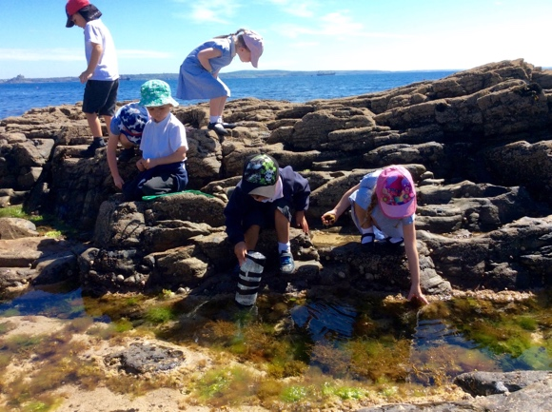
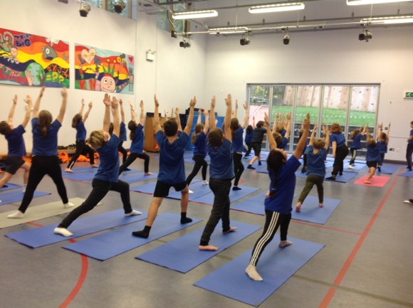
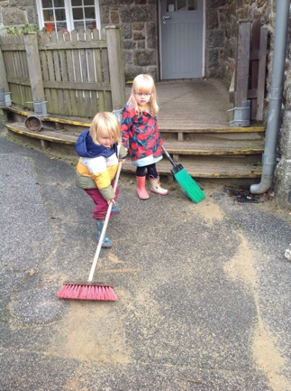

Job Description
Class Teacher: Mousehole School
Job Title: | Class Teacher
Salary Range: | Main Scale dependent on experience
Base: | Mousehole School
Responsible to: | Head Teacher/ Governing Body
Direct Supervisory Responsibility for: | The post holder may be responsible for the deployment and supervision of the work of teaching assistants relevant to their responsibilities
Important Functional Relationships: Internal/External | Other Teaching Staff, Support Staff, Pupils, Parents

Main Purpose of Job:
- Be responsible for the learning and achievement of all pupils in the class/es ensuring equality of opportunity for all
- Be responsible and accountable for achieving the highest possible standards in work and conduct
- Treat pupils with dignity, building relationships rooted in mutual respect, and at all times observing proper boundaries appropriate to a teacher’s professional position
- Work proactively and effectively in collaboration and partnership with learners, parents/carers, governors, other staff and external agencies in the best interests of pupils
- Act within the statutory frameworks, which set out their professional duties and responsibilities and in line with the duties outlined in the current School Teachers Pay and Conditions Document and Teacher Standards
- Take responsibility for promoting and safeguarding the welfare of children and young people within the school

Main Duties and Responsibilities:
All teachers are required to carry out the duties of a schoolteacher as set out in the current School Teachers Pay and Conditions Document. Teachers should also have due regard to the Teacher Standards. Teachers’ performance will be assessed against the teacher standards as part of the performance management process as relevant to their role in the school.

Teaching

- Deliver the curriculum as relevant to the age and ability group/subject/s that you teach;
- Be responsible for the preparation and development of teaching materials, teaching programmes and pastoral arrangements as appropriate;
- Be accountable for the attainment, progress and outcomes of pupils you teach;
- Be aware of pupils’ capabilities and their prior knowledge - plan teaching and differentiate appropriately to build on these demonstrating knowledge and understanding of how pupils learn;
- Have a clear understanding of the needs of all pupils, including those with special educational needs; gifted and talented; EAL; disabilities; and be able to use and evaluate distinctive teaching approaches to engage and support them;
- Demonstrate an understanding of and take responsibility for promoting high standards of literacy including the correct use of spoken English (whatever your specialist subject);
- If teaching early reading, demonstrate a clear understanding of appropriate teaching strategies e.g. systematic synthetic phonics;
- Use an appropriate range of observation, assessment, monitoring and recording strategies as a basis for setting challenging learning objectives for pupils of all backgrounds, abilities and dispositions, monitoring learners’ progress and levels of attainment;
- Make accurate and productive use of assessment to secure pupils’ progress;
- Give pupils regular feedback, both orally and through accurate marking, and encourage pupils to respond to the feedback, reflect on progress, their emerging needs and to take a responsible and conscientious attitude to their own work and study;
- Use relevant data to monitor progress, set targets, and plan subsequent lessons;
- Set homework and plan other out-of-class activities to consolidate and extend the knowledge and understanding pupils have acquired as appropriate;
- Participate in arrangements for examinations and assessments within the remit of the School Teachers’ Pay and Conditions Document.

Behaviour and Safety

- Establish a safe, purposeful and stimulating environment for pupils, rooted in mutual respect and establish a framework for discipline with a range of strategies, using praise, sanctions and rewards consistently and fairly;
- Manage classes effectively, using approaches which are appropriate to pupils’ needs in order to inspire, motivate and challenge pupils;
- Maintain good relationships with pupils, exercise appropriate authority, and act decisively when necessary;
- Be a positive role model and demonstrate consistently the positive attitudes, values and behaviour, which are expected of pupils;
- Have high expectations of behaviour, promoting self-control and independence of all learners;
- Carry out playground and other duties as directed and within the remit of the current School Teachers’ Pay and Conditions Document;
- Be responsible for promoting and safeguarding the welfare of children and young people within the school, raising any concerns following school protocol/procedures.

Team Working and Collaboration

- Participate in any relevant meetings/professional development opportunities at the school, which relate to the learners, curriculum or organisation of the school, including pastoral arrangements and assemblies;
- Work as a team member and identify opportunities for working with colleagues and sharing the development of effective practice with them;
- Contribute to the selection and professional development of other teachers and support staff including the induction and assessment of new teachers, teachers serving induction periods and where appropriate threshold assessments;
- Ensure that colleagues working with you are appropriately involved in supporting learning and understand the roles they are expected to fulfil;
- Take part as required in the review, development and management of the activities relating to the curriculum, organisation and pastoral functions of the school;
- Cover for absent colleagues within the remit of the current School Teachers’ Pay and Conditions document.

Administration

- Register the attendance of and supervise learners, before, during or after school sessions as appropriate;
- Participate in and carry out any administrative and organisational tasks within the remit of the current School Teachers’ Pay and Conditions Document.

Professional Development

- Regularly review the effectiveness of your teaching and assessment procedures and its impact on pupils’ progress, attainment and well-being, refining your approaches where necessary, and responding to advice and feedback from colleagues;
- Be responsible for improving your teaching through participating fully in training and development opportunities identified by the school or as developed as an outcome of your performance management review.

Main Duties and Responsibilities:
All teachers are required to carry out the duties of a schoolteacher as set out in the current School Teachers Pay and Conditions Document. Teachers should also have due regard to the Teacher Standards. Teachers’ performance will be assessed against the teacher standards as part of the performance management process as relevant to their role in the school.

Teaching

- Deliver the curriculum as relevant to the age and ability group/subject/s that you teach;
- Be responsible for the preparation and development of teaching materials, teaching programmes and pastoral arrangements as appropriate;
- Be accountable for the attainment, progress and outcomes of pupils you teach;
- Be aware of pupils’ capabilities and their prior knowledge - plan teaching and differentiate appropriately to build on these demonstrating knowledge and understanding of how pupils learn;
- Have a clear understanding of the needs of all pupils, including those with special educational needs; gifted and talented; EAL; disabilities; and be able to use and evaluate distinctive teaching approaches to engage and support them;
- Demonstrate an understanding of and take responsibility for promoting high standards of literacy including the correct use of spoken English (whatever your specialist subject);
- If teaching early reading, demonstrate a clear understanding of appropriate teaching strategies e.g. systematic synthetic phonics;
- Use an appropriate range of observation, assessment, monitoring and recording strategies as a basis for setting challenging learning objectives for pupils of all backgrounds, abilities and dispositions, monitoring learners’ progress and levels of attainment;
- Make accurate and productive use of assessment to secure pupils’ progress;
- Give pupils regular feedback, both orally and through accurate marking, and encourage pupils to respond to the feedback, reflect on progress, their emerging needs and to take a responsible and conscientious attitude to their own work and study;
- Use relevant data to monitor progress, set targets, and plan subsequent lessons;
- Set homework and plan other out-of-class activities to consolidate and extend the knowledge and understanding pupils have acquired as appropriate;
- Participate in arrangements for examinations and assessments within the remit of the School Teachers’ Pay and Conditions Document.

Behaviour and Safety

- Establish a safe, purposeful and stimulating environment for pupils, rooted in mutual respect and establish a framework for discipline with a range of strategies, using praise, sanctions and rewards consistently and fairly;
- Manage classes effectively, using approaches which are appropriate to pupils’ needs in order to inspire, motivate and challenge pupils;
- Maintain good relationships with pupils, exercise appropriate authority, and act decisively when necessary;
- Be a positive role model and demonstrate consistently the positive attitudes, values and behaviour, which are expected of pupils;
- Have high expectations of behaviour, promoting self-control and independence of all learners;
- Carry out playground and other duties as directed and within the remit of the current School Teachers’ Pay and Conditions Document;
- Be responsible for promoting and safeguarding the welfare of children and young people within the school, raising any concerns following school protocol/procedures.

Team Working and Collaboration

- Participate in any relevant meetings/professional development opportunities at the school, which relate to the learners, curriculum or organisation of the school, including pastoral arrangements and assemblies;
- Work as a team member and identify opportunities for working with colleagues and sharing the development of effective practice with them;
- Contribute to the selection and professional development of other teachers and support staff including the induction and assessment of new teachers, teachers serving induction periods and where appropriate threshold assessments;
- Ensure that colleagues working with you are appropriately involved in supporting learning and understand the roles they are expected to fulfil;
- Take part as required in the review, development and management of the activities relating to the curriculum, organisation and pastoral functions of the school;
- Cover for absent colleagues within the remit of the current School Teachers’ Pay and Conditions document.

Administration

- Register the attendance of and supervise learners, before, during or after school sessions as appropriate;
- Participate in and carry out any administrative and organisational tasks within the remit of the current School Teachers’ Pay and Conditions Document.

Professional Development

- Regularly review the effectiveness of your teaching and assessment procedures and its impact on pupils’ progress, attainment and well-being, refining your approaches where necessary, and responding to advice and feedback from colleagues;
- Be responsible for improving your teaching through participating fully in training and development opportunities identified by the school or as developed as an outcome of your performance management review.

General/Other:
- To ensure that pupils needs are prioritised and to have a clear sight of how this role impacts on the school’s and the trust’s pupils at all times
- To act as a Trust team member and provide support and cover for other staff where needs arise inclusive of occasional work at other sites within a reasonable travel distance
- To be aware of and adhere to all Trust policies and procedures
- To be responsible for your own continuing self-development and attend meetings as appropriate
- Regularly review the effectiveness of your teaching and assessment procedures and its impact on pupils’ progress, attainment and well-being, refining your approaches where necessary, and responding to advice and feedback from colleagues;
- Be responsible for improving your teaching through participating fully in training and development opportunities identified by the school or as developed as an outcome of your performance management review
- To undertake other duties appropriate to the post as required

Person Specification: | Essential | Desirable | Recruiting method
Education and Training | NQT or Qualified Teacher Status |  | Application/ certificates
Skills and Experience | Ability to create a stimulating and safe learning environment  Ability to plan, prepare and deliver the curriculum as relevant to the age and ability group/subject that you teach  Ability to assess and record the progress of pupils’ learning to inform next steps and monitor progress  To teach using a wide variety of strategies to maximise achievement for all children, including those with special educational needs and high achievers  Ability to successfully deploy a wide range of effective behaviour management strategies  High level of oral and written communication skills and an ability to work in partnership with other staff. | Knowledge of current education and professional  developments and an understanding of their  application in a whole school context | Application/Interview/Assessment
Specialist Knowledge and Skills | Extensive knowledge and understanding of how to use and adapt a range of teaching, learning and behaviour management strategies, including how to personalise learning to provide opportunities for all learners  Extensive knowledge and well-informed understanding of the assessment requirements and arrangements for the curriculum areas being taught  Demonstrates an awareness, understanding and commitment to the protection and safeguarding of children and young people  Demonstrates an awareness, understanding and commitment to equal opportunities |  | Application/Interview/Assessment
Behaviours and Values | Strong professional relationships with parents and pupils.  Ability to be cheerful, flexible and have a good sense of humour. ▪ Evidence of being a team player.  Two fully supportive references from appropriate sources.  Display an understanding and commitment to the safeguarding of children; successful completion of an enhanced DBS and safeguarding checks. |  | Application/Interview/Assessment/Enhanced DBS Check

Special Conditions related to the post
- To run extra-curricular clubs

The Trust is committed to safeguarding, promoting the welfare of children and to ensuring a culture of valuing diversity and ensuring equality of opportunities.

Successful applicants must be suitable to work with children and will need to undertake the following before commencing employment:

- Enhanced Disclosure & Barring Service (DBS) Certificate with barred list information
- Receipt of two satisfactory employer references one of which must be from your current or most recent employer
- Satisfactory verification of relevant qualifications
- Satisfactory health check

All new employees will be required to undertake mandatory training required by the Trust.

Application information
Head Teacher (Sept 2022): Sarah Trow Tel: 01736 363627
Business manager: Nigel Carter
School secretary: Rebecca Bond

Tel: 01736 731427

Mousehole School
Foxes Lane
Mousehole
Penzance
TR19 6QQ

www.mousehole.cornwall.sch.uk

We hope you find this pack provides all the information you need to consider an application for this post.
Any questions or matters you would like to discuss informally, or to arrange a visit please contact the school.

Application packs can be downloaded from http://www.tpacademytrust.org or the school website.
Completed applications to be returned by the closing date Monday 13th June to:
Sarah Trow or secretary@mousehole.cornwall.sch.uk

School group – Group 1
Salary Range – Main scale dependent on experience
Shortlisting: Tuesday 14th June 2022
Interview dates: Friday 17th June 2022
Commencement Date: September 2022

Truro and Penwith Academy Trust are committed to Safeguarding and promoting the welfare of children and young people and expects all of our staff and volunteers to share this commitment. Applicants must be willing to undergo child protection screening and employment checks, including enhanced DBS clearance and full reference checks with previous employers.

