ARCHDIOCESE OF LIVERPOOL
IN PARTNERSHIP WITH LIVERPOOL LOCAL AUTHORITY
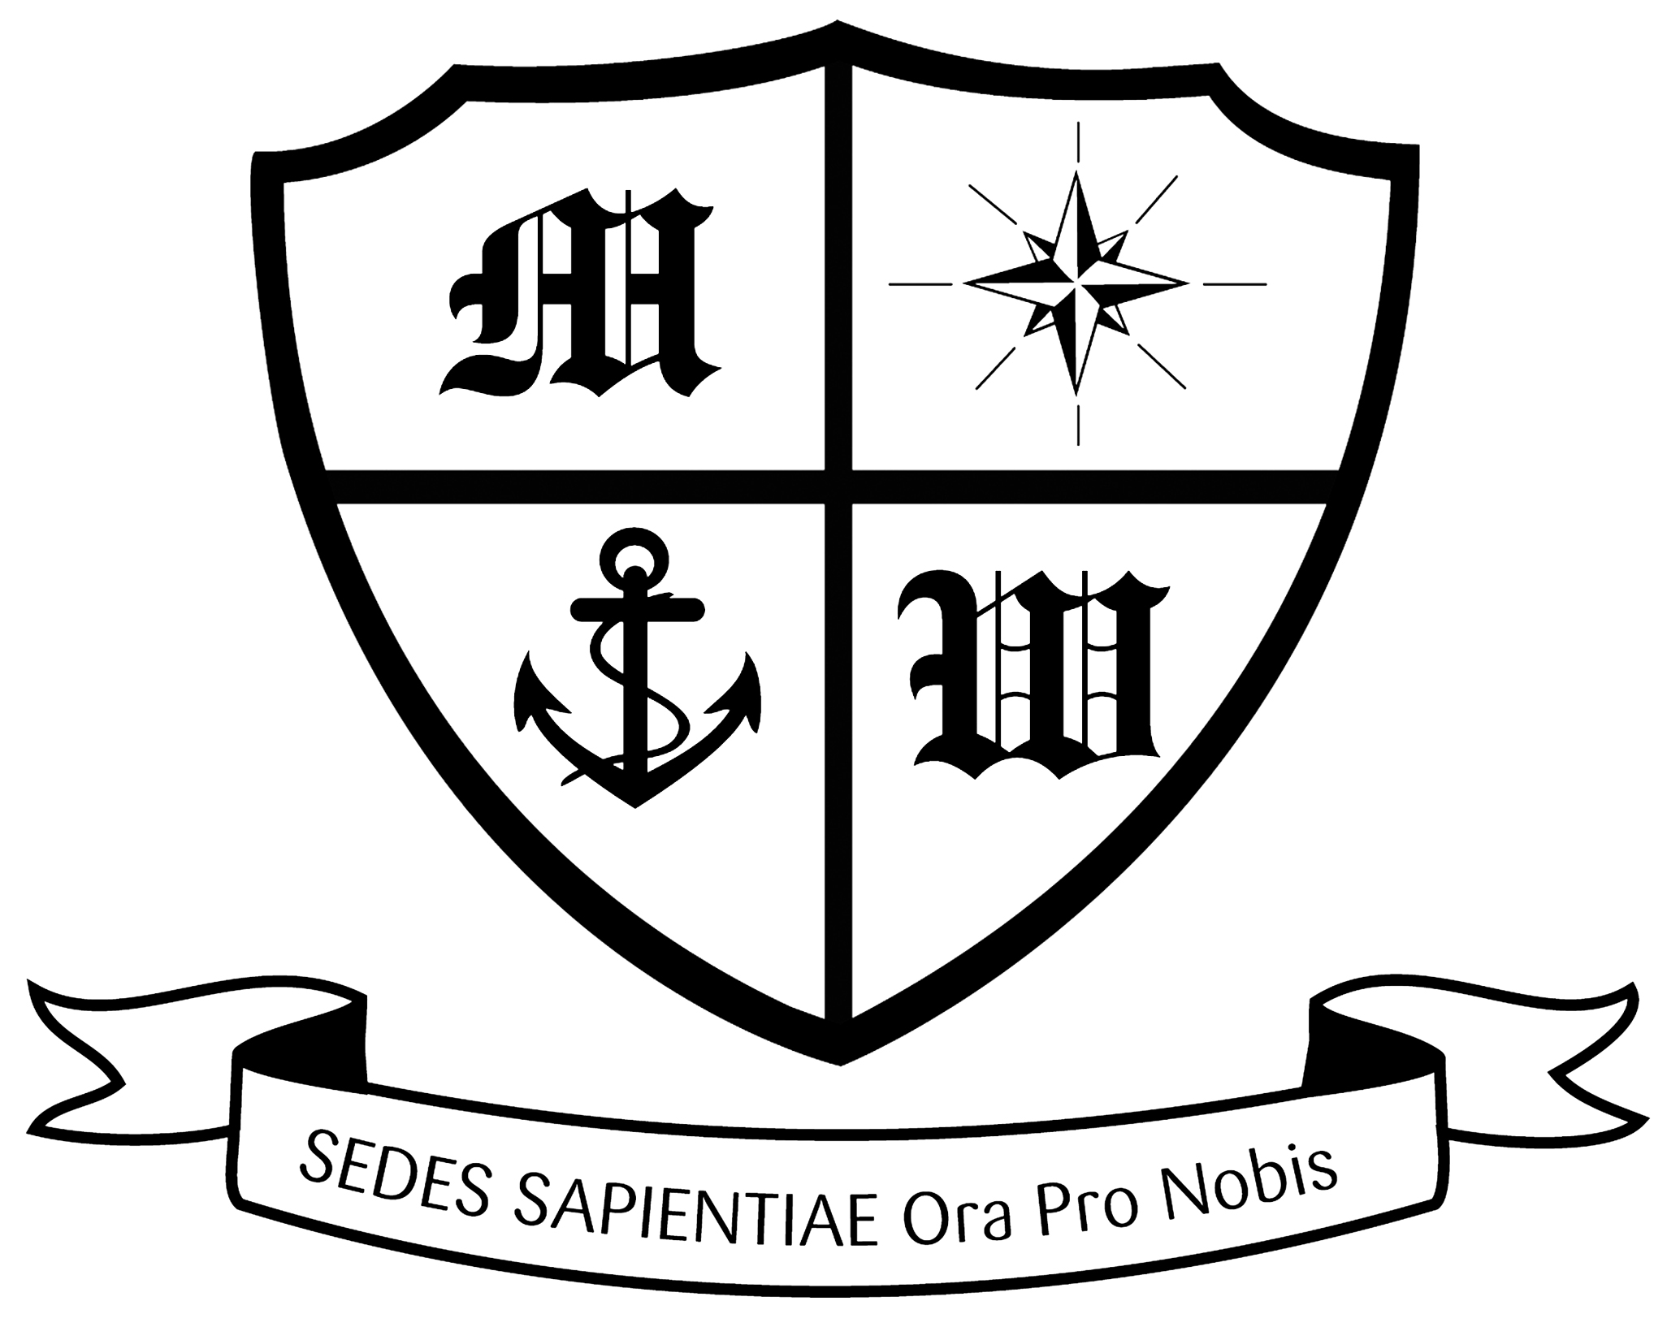

Much Woolton Catholic Primary School

Headteacher Mr M White

 0151 428 6114
E: office@muchwoolton.co.uk
www.muchwoolton.co.uk
Watergate Lane, Woolton, Liverpool. L25 8QH

With Jesus we love, learn and grow

Class Teachers (MPS 1- UPS3) from September 2025
1 full time, 1 part time (0.6)
Applicants must be able to teach across the primary age range

NOR: 408 (age 4-11) Group 3

The Governing Body of this successful, happy and forward thinking Catholic school wish to appoint an outstanding, energetic and creative classroom practitioner to join our increasingly diverse and successful school.

Our school can offer you:
- A welcoming, happy environment where pupils and staff enjoy coming to school.
- A school firmly rooted in Gospel Values.
- Hard working, dedicated and enthusiastic colleagues.
- Excellent support of Governors and parents.

The successful candidate will:
- Have a commitment to the Catholic ethos of the school and be expected to sign the Catholic teacher contract.
- Hold or be committed to completing CCRS.
- Be an excellent, enthusiastic and creative classroom practitioner with excellent organisational skills and a range of teaching styles.
- Be able to support children from increasingly diverse backgrounds and diverse needs
- Be willing to learn from others and to conduct research within their own practice
- Will set high standards both in class and around the school
- Will have the highest expectations of pupils in their personal development, including behaviour
- Have a good sense of humour and strong interpersonal skills
- Be able to work effectively as part of a team, in developing the talents of children and adults alike
- Must lead an extracurricular club and be wiling to attend overnight residential visits

Applications should take the form of a handwritten letter, no more than 2 sides of A4 in addition to the CES application documents included jhere. All applications are addressed to Mr M White, Headteacher, at the school address. All applications are subject to suitable references.

Closing date: Friday 25 April 2025
Shortlisting and interviews to be confirmed.
A tour of the school will be held on Tuesday 22 April at 4pm. Please book onto this by calling our office.

Much Woolton is a SAFE school where we are committed to safeguarding children and safer recruitment practices and will undertake all the required DFE pre-employment checks on the successful candidate including an Enhanced DBS Disclosure including a Barred List check.

The successful candidate will be required to sign a Catholic Education Service contract and a Disqualification by association declaration.

