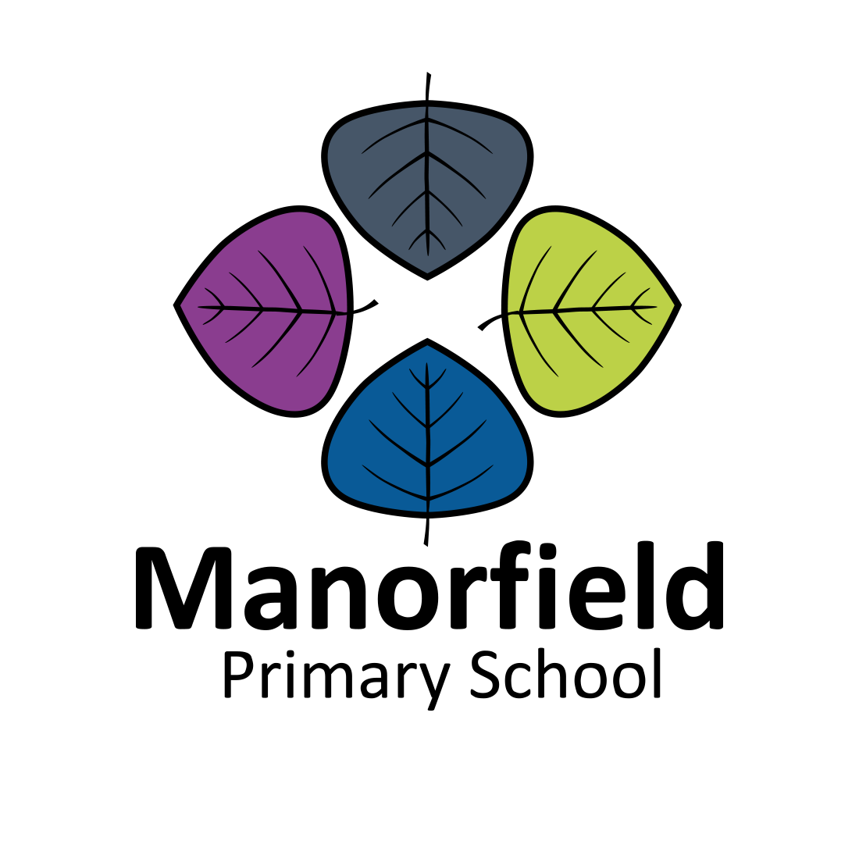
Wyvis Street
London E14 6QD

Excellent Class teachers required – NQTs encouraged to apply
From September 2021

We are looking for two enthusiastic and talented teachers to join the friendly and hard-working team at our exciting and vibrant school. These are new roles, as we grow and improve our offer.

With an experienced, established staff-team already in place, now is the perfect time to join us, particularly if you are starting out on your career.

These are exciting times at Manorfield, with an exciting vision for the future.

You will:
Be committed to high standards and improving achievement for all.

Be dedicated to providing good quality teaching for children of all abilities who are enthusiastic about their learning.

Have excellent interpersonal skills and the ability to work with an effective, creative and dedicated staff team to continue to develop high quality teaching and learning.

Be able to work in partnership with enthusiastic and supportive parents, governors and the wider community.

For an application pack, please e-mail the school with your name and address:

head@manorfield.towerhamlets.sch.uk

Closing date: Friday 14th May 2021, 9am

Interviews: Week of 24th May 2021

Visits to the school are strongly encouraged.

To discuss the post further, please telephone Paul Jackson, Headteacher,

on 020 7987 1623.

Manorfield School is committed to the safeguarding and welfare of our children and young people and expects all our staff and volunteers to share this commitment.

All posts are subject to an enhanced DBS check.

We welcome applications from suitably skilled candidates regardless of ethnicity, gender, disability, sexuality, religion or age.

