Appointment of a
Class Teacher

Application Pack

Welcome to Perry Wood
We strive to build strong links between home and school so that we can work together for the benefit of our children. We want our children to grow in to responsible adults with an understanding of the communities and world in which they live. We are a richly diverse community, and pride ourselves on our inclusive practice.
We have high expectations of our children and work as a team to offer a range of opportunities. Valuing every child for their own uniqueness and explore the many talents they may possess is a strength of our school. Celebrating these talents through a creative, inspiring curriculum which provides children with aspirational ideas for their futures is key to every aspect of school life.

In summary, our school is more than just an educational establishment. It is a place which offers children the stability and enrichment that they need to become the unique individuals that they were created to be. We believe that we provide an ethos where children learn effectively and develop into well rounded and responsible citizens.

We hope this prospectus will give you a brief insight in to our very special school and look forward to welcoming you to our learning family.
Suzanne Beston
Head

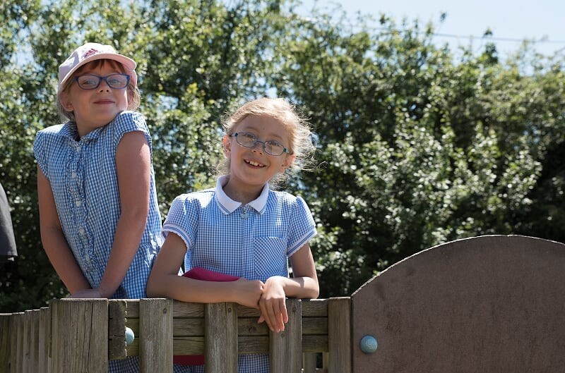

“The school motto of ‘Roots to grow & wings to fly’ encompasses the view school leaders take of those in their charge as they prepare them to embrace
the opportunities of life.”
Ofsted, 2016
Olivia Hennessey
Assistant Head
Fay Munlsow
Assistant Head
Clare Mahoney
Deputy Head
Nicky Balrey
Deputy Head
Suzanne Beston
Head Teacher

School Leadership

The School has a strong Leadership team

The leadership team strive to support all members of staff in their daily work and in also in their quest for furthering their own careers.
The Leadership team is made up of ; Head; Suzanne Beston
- Deputy Head Teachers; Clare Mahoney(KS1) and Nichola Barley
- Assistant Head Teachers; Fay Munslow and Olivia Hennessey.
All leaders teach within school and value the importance of this.
All teachers have the opportunity to lead a subject and are offered high quality training to understand subject leadership. The school values succession planning.

GENERAL DUTIES/RESPONSIBILITIES FOR ALL SCHOOL and NURSERY STAFF:

Role Description

- To carry out school policy as documented and/or as directed by the Head of School.
- To present the school and nursery in a positive way in the community.
- To respect the confidential nature of all information acquired in the performance of the job either verbally or in writing.
- To work in a responsible and safe manner, paying attention to all Health and Safety procedures operating within the school and nursery.
- To assist in the provision of a high-quality educational experience for all children.
- To assist in the provision of a high-quality service leading to reduced inequalities and improved outcomes for children

GENERAL REQUIREMENTS:

The Appointment is subject to the current conditions of employment for teachers contained in the School
Teachers’ Pay and Conditions document, the 1998 School Standards and Framework Act, the required standards for Qualified Teacher status and other current legislation.
Foster good professional relationships with all staff, providing guidance and support in implementing policies and procedures. Promote good relations with parents, governors, volunteers and the wider community,
ensuring, as far as possible, the involvement of all in the life and ethos of the school.
Demonstrate strategic vision and planning, making use of detailed information and statistical analysis to
improve pupil performance.

“The curriculum is wide ranging and exciting.”

Teaching and Learning
To create and manage a caring, supportive, purposeful and stimulating environment which is conducive to children’s learning.
To plan and prepare lessons in order to deliver the National Curriculum ensuring breadth and balance in all subjects.
To identify clear teaching objectives and learning outcomes, with appropriate challenge and high expectations.
To maintain good order and discipline among the pupils, safeguarding their health and safety.
To organise and manage groups or individual pupils ensuring differentiation of learning needs, reflecting all abilities.
To plan opportunities to develop the social, emotional and cultural aspects of pupils’ learning.
To maintain a regular system of monitoring, assessment, record-keeping and reporting of children’s progress.
To prepare appropriate records for the transfer of pupils.
To ensure effective use of support staff within the classroom, including parent helpers. To participate in staff meetings as required.
Contribute to the development and co-ordination of a particular area of the curriculum.
To be part of a whole school team, actively involved in decision-making on the preparation and
development of policies and programmes of study, teaching materials, resources, methods of teaching
and pastoral arrangements.
To ensure that school policies are reflected in daily practice.
To communicate and consult with parents over all aspects of their children’s education – academic, social and emotional.
To continue professional development, maintaining a portfolio of training undertaken.

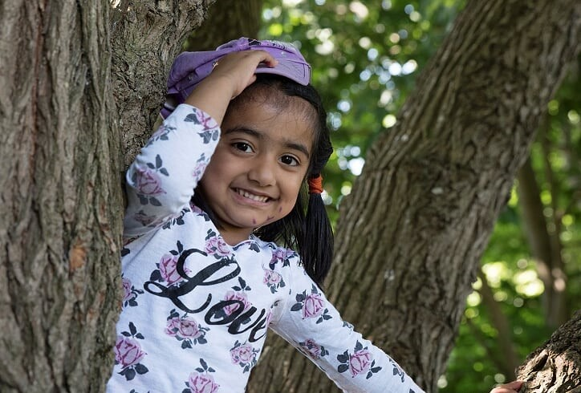
“Pupils cheerfully explain that they enjoy their learning.”

Sport, the Arts and Clubs
Budding athletes will achieve at Perry Wood, in our extensive grounds and two indoor PE spaces, with additional 60m running track. We regularly compete in local sporting competitions and welcome professional coaches to our school to ensure children have the best possible sporting provision. In addition to PE lessons, our professional coaches also run lunchtime activities and after school clubs, ensuring being active is part of the daily diet of Perry Wood children. The Griffin Sports Festival is a highlight of the autumn term, encouraging all pupils to engage in sport and reap the benefits of an active lifestyle.

We are also very proud of our arts provision. Regularly working in collaboration with professional artists of all styles means that Perry Wood pupils are able to experience high quality arts education. Performances
and showcases are regular calendar events for our children, sharing their talents both locally and
nationally. Our love of the arts is celebrated during our annual Griffin Arts Festival (GAF) in the summer term,
with a two-week extravaganza of all things artistic!

Do you have a talent in any of these areas? We can provide opportunities for you to share these talents with the Children of Perry Wood. Teach what you enjoy and be excited about inspiring Perry Wood children.

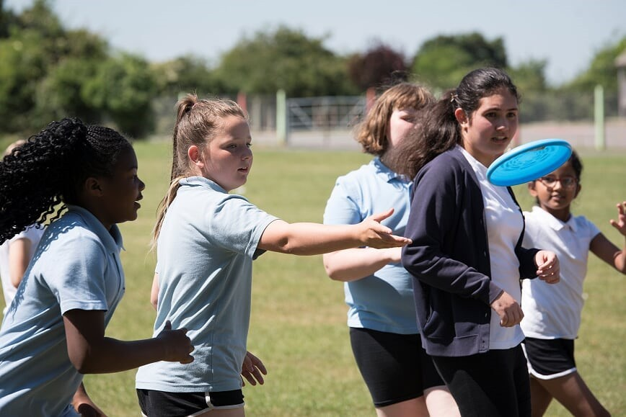

“...after-school clubs offered to pupils each week provide enjoyable opportunities for pupils to extend their
learning...This has a positive impact on pupils’ learning and preparation for life in the wider world by giving them experience of important skills for the future.”

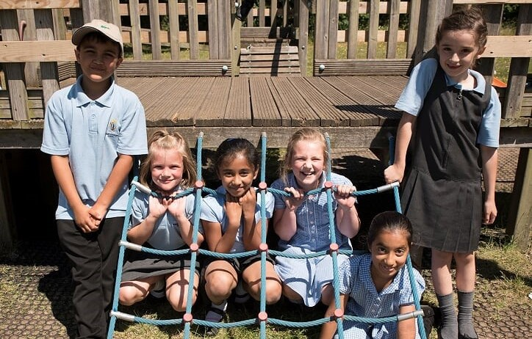
“The caring and nurturing ethos that permeates school life supports pupils well in their learning. This is a key driver of pupils’ success in learning.
Pupils feel comfortable and willing to learn because of the support they receive.”

PERSON SPECIFICATION
Must hold qualified teacher status.
Has a thorough up to date knowledge of the range of teaching, learning and behaviour management strategies and how to implement them effectively.
Has a thorough understanding of the national curriculum.
Has knowledge and understanding of the implications of equal opportunities,
multicultural education and inclusion.
Has knowledge and understanding of the potential of computer technology to enhance the curriculum
Is able to prepare and plan effectively. Has good organisational skills.
Is passionate about education.
Is ambitious for the school, for the staff and for every child.
Is inspirational and able to motivate every pupil to achieve their full potential. Is child-focused.
Can communicate effectively and has the ability to maintain and develop effective relationships with pupils, parents, staff, governors and the wider community.
Has a commitment to develop relationships with parents so that they are partners in their child’s learning.
Has the ability to listen to and respond to others.
Is approachable, but able to set appropriate professional boundaries.
Has a positive outlook and the ability to manage stressful situations sensitively. Is innovative, flexible, creative, open to change and new ideas.
Is dynamic, energetic and enthusiastic. Is trustworthy, fair and kind.
Is aware of the legal requirements, national policy and guidance on the safeguarding of children.

Please complete an application form, this must include email addresses and direct/
mobile phone numbers of two professional referees, making clear in what capacity they know you. This must be submitted along with your Supporting Statement to complete your application.
Please ensure your supporting statement outlines your experiences and how you feel you would be a good fit for this role. We are keen to know specific things about you including your areas of strength and interest within the Primary curriculum and how you see yourself in relation to the school’s vision. Please note that a generic statement will not be considered.
Please ensure your application form contains no chronological gaps and has full and ac- curate information.
Perry Wood Primary and Nursery School is committed to recruiting with care and safe- guarding the welfare of children and young people; we expect all staff and volunteers to
share this commitment. All posts are subject to an Enhanced Disclosure application to the
Disclosure and Barring Service and check against the ISA barred list for children, plus verification of the right to work in the UK.

Griffin Schools Trust operates an equal opportunities policy. Perry Wood Primary and Nursery School
St Albans Close Worcester WR5 1PP 01905 354800
head@perrywood.worcs.sch.uk

