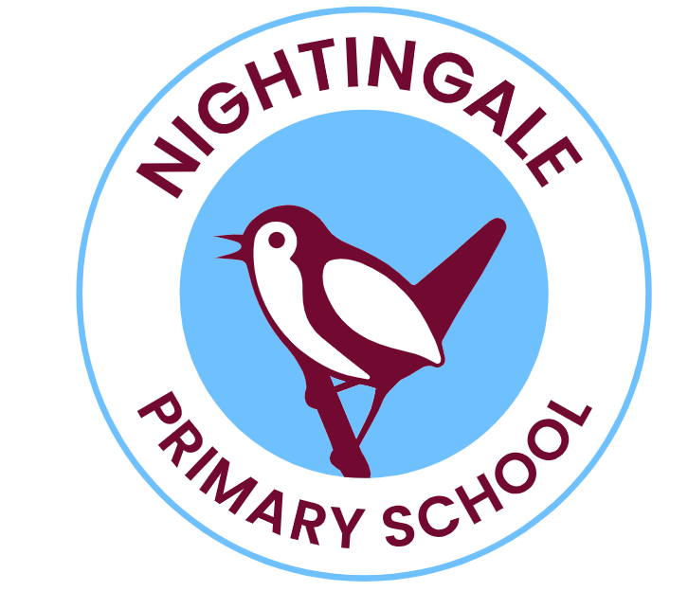

Class Teacher (Possible TLR for Curriculum Leadership Area)
Main Pay Scale – Full Time – Maternity Cover
Start Date – January 2025
Nightingale Primary School is seeking to appoint a dedicated and talented teacher to join the team in our three-form entry primary school. The post would be suitable for either an Early Career Teacher seeking a nurturing school to undertake their first teaching post or a more experienced colleague who is looking for a supportive environment in which to grow and develop further. For a suitably experienced and skilled candidate, we may be able to offer a TLR to lead an area of the curriculum.
The school is located on a large site in a leafy, green suburb of East London, whilst also affording all the opportunities of quick access to the amenities of Central and East London. We are committed to providing our children with excellent opportunities academically, in exploring their wider interests and talents and in their personal development.
Our most recent Ofsted report (October 2023) said:
- Staff feel well supported. They appreciate the trust placed in them. They know that leaders listen to them and consider their well-being and workload.
- Effective training supports teachers
- Pupils enjoy attending this vibrant, caring and friendly school.
- Parents, pupils and staff are all extremely positive about the recent improvements to the school.
- Pupils, parents and staff all agree that behaviour at the school is excellent.
- Pupils’ wider development is exceptional.
- Governors are very committed to the school.

Redbridge is committed to safeguarding and promoting the welfare of children, young people and vulnerable adults. Such posts will require a DBS check and references will be taken up prior to interview. Embracing diversity and promoting equalities for all.
Visits to the school are warmly welcomed and encouraged. To make an appointment or for any further information, please contact Nicki Poli on 020 8989 9987.
To apply for this post please download the application and email to nicki.poli@redbridge.gov.uk.

The closing date for applications: Friday 18th October 2024, noon
Shortlisting will take place on: Friday 18th October 2024
Interviews and tasks will take place on: Wednesday 23rd October 2024

