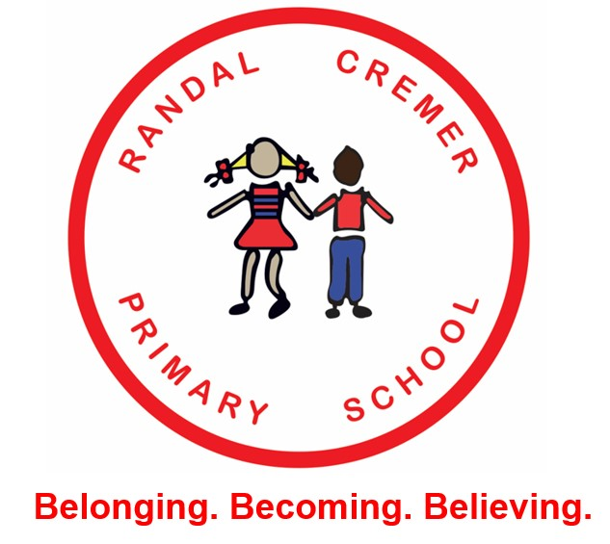

Randal Cremer, in Hoxton, Hackney are looking to recruit class teachers for either Key Stage 1 or 2 from September 2022.

Whether you are a teacher about to start on your career, so an experienced teacher on Upper Pay Scales, this could be the school for you.

Possible TLR available for an experienced candidate.
Do you believe that every child has the right to the highest possible standard of education?

Are you willing to work hard to ensure that no child gets left behind?

Are you excited by pedagogy and want to engage in quality CPD to develop yourself and become the best teacher and leader you can be?

Are you committed to working in a team that puts children at the heart of decision making?

If so, Randal Cremer, in the heart of Hackney, London is the school for you.

Visits to the school are warmly welcomed. For an informal chat about the role please speak to the Head Teacher, Jo Riley. Tel 02077398162 or email jriley@randalcremer.hackney.sch.uk

Randal Cremer is committed to providing equality of opportunity and to safeguarding and promoting the welfare of children and young people and expects all staff to share this commitment. The successful applicant will be required to complete an enhanced DBs form.

Closing Date: Mid-Day, Monday 14th March 2022.

For an application form and job description please contact the school office on admin@randalcremer.hackney.sch.uk

