Class teacher
Queen Eleanor Primary Academy September 2021

1

Dear Colleague

Thank you for your interest in the role of Classroom Teacher at Queen Eleanor Primary Academy. I hope that you will find this information pack
helpful in finding the information that you need and giving you an insight into our school community, to support your application.
Queen Eleanor Primary Academy joined Creative Education Trust in September 2013. Our network consists of eleven secondary and six primary academies in the Midlands and Norfolk plus a central team. Further schools are in the pipeline and our medium- term ambition is to be a trust of 25 schools.
As an academy sponsor, Creative Education Trust is focused on the quality of the educational experience it provides for its students. All our schools that have been visited by Ofsted since joining the Trust are now rated ‘good’, having previously been ‘inadequate’ before joining the Trust.
Working in partnership, Queen Eleanor Primary Academy and the Trust have

made much progress in recent years. We were delighted to have been awarded a ‘good’ judgement from Ofsted in December 2017. The report notes many strengths, including the shared vision and high expectations and the warm, nurturing and friendly atmosphere within the school. Building on those strengths, we’re ambitious to do much more.
At Queen Eleanor Primary Academy, we are highly committed to our vision of excellence for all members of our school community. We are looking to appoint a deputy head teacher who will support the aims and ethos of the school, developing both pupils, families and staff. Queen Eleanor has a strong emphasis on behaviour for learning and academic rigour in all subjects.
We are dedicated to providing a high-quality education for all the pupils who attend our school, regardless of their starting points. We also place a strong emphasis on the importance of staff development and the successful candidate can be assured that they will receive the support that they need to help them excel.
Further information about the school can be found on our website at http://www.queeneleanoracademy.org.uk. You can also watch a short video on what it means to be part of Creative Education Trust, illustrating the Trust’s ‘Knowledge Connected’ approach to learning on the following YouTube channel: www.youtube.com/user/creedacad.
If you feel that this is a role that interests you and that you would be able to make a difference to our wonderful pupils, then we would be delighted to discuss this vacancy with you further. Please feel free to contact us on 01604 761200 or by e-mail at isaac.howarth@queeneleanoracademy.org.uk.
I look forward to hearing from you. Yours sincerely,
Isaac Howarth
Head Teacher
“We are looking an enthusiastic, thoughtful and reflective practitioner ready to play a key role in the leadership and further development of Queen Eleanor Primary Academy.”

2

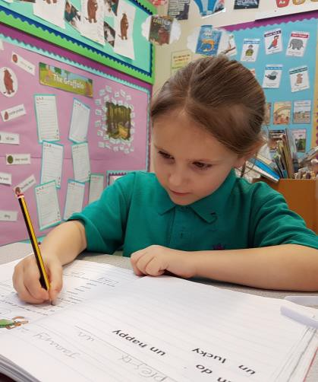
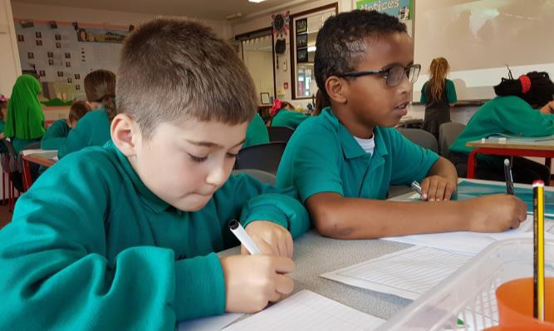
ABOUT CREATIVE EDUCATION TRUST

Creative Education Trust inspires and enables young people to build successful lives on foundations of learning, resilience and employability. We believe that a rewarding educational experience and the highest possible qualifications are the best way to ensure social mobility for young people.
Creative Education Trust is a growing multi-academy trust educating over 13,000 children in England. It was established in 2010 to work in England’s post-industrial cities and coastal towns: areas of economic disadvantage and with a history of academic underachievement. We transform these schools by integrating a knowledge- rich curriculum with skills and creativity.
Creative Education Trust defines creativity as the ability to find connections between the things we know and turn these connections into new ideas and action. The academic arts and the sciences, practical subjects and life skills all need this creativity, and creativity is valued highly by employers. Our staff and expert advisers use imaginative methods for linking knowledge across subject boundaries, fostering personal development and resilience and developing practical skills that prepare students for their transition to adult life and employment.

- Raise their attainment in exams and tests through outstanding teaching
- Make them intellectually curious with a sense of confidence
- Increase their participation in HE, FE and apprenticeships
- Ensure they have employable skills and attitudes
- Create rounded individuals through a
wide choice of co-curricular activities ⬆ Educational rigour
  - Organisational effectiveness
  - Financial efficiency
  - Partnership & recognition of local identity
  - Respect for autonomous leadership
  - Quality not quantity
  - Promoting practical creativity

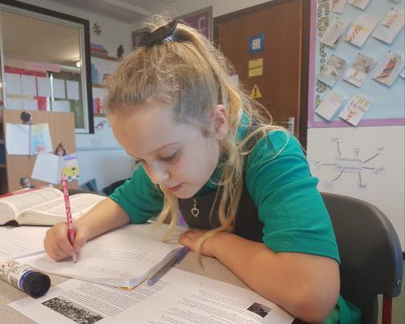
ABOUT
QUEEN ELEANOR PRIMARY ACADEMY

Queen Eleanor Primary Academy is a welcoming and ambitious school, situated in the heart of Northampton, serving the thriving community of Far Cotton and beyond. Here at Queen Eleanor, we value diversity and set high aspirations for all pupils. Our vision is that all members of our school community will be inspired to learn, equipped to succeed, have an enriched experience during their time here and as such, will go on to excel in all aspects of life.

At Queen Eleanor, we place high importance on creativity and seek to provide children with a broad and relevant curriculum that will teach them the skills that they need to succeed throughout their lives. We work hard to ensure that pupils’ learning experiences are engaging and original and teachers within the school are encouraged to seek out innovative ways to bring the curriculum to life for our pupils, who come from a wide range of backgrounds.

Our school values are strongly embedded throughout the work of the school. We believe that they create a solid platform for effective learning. We have a strong inclusion team within the school, and we believe in the importance of working closely with parents to maximise opportunities for learning.

At Queen Eleanor, we are not afraid to challenge existing ideas about education in our continued journey towards excellence. We want to be sure that our provision fully meets the needs of the children who learn here, and we believe that we can achieve this through highly reflective practice at all levels.

Exciting times at Queen Eleanor Primary Academy…
- Nursery provision opened in September 2019.
- New digital screens in every classroom from September 2019.
- An exciting period of curriculum development.
- New professional development opportunities across the Trust.
- A supportive network of financial and HR support within the Trust.

“Pupils’ progress in reading, writing and mathematics is good. Pupils are well equipped for their next stage of education.”

Ofsted 2017

To see full details of the school performance data please visit:
https://www.compare-school-performance.service.gov.uk/school/139650/queen-eleanor-primary-academy

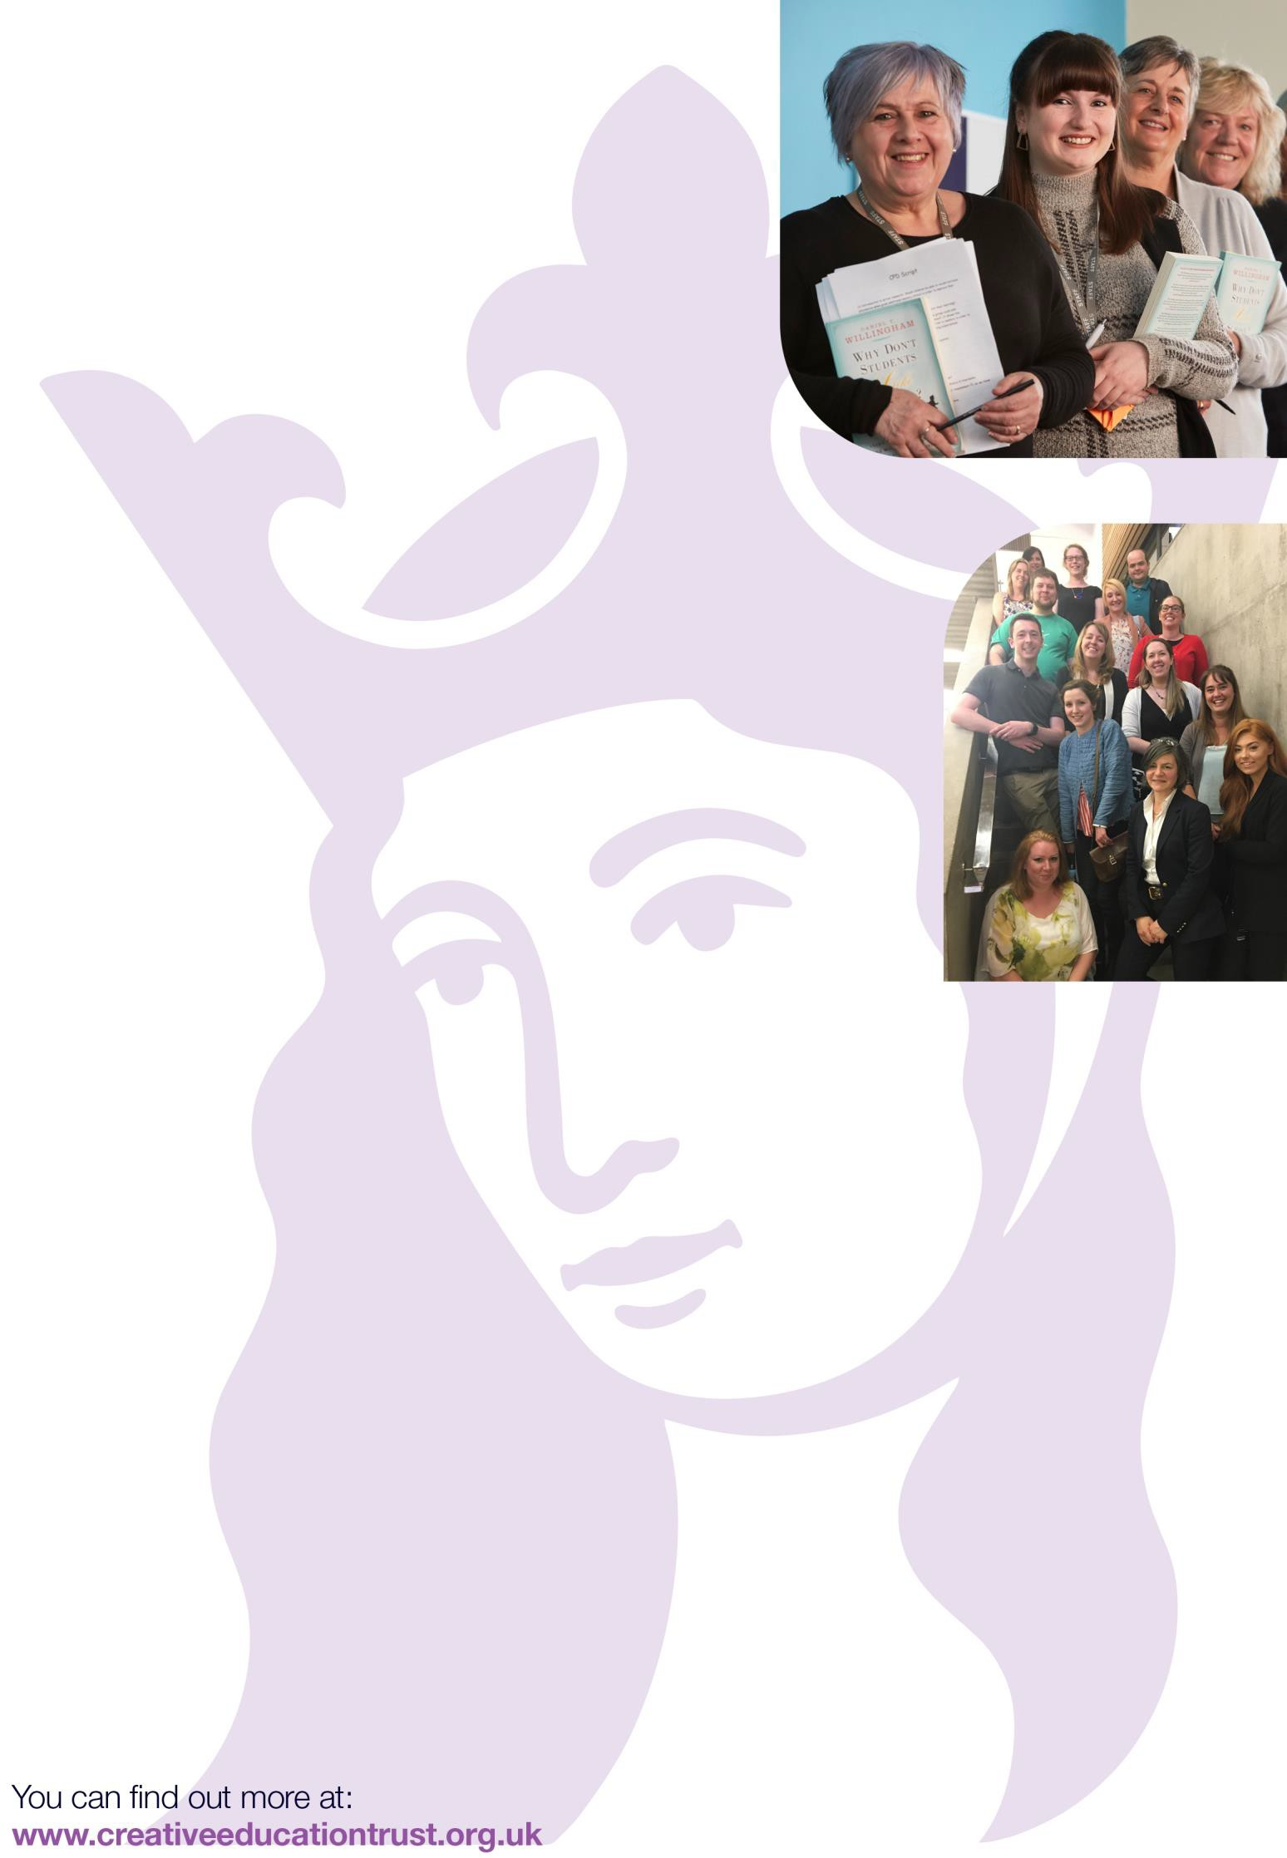
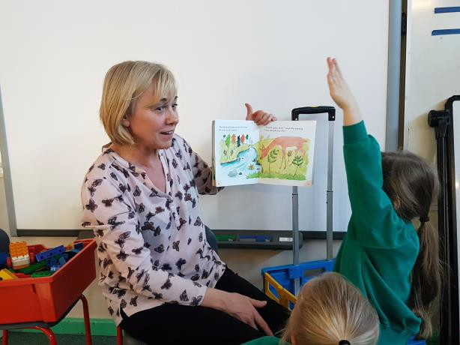
SUPPORT FOR OUR STAFF
Queen Eleanor Primary Academy is committed to the professional development of all staff, at all levels of experience and in all roles within the school. The school’s vision that all members of the school community are inspired, enriched, equipped and, as a result, excel applies to staff as much as it does to pupils.
We believe that school improvement should stem from reflective practice at classroom level alongside strategic decisions based upon the performance of pupils. As such, professional development opportunities will be provided for all staff throughout the course of any given year. These will take various forms, which include:

Staff meetings, addressing whole school issues for teaching staff.
In-house support, including training, mentoring and coaching sessions.
Online training, either for identified individuals or groups, or to address whole school needs.
Training courses, identified by SLT to address specific needs within the school.
Training courses, identified by the staff member or their line manager, based on individual development needs and/or professional interests.
Development opportunities within other schools, either locally, within the Trust, or schools with relevant specialities.
Opportunities to take part in development projects or research projects covering a range of subject areas and issues in education.

Line managers within the academy work closely alongside our reflective practitioners to ensure that they are receiving development opportunities tailored to their specific needs. We use purpose-made tools to support staff development and work with colleagues from across the Trust to develop these.
In addition to the CPD opportunities provided within the school, staff working at Queen Eleanor have access to high-quality collaborative and development experiences through the Creative Education Trust annual Primary Training Day and working parties focusing on key areas of school improvement and staff development.
“Staff work well together and feel valued and supported. The whole-school team has a strong work ethic.”
Ofsted 2017

NQT Class Teacher JOB DESCRIPTION AND PERSON SPECIFICATION

LOCATION
Queen Eleanor Academy

SALARY
M1

The main responsibilities of the class teacher are:
- To undertake the professional duties and responsibilities of a teacher as set out in the
current Teachers’ Pay and Conditions Document.
- To plan, implement and deliver an appropriate and differentiated curriculum for all pupils in a class.
- To contribute to raising standards of pupil
attainment.
- To promote the progress and well-being of every
child.
- To coordinate development and activities within
their own subject area.
- To ensure safeguarding procedures are followed
as stated in the Safeguarding Policy.
- To regularly assess and monitor the progress and attainment of pupils in their class and provide appropriate intervention where needed as a result.
- To follow and implement the academy’s policies consistently in all aspects of academy life.
- To build professional relationships with parents
and carers.
- To plan for and utilise support staff effectively to enhance the learning experiences of all pupils.
- To be an active member of the academy community, engaging with staff, pupils, parents, governors and the wider community. Together with any other duties deemed reasonable by the Head teacher and the Governing Body.

The post holder’s responsibility for promoting and safeguarding the welfare of children and young people for whom s/he comes into contact will be to adhere to and ensure compliance with the School’s Child Protection Policy at all times. If, in the course of carrying out the duties of the post the post holder becomes aware of any actual or potential risks to the safety or welfare of children in the school s/he must report any concerns to his/her Line Manager or the School’s Child Protection Officer.

This job description reflects the major tasks to be carried out by the post holder and identifies a level of responsibility at which they will be required to work. In the interests of effective working, the major tasks will be reviewed from time to time to reflect changing needs and circumstances. Such reviews and any consequential changes will be carried out in consultation with the post holder.

PERSON SPECIFICATION
 | ESSENTIAL | DESIRABLE
Education and Qualifications | Certificate of Education  Bed, other education degree, PGCE, QTS (can be through a school-based training route)  Satisfactory clearance of DBS disclosure | A first degree relevant to education  Relevant professional development activities undertaken in the last three years.
Experience and Knowledge | A track record of quality teaching  Good knowledge and understanding of the primary National Curriculum  A deep understanding and practice of assessment tools for learning  A subject specialism | More than one subject specialism
Ability and Skills | Ability to plan for challenge  Ability to work in a team  Good interpersonal skills  Good classroom management skills  Ability to manage behaviour and form strong and productive relationships with the children  Ability to continue to improve own practice | Can demonstrate the beginnings of leadership skills in developing a subject across the school  Ability to develop a leadership role in order to lead a subject area
Equal Opportunities | Ability to demonstrate awareness/understanding of equal opportunities
Parents and Community | An ability to work effectively with parents and the extended school community.
Education Philosophy | A deep commitment to ensuring all children at Queen Eleanor Academy achieve all that they are capable of.
Creative Education Trust is committed to safeguarding and promoting the welfare of our children and young people and expects all staff and volunteers to share this commitment. The successful applicant will be required to undertake relevant safeguarding checks in line with Government safer recruitment guidelines.

