
Dodworth St John the Baptist
C of E Primary Academy

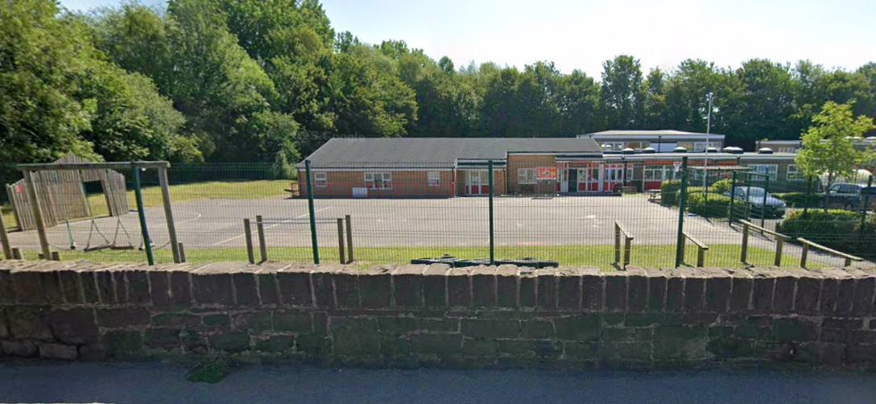



Class Teacher Recruitment Pack
Advert
Title | Permanent Class Teacher (Reception/Year 1)
Location | Dodworth St John the Baptist C of E Primary Academy
Days/Hours | Full Time
Pay Range | Main Pay Scale
Required from | September 2026

Dodworth St John the Baptist is a special place with a distinctive Christian ethos. We are looking for an experienced, dynamic, enthusiastic and committed class teacher to teach in a mixed Reception/Year 1 class. This is a unique opportunity to work in a lovely school. This is a permanent position.

We are looking for someone who:
- Has high expectations and is committed to ensuring all children make excellent academic and social progress;
- Is a creative classroom practitioner;
- Has the ability to inspire and motivate;
- Has an excellent understanding of assessment for learning;
- Has a strong understanding of the EYFS Framework;
- Is able to communicate well with good interpersonal skills;
- Is committed to an inclusive ethos where every person matters;
- Has strong behaviour management skills;
- Has strong knowledge and experience in children with additional needs;
- Can work well as part of a team;
- Is willing to follow our Christian vision;
- Is warm, kind, caring, positive and has a sense of humour.

We can offer:
- A nurturing, caring and inclusive school;
- A forward-thinking Trust that takes professional development, workload and staff wellbeing seriously;
- A friendly, hard-working, professional and supportive team of staff and governors;
- Happy and enthusiastic children who enjoy learning and behave well;
- A commitment to your professional development.

This post is suitable for Early Career Teachers or someone with more experience.

We warmly encourage you to visit school before you apply. For further details about the role or to arrange a visit, please contact Lee Swift on lee.swift@dodworthstjohn.enhanceacad.org.uk or telephone 01226 286514.

Enhance Academy Trust has an absolute commitment to safeguarding and promoting the welfare of children. The successful applicant will be required to undertake an enhanced criminal record check via the DBS. The Trust values the diversity of our workforce and welcomes applications from all.

Applicants will need to use the link below to complete online application form.

Recruitment

Selection Timeline
Closing Date: Monday 11th May at 4pm
Shortlisting: Tuesday 12th May
Interviews: Likely to be 18th May

Enhance Academy Trust
Enhance Academy Trust is a Church of England Multi-Academy Trust comprising of sixteen primary schools located across Wakefield and Kirklees and a post 16 performing arts free school. The Trust was established in 2012 as a sponsor of Church of England and Community Schools.
The Trust works very closely with its academies and encourages them to help each other whilst at the same time allowing them a reasonable amount of earned autonomy. We have kept to this model whilst expanding and want to continue to follow similar principles in the future.
Our vision is to deliver improved educational outcomes and learning skills to enable our young people to live well in the world around them. We also aim to allow our academy leaders and staff to develop the individual character of our academies so they can best serve their local communities.

Enhance Academy Trust - Home



Our School Vision
At Dodworth St John the Baptist Primary Academy, we prepare our pupils for the adventures life brings. By fostering respect, curiosity, and teamwork, we aim to nurture individuals who will contribute positively to their community and the wider world.
Together, we build a legacy of pride, purpose, and possibility for the future.
Our vision is rooted in the Christian principles of guiding kindness, honesty, and unity, (Mark 1:3: “Prepare the way for the Lord, make straight paths for Him” from John, who pointed the way), to embrace learning and life in all its fullness (John 10:10).



Our School
Dodworth St John the Baptist is a smaller than average-sized school with 106 children on roll. We are really pleased with our improving reputation within our local community.
In our most recent Parent Survey in March 2026:

In order for children to achieve high standards and make good progress throughout their school journey at Dodworth St John, we are committed to providing a stimulating and engaging curriculum which extends far beyond the limitations of the classroom:
• We plan many opportunities for learning beyond the classroom including field trips, class trips and residentials.
• We pride ourselves on the large range of activities that are provided as part of our wider after school club offer. This includes Young Voices Club, Community Brass Band and plenty of sporting opportunities. This enables children to find their passion and to continue to grow and develop as individuals.
We work in partnership with parents to ensure that our children develop essential skills and are well prepared for Secondary School. We aim for children to be aware of what they enjoy, to find their passion and their interests and to be kind, well-rounded individuals. Ultimately, we strive for our children to be compassionate, independent and responsible people who are prepared in every sense to embrace the next stage of their education.

Our Curriculum
At Dodworth St. John’s the Baptist, our children are at the heart of our curriculum, which has been carefully planned and sequenced to ensure children continue to build on their knowledge, skills, and experiences as they move along their educational journey. Our curriculum is designed so that children can understand and embed key concepts in their long-term memory, before progressing further.
Although our curriculum is founded on the knowledge set out in the National Curriculum, 2014, it is also rooted in opportunities for children to develop their interpersonal skills, self-confidence, resilience, perseverance, independence, and empathy. We want all our children to have high aspirations, strive to be the best they can be and work towards their goals in life.
Our curriculum aims to ensure that pupils achieve broad and deep subject expertise and aspires to widen pupils’ knowledge through developing their ability to recall, remember and further extend their prior learning.
Through our carefully considered sequences of learning, our children will be exposed to a high level and wide range of vocabulary, which will allow them to deepen their understanding of the curriculum subjects taught.
Everything has been written with the intention that all our children can access and experience success. Small steps of knowledge have been identified for each subject, which work towards meeting the end points that we want our children to achieve.
A key outcome that we aim to achieve from our intentional, knowledge-rich curriculum is confidence. We want all our children to be confident learners. By this, not only do we mean confident speakers who are able to share their knowledge in a way that can be understood by others, but we also want children to be confident to ask for help when they need it, as well as to be confident to help others. We want our children to see that a lack of knowledge or a ‘mistake’, is part of learning, and not something to be disappointed by. As Albert Einstein once said, “failure is success in progress.”
As well as providing opportunities for personal development, we also place great emphasis on Music and the Arts. Through these subjects, children also get to develop their creative-self and confidence to express and reflect on who they are – what makes them unique.

MAIN PURPOSE
To be responsible for achieving the best possible standards in work and conduct for all pupils in the class and to promote and safeguard the welfare of all pupils within the school.
DUTIES AND RESPONSIBILITIES
All Teachers are required to carry out the duties of a school teacher as set out in the current ‘School Teachers’ Pay and Conditions Document’ and all Teachers job descriptions are linked to the DfE Teachers’ Standards 2012. Teachers’ work performance will be assessed against the Teachers’ Standards as part of the performance management process.
The post holder shall:
Set high expectations which inspire motivate and challenge pupils
- Teach pupils across the age and ability range
- Establish clear targets for achievement and evaluate progress through the use of appropriate assessments and take into account analysis of these data
- Prepare, develop and deliver teaching programmes using materials and techniques which will engage and stimulate pupils of all abilities.
- Give pupils regular feedback, both orally and through accurate marking and encourage pupils to respond to the feedback, reflect on progress and take a responsible and conscientious attitude to their own work and study.

Promote good progress and outcomes by pupils
- Monitor the personal and social development, health and welfare of each pupil in the class
- Have a thorough knowledge of all pupils in the class through data provided, and contact with pupils, parents and staff colleagues as appropriate
- Be aware of the relevant curriculum for all pupils in the class and monitor the academic progress of pupils through their reports, studies, grades and contact with other teachers.
- Encourage and be aware of the involvement of pupils in the school’s extracurricular activities.
- Be aware of pupils’ capabilities and prior knowledge. Plan teaching to build on these, demonstrating knowledge and understanding of how pupils learn.
- Use an appropriate range of observation, assessment, monitoring and recording strategies as a basis for setting challenging learning objectives for pupils of all backgrounds, abilities and dispositions and to underpin good quality teaching and learning.
Job Description
Job Description
Demonstrate good subject and curriculum knowledge
- Maintain a secure up-to-date knowledge of relevant subject areas through participation in training and development opportunities identified by the school or as an outcome of the appraisal process.
- Deliver the curriculum as relevant to the age and ability of the pupils.
- Set appropriate homework in line with school policy and the homework timetable.
- Support the development the pupils’ reading, writing, mathematics and communication skills through the curriculum.
- Demonstrate an understanding of and take responsibility for promoting high standards of literacy including the correct use of spoken English at all times.

Plan and teach well-structured lessons
- Contribute to the development of schemes of work.
- Engage in short, medium and long term planning of lessons and sequences of lessons.
- Demonstrate a clear understanding of appropriate teaching strategies relevant to the age and abilities within the group.
- Plan and undertake enrichment & extension activities where possible to consolidate and extend the knowledge and understanding pupils have acquired.

Adapt teaching to respond to the strengths and needs of all pupils
- Monitor the progress of groups to close any gaps between them.
- Teach lesson which meet the needs of all learners

Make accurate and productive use of assessment
- Use formative and summative assessment opportunities to maximise pupils’ progress.
- Use relevant data to monitor progress, set targets, set homework and plan subsequent lessons.
Manage behaviour effectively to ensure a good and safe learning environment
- Implement whole school strategies to support behaviour for learning.
- Carry out morning afternoon and break time duties as directed.
- Establish a framework for discipline with a range of strategies using praise, sanctions and rewards consistently and fairly.
- Maintain good relationships with pupils, exercise appropriate authority and act decisively as necessary.
- Be a positive role model and consistently demonstrate the positive attitudes, values and behaviour which are expected of pupils.
- Promote and safeguard the welfare of all pupils within the school, raising any concerns in accordance with the school’s protocols and procedures.
Job Description
Fulfil wider professional responsibilities
- Support the school’s Initial Teacher Training activity as appropriate.
- Take opportunities to develop professionally and share good practice to develop consistently high standards of teaching and learning.
- Work collaboratively with our partner schools to support pupils’ transition.
- Facilitate the work of support staff to enhance pupils’ progress.
- Work collaboratively with parents and carers to support pupils’ progress.
- Support pupils to develop wider key skills.
- Uphold all school and Enhance Academy Trust policies.
- Attend and actively participate in meetings.
- Make a positive contribution to the wider life and ethos of the school.
Person Specification
Knowledge, Experience and Skills
 | Essential (E) or Desirable (D) | How Identified
Qualifications
Qualified Teacher Status | E | A
Evidence of continuous professional development | E | A
Ambition to become a middle leader | D | A
Experience
Experience of teaching in Early Years or Key Stage One | E | A, I, R
Experience of teaching in more than one Key Stage | D | A, I, R
Experience of leading a subject | E | A, I, R
Knowledge and Understanding
Understanding of the National Curriculum | E | A, I, R
Ability to deliver well planned and stimulating lessons across the curriculum and ability range | E | A, I, R
Knowledge and understanding of effective behaviour management strategies and the ability to put these into practice | E | A, I, R
Knowledge of what constitutes effective teaching and learning | E | A, I, R
Knowledge of SEN Code of Practice | E | A, I, R
Knowledge of the teaching of phonics | E | A, I, R
Ability to use strategies needed to establish consistently high standards of behaviour | E | A, I, R
Ability to lead a subject throughout school | E | A, I, R
Skills
Able to play a full and active role in a team | E | A, R
Clear understanding of expectations, accountability and consistency | E | A, I, R
Aligned with the values of Enhance Academy Trust | E | A, I, R
Commitment to safeguarding and welfare of pupils | E | A, I, R
Excellent classroom practitioner | E | A, I, R
Effective and systematic behaviour management, with clear expectations and the consistent use of praise and consequences | E | A, I, R
Excellent communication, planning and organisational skills | E | A, I, R
Fulfil Wider Professional Responsibilities
Understand when and how to seek advice and support | E | A
Able to develop and maintain effective relationships with pupils, staff, parents, governors and the wider community | E | A, R
Committed to own professional development | E | A, I, R
Ability to reflect on own practice and identify areas for development | E | A, I, R
Personal Qualities and Attributes
Integrity | E | A, R
Warmth and humour | E | A, I, R
Self-motivated | E | A, R
Enjoys a challenge | E | A, R
Enthusiastic and optimistic | E | A, I, R
A team player with a can-do attitude | E | A, R
A = Application Form I = Interview Process R = Reference

Further Details

We warmly encourage you to visit school before you apply. For further details about the role or to arrange a visit, please contact Lee Swift on
lee.swift@dodworthstjohn.enhanceacad.org.uk or telephone 01226 286514.

To Apply

Applicants will need to use the link below to complete online application form.

Recruitment

Selection Timeline

Closing Date: Monday 11th May at 4pm
Shortlisting: Tuesday 12th May
Interviews: Likely to be Tuesday 19th May

Next Steps

