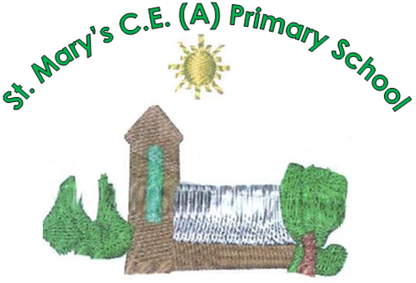
St. Mary’s C.E. (A) Primary School
Manchester Road
Greenfield
Saddleworth
OL3 7DW

Telephone: 01457 872 264
Email: info@greenfieldstmary.oldham.sch.uk
Website: www.greenfieldstmaryspriamaryschool.co.uk


gsmprimary facebook.com/gsmprimary

Executive Headteacher: Mrs R. Hunter
Head of School: Mr R Selby

Job Advert

Exciting Opportunity at Greenfield St Mary’s!

Class Teacher & SENCO (Teachers Pay Scale + TLR 2)
Are you passionate about making a difference in children’s lives? Do you want to inspire young learners, champion inclusion and be part of a caring, ambitious school community?
Greenfield St Mary’s is delighted to offer an exciting opportunity for a dedicated and enthusiastic professional to join our team as a Class Teacher and Special Educational Needs Co-ordinator (SENCO).
We are looking for someone who shares our commitment to excellence, inclusion and ensuring every child has the opportunity to flourish academically, socially and emotionally.

About Our School
Greenfield St Mary’s is a happy, welcoming village school at the heart of its community. We pride ourselves on being a caring and inclusive school where children are valued as individuals and supported to achieve their full potential.
As part of our school community, you will benefit from:
- A warm, inclusive and nurturing environment where children feel safe, happy and ready to learn.
- Enthusiastic, creative children who are eager to learn and thrive.
- Strong values of love, kindness, growth, service, courage and respect underpin all that we do, creating a nurturing and inclusive community where every child and adult is valued, supported and empowered to flourish.
- A highly committed, experienced and supportive team of staff and governors.
- Strong, positive partnerships with parents and the wider community.
- A professional learning culture that encourages collaboration, innovation and continuous improvement.
- Membership of the Dovestone Learning Partnership, providing exciting opportunities to share expertise, access resources and learn from colleagues across nine schools.
- A strong Christian ethos that underpins our values, relationships and approach to education.

About the Role
This is an exciting opportunity for an inspiring educator to combine high-quality classroom teaching with a key leadership role in special educational needs and disabilities (SEND).

As Class Teacher, you will:
- Inspire, motivate and engage children through creative, effective and high-quality teaching.
- Set high expectations for every pupil’s achievement, progress and behaviour.
- Create a positive, inclusive classroom where every child feels valued and supported.
- Build strong, positive relationships with pupils, parents, colleagues and the wider school community.
- Embrace the school’s Christian ethos and values.
- Bring a positive, proactive and solution-focused approach to overcoming challenges and improving outcomes for all learners.

As SENCO, you will:
- Lead the strategic development of the school’s SEND policy, provision and inclusive practice.
- Oversee the day-to-day implementation of SEND procedures and co-ordinate support for pupils with additional needs and disabilities.
- Provide professional guidance, advice and support to colleagues to strengthen inclusive teaching and learning.
- Work in close partnership with pupils, families, staff and external agencies to ensure appropriate, effective provision.
- Champion the needs of individual pupils, ensuring every child receives the support and opportunities they need to succeed.

What We Can Offer You
At Greenfield St Mary’s, we believe that happy, supported staff make a real difference to children’s lives. We offer you the opportunity to:
- Make a meaningful and lasting difference to the lives of children and families.
- Work alongside a talented, dedicated and collaborative team.
- Contribute to a school community that celebrates individuality, values diversity and respects the unique abilities of every child.
- Develop your professional expertise through collaboration and shared best practice.
- Benefit from the wider opportunities, resources and professional networks offered by the Dovestone Learning Partnership.
- Be part of a school that strives for excellence while keeping children’s wellbeing and individual needs at the heart of everything it does.

Are You the Person We’re Looking For?
We would love to hear from someone who is passionate about inclusive education, committed to high standards and excited by the opportunity to contribute to the continued success of our school.
If you are an inspiring teacher with a strong commitment to meeting the needs of every learner, and you are ready to make a positive impact both in the classroom and across the school, we would be delighted to hear from you!

How to Apply
Interested candidates are invited to complete the application form and submit the required documentation.
The application pack includes:
- Job Description and Person Specification
- Application Form
- Right to Work in the UK Form
Please note: An enhanced Disclosure and Barring Service (DBS) check will be required for the successful candidate.
Come and be part of the Greenfield St Mary’s community, where every child matters, every achievement counts and every member of staff has the opportunity to make a difference.

Closing Date: Wednesday 11th November 2026
Shortlisting: Thursday 12th November 2026
Interviews: Wednesday 18th November 2026

Visits to the school are welcome. Please contact the office on 01457 872264 to arrange a visit.

