8 March 2021

Dear Applicant

FULL TIME CLASS TEACHER (PERMANENT)

Main pay scale (up to M4) + 1 Special Needs Allowance

Required for 1st September 2021

Thank you for your interest in the above post. I am pleased to send you the attached information and very much hope that on reading it you will feel encouraged to apply:

In order to apply, you should:

- Complete the Appendix A, Equal Opportunities Form and Application form, giving the names and email addresses of two referees. Referee (1) should be your present or most recent employer.

- Return your completed application form and supporting documents to the school address or alternatively via email to HR@talbot.sheffield.sch.uk by the closing date of Friday 9th April 2021 at 12.00pm.

- We encourage all applicants to visit the school. If you would like to arrange to visit the school this will take place after 4pm Mon-Fri. Please contact Nichola Jones on the telephone number above to arrange or via email njones@talbot.sheffield.sch.uk.

Interviews will take place week commencing 26.04.21.

I hope you find this information useful and I look forward to receiving your completed application.

Yours sincerely

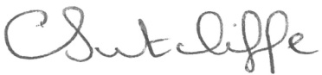

Carolyn Sutcliffe
Headteacher

