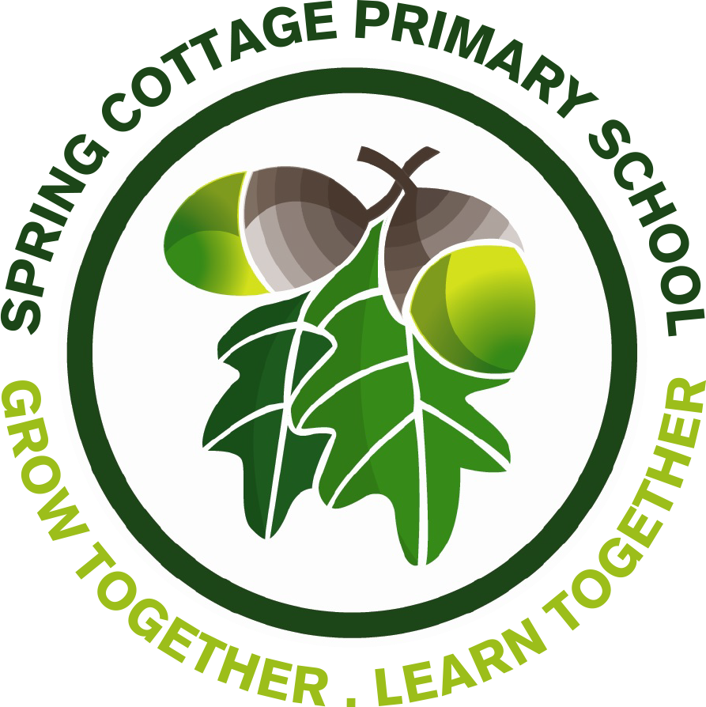

Post title: Class teacher MPS (main pay scale)
Location: Spring Cottage Primary School
Reporting to: Head of School - Mrs H. Chamberlain
Start Date: September 2022
Location: Kingston Upon Hull
Closing Date and time: 4pm on Wednesday 18th May 2022
Interviews: W/c 23rd May 2022

We are looking to recruit a passionate, highly motivated and enthusiastic teacher to support learning and join our dedicated team. Spring Cottage Primary School is one of the most exciting and successful primary schools in Hull. We are the only educational establishment in this area to have achieved status as a Google Reference School and pride ourselves in being innovative and forward thinking. Staff are well supported within a culture of continuous professional development and are encouraged to take on new and more senior roles within the school and trust as they develop in their career.

We are a values-based and highly inclusive school, serving a vibrant community who make a positive contribution to wider social and economic agendas. Visits to the school are welcomed and encouraged. Please email admin@springcottage.hull.sch.uk or call the school (01482 794183) to arrange.

The successful candidate will:
- Be committed to delivering excellent learning opportunities for children.
- Set high expectations for pupil’s behaviour in line with school policy.
- Be able to deliver high quality teaching to all pupils ensuring effective use of teaching time.
- Understand that every child can be successful in their learning.
- Be a team player and have a commitment to our values of Happiness, Determination and Respect.

We can offer:
- A supportive, friendly and dedicated staff team.
- A workplace dedicated to equal opportunities.
- A comprehensive programme of training & development.
- Pupils who are happy, well behaved and have positive attitudes towards their learning.

Any experience or interest in the area of computing would be desirable but is not essential for the post advertised.

Closing date for application forms is 4pm on Wednesday 18th May 2022.

Any offer of appointment to the post will be subject to the receipt of a satisfactory clearance from the Disclosure and Barring Service. The school is committed to safeguarding and promoting the welfare of children and young people and expects all staff and volunteers to share this commitment.

Please note unsuccessful candidates will not be contacted.
Although the post is attached to Spring Cottage Primary School, as an employee of Horizon Academy Trust you may be required to work at other schools in the MAT.

