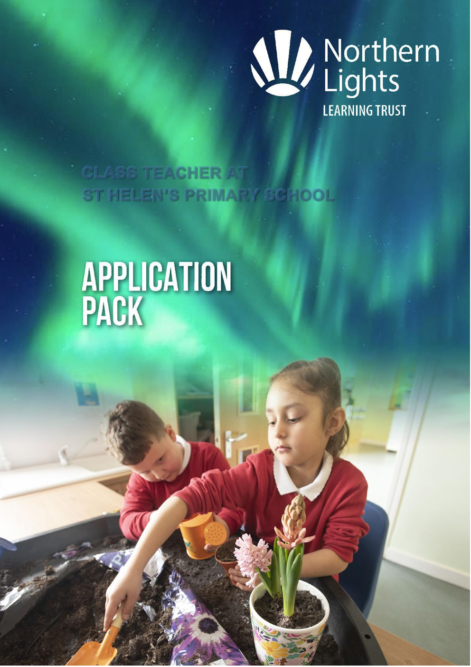
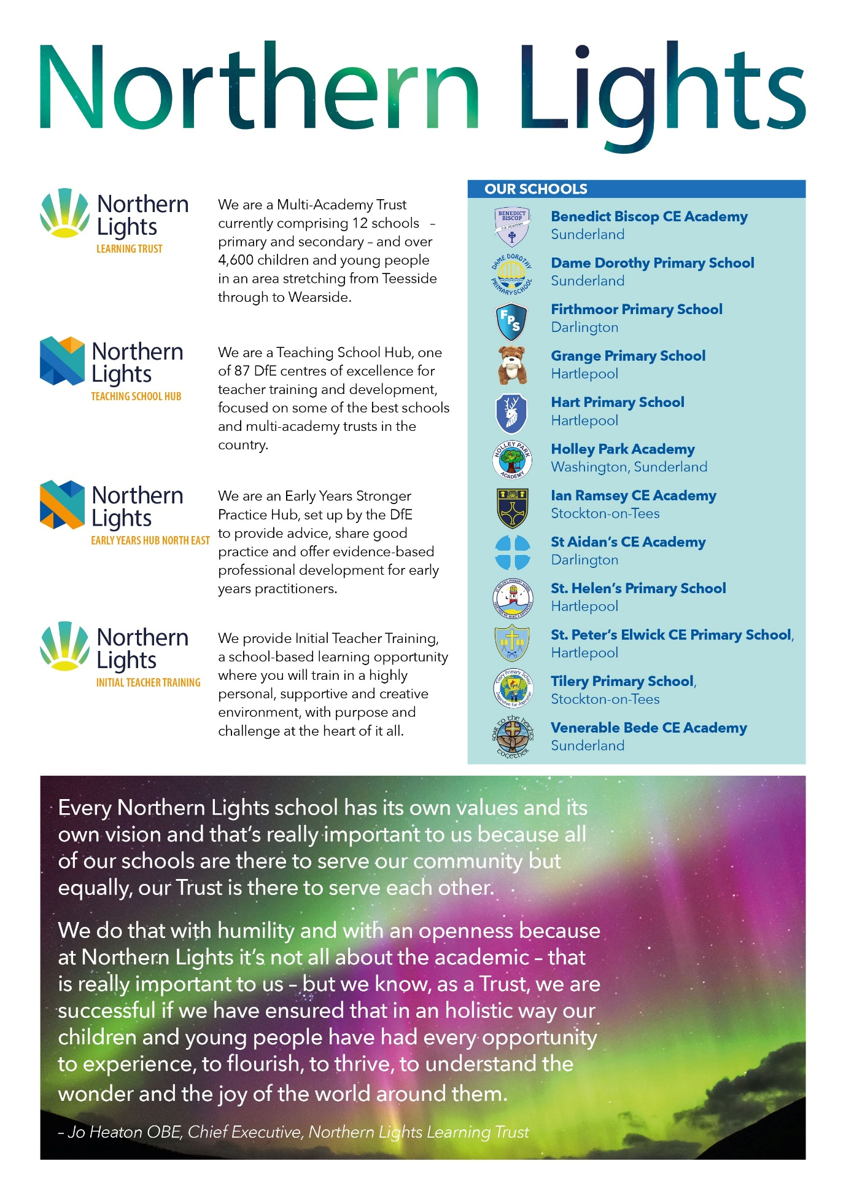



Welcome from the CEO

Thank you for your interest in the position of Class Teacher within Northern Lights Learning Trust.

We are a growing Multi-Academy Trust that is currently made up of 3 secondaries and 9 primaries across Wearside and Teesside, with our central offices based in Seaham. We educate over 4600 pupils and employ over 700 members of staff and serve a diverse range of schools and communities. Each of our schools have their own individual ethos, values and vision, which sit together as part of our Northern Lights vision of ‘Shining Together and Stronger Together’. As a CofE MAT, our schools are a mixture of Church and non-Church schools that range in size and levels of disadvantage. We see this diversity as a real strength to learn from and work with each other.

As a Multi-Academy Trust we are at the heart of the current educational landscape, as a designated DfE Centre of Excellence as a Teaching School Hub and DfE Early Years Hub, responsible for teacher development across all ages and phases of education, working with over 300 schools. We are collaborative in our approach and value professional development highly in all we do.

We are looking for someone whose values align with us as a Trust and has the drive and ambition to work collaboratively to provide the best opportunities and outcomes for our young people.

We look forward to receiving your application.

Yours faithfully

Jo Heaton OBE
Chief Executive Officer



Class Teacher

Permanent position required for
1st September 2026
St Helen’s Primary School
M1 – UPS3 (£32,916 – £51,047)
Teachers pay and conditions
Are you organised, enthusiastic and welcoming?
Would like to make a difference to children’s learning and well-being?

Northern Lights Learning Trust are looking to appoint an enthusiastic teacher to join St
Helen’s Primary School. This position is permanent from 1st September 2026. Candidates must be able to demonstrate high standards of classroom practice, good inter-personal skills and be supportive of the school’s ethos and values.

The successful candidate will:

- Have high expectations of learning and behaviour and inspire and motivate our children
- Have a secure understanding of supporting children with communication and interaction difficulties
- Support, nurture and understand with high expectations.
- Seek to make learning exciting and a positive experience.
- Communicate well with parents, carers and members of staff, as well as pupils.
- Strive to be driven and proactive.
- Work well as part of a team.
- Show willingness to contribute to school life outside of the classroom.
- Consider yourself to be IT literate

If this is you, we would really welcome your application

In return you will receive:

- A supportive working environment that puts people at the heart of the organisation
- The opportunity to work as part of a growing Trust and shape this role
- Continuous professional development
- A range of Trust initiatives that improve wellbeing. Current initiatives include an annual wellbeing day.
- National Terms and Conditions of Employment
- Teachers’ Pension Scheme/ Local Government Pension Scheme

Employee welfare and benefits package including:

- 24-hour GP access
- Nurse support service
- Mental health services, including stress management, mental health first aid training and bereavement support
- Free Flu vaccinations
- Counselling Services
- Physiotherapy
- Financial wellbeing coaching
- Maternity and Paternity support
- Menopause support
- Access to useful wellbeing resources
- Cycle to work scheme
- Lifestyle savings including discounts on shops, food and drink and days out

CLOSING DATE:
Applications must be received by: 9:00am on 11th June 2026
Shortlisting will take place on: 12th June 2026
Interviews will take place on: 16th June 2026
We welcome any visits to the school from 1st June 2026

HOW TO APPLY:
Applications should be submitted via email to louise.metcalfe@nllt.co.uk or if you prefer you can submit through post to St Helen’s Primary School, Durham Street, Headland, Hartlepool, TS25 0HG.
Applications will only be considered on receipt of an application form, CV’s and other forms of application will not be accepted. For further information, or if you would like to arrange a visit to the school, please contact us on recruitment@nllt.co.uk

Details of the school can be found on the school website:
www.sthelensprimaryschool.co.uk
JOB DESCRIPTION

JOB DESCRIPTION

Post: Class Teacher
Responsible to: Headteacher, Governors, Board of Directors
Salary band: M1– UPS3
Start date: September 2026

Purpose of Job:

OVERALL RESPONSIBILITY

- To meet the requirements of a teacher as set out in the School Teachers Pay and Conditions Document and The Professional Standards for Teachers;
- Teach within all areas of the school and model good practice;
- Resource the learning environment to an outstanding level;
- Prepare and present report to the Senior Leadership Team on pupil progress;
- Analyse pupil data and plan to improve provision with improved outcomes for all children.

DUTIES

Principal Duties:

- Plan effectively to achieve outstanding outcomes and progress for all learners;
- Teach in a variety of styles to engage and motivate learners securing outstanding behaviours for learning;
- Further develop our outstanding curriculum;
- Responsible for day-to-day management of resources;
- Observing learning and changing provision to meet pupil needs;
- Develop parental partnerships;
- Ensuring statutory welfare requirements are met;
- Active participation in our whole school team.

.
Additional responsibilities – the post holder must:

- Promote and safeguard the welfare of the children and young people that they are responsible for or come into contact with.
- Act in compliance with data protection principles in respecting the privacy of personal information held by the Academy.
- Comply with the principles of the Freedom of Information Act 2000 in relation to the management of Academy records and information.
- Carry out their duties with full regard to the school’s Equal Opportunities Policy, Code of Conduct, Child Protection Policy and all other Academy Policies.
- Comply with the Academy Health and Safety rules and regulations and with Health and Safety legislation.

PERSON SPECIFICATION
CLASS TEACHER

CATEGORY | ESSENTIAL | DESIRABLE | METHOD OF ASSESSMENT
APPLICATION FORM | - Well-presented and complete application form |  | Application
QUALIFICATIONS | - Relevant Degree  - Qualified Teacher Status | - Evidence of further education related qualifications | Application  Certificates
EXPERIENCE | - Experience working in a primary school environment  - Evidence of good/ outstanding teaching  - Evidence of planning for effective learning  - Understanding of strategies required to ensure all pupil groups make good progress | - Working across Key Stages one and two | Application  Interview  References
PROFESSIONAL DEVELOPMENT | - Professional development covering curriculum issues  - Commitment to further develop professional skills and practice | 1.Professional development linked to support children with Special Educational Needs
SKILLS AND KNOWLEDGE | 1.  2. | A clear vision and understanding of the needs of pupils  A commitment to ensure that all pupils have the opportunity to achieve the highest standards.  3.Ability to offer skills to develop the wider curriculum  4.Understand and regard for safeguarding arrangements for protection of all children | - A good knowledge of current educational issues  - Ability to support families in providing opportunities and experiences to enrich a child’s childhood.  - Knowledge or skills linked to inclusive practice. |  | Application  Interview  Lesson  Observation
PERSONAL QUALITIES | - Caring attitude towards pupils and parents  - A good health and attendance record  - Ability to work collaboratively as part of a school team  - Ability to make decisions and take responsibility  - Willingness to contribute to the wider life of the Academy |  | Application  Interview  References
OTHER | - Recommendation from both referees  - Fully enhanced DBS clearance with children’s barred list check | - Strong recommendation | References  DBS certificate

References:
References will be requested prior to interview, unless there are exceptional circumstances, and the applicant does not give consent to do so on the application form. Please contact us to discuss further if you do not consent.
DBS:
Northern Lights Learning Trust is committed to safeguarding and promoting the welfare of
children and young people and expects all staff and volunteers to share this commitment.
An application for a DBS certificate will be submitted for all candidates once they have been
offered the position. For posts in regulated activity, the DBS check will include a barred list
check. During the recruitment process, any offences, or other matters relevant to the position will be considered on a case-by-case basis.

Any offer of employment will be subject to receipt of a satisfactory DBS Enhanced Disclosure.

Safeguarding:
Northern Lights Learning Trust is committed to safeguarding and promoting the welfare of children and expects all staff and volunteers to share this commitment. Everyone who comes into contact with children and their families and carers has a role to play in safeguarding children. To fulfil this responsibility effectively, all professionals should make sure their approach is child centred. This means that they should consider, at all times, what is in the best interests of the child.

Pre-employment occupational health:
Pre-employment occupational health checks are an essential part of the selection and recruitment process to assess if any reasonable adjustments are required. In some circumstances, an appointment with Occupational Health may be required to assess fitness for the role.
Equal opportunities:
Northern Lights Learning Trust are an equal opportunity employer. We want to develop a more diverse workforce and we positively welcome applicants from all sections of the community. Applicants with disabilities will be granted an interview if the essential job criteria are met.

Artificial Intelligence and Recruitment at Northern Lights Learning Trust
Northern Lights Learning Trust is committed to embracing innovation while maintaining fairness and integrity in our recruitment processes. We recognise that candidates may choose to use AI tools to support the preparation of their applications. While this is acceptable, we expect all submissions to reflect the applicant’s own experiences, values, and suitability for the role and it is essential that AI is used appropriately.

AI must not be used to:
- provide misleading or false information at any stage of the application journey
- inflate or invent qualifications, skills or experience
- complete assessments as part of the recruitment process
- create generic responses and copy them into your application
If you have any questions about the use of AI in your recruitment process with us, please email: hradmin@nllt.co.uk

