Dear Applicant,

CLASS TEACHER (M1 – M6)

Thank you for your interest in applying for a class teacher position in our school.

We are a small, friendly one form entry primary school in the heart of London near to Paddington Station and Hyde Park. We have a fantastic school community that is ready to welcome a new member of our staff team. Our children’s families come from over 55 different countries and we are a truly international school.

We are looking for a new class teacher to join our supportive and friendly staff team. We have the experience in our team to support you on the next stage of your career journey and this is a great time to join our school as we develop the learning for the children.

You are welcome to arrange an appointment to visit the school in person (subject to our current risk assessment measures) and I am also happy to speak to candidates via video conferencing. Please get in touch with the school office if you would like an appointment.

The closing date for applications is Friday 23rd April. Only candidates shortlisted for interview will be contacted. You should use the standard LDBS (London Diocese) Board of Schools application form. CV applications will not be accepted.

I look forward to receiving your application.

Kind regards,

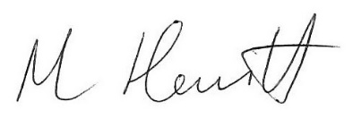

Mr Mark Hewitt
Headteacher

