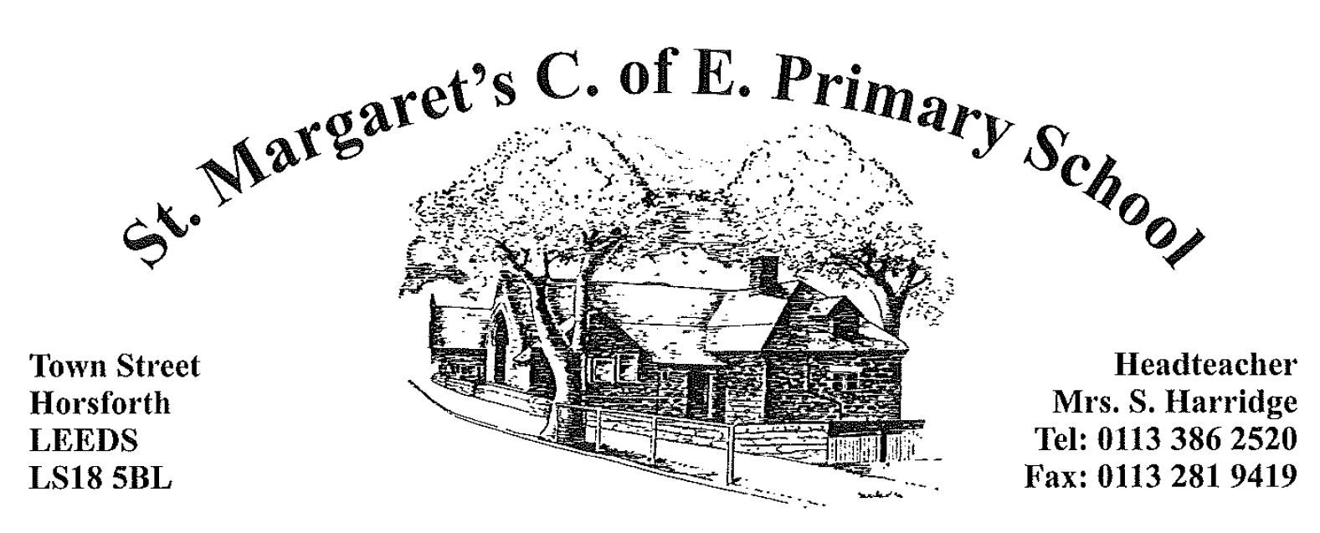

June 2023
St Margaret’s C of E Primary School are excited to be able to offer the opportunity to a committed and enthusiastic teacher to join our school. The post is for a part time (2 days) class teacher to cover Maternity leave in lower Key Stage 2 from September 2023.
The successful candidates will:
- Be, or have aspirations to be, an outstanding practitioner
- Be enthusiastic, hardworking, resourceful and keen to ensure that the highest standards of pupil achievement, personal developments and well-being are attained
- Have high expectations of the children’s learning and behaviour
- Work effectively as part of a team
- Have good interpersonal skills and the ability to work with parents and carers to achieve the best outcomes for their children
- Have an understanding and commitment to providing an inclusive education for all children.

St Margaret’s C of E Primary School is a successful, inclusive, popular two form entry primary school with innovative and creative approaches to learning. We are a vibrant and caring place to learn, providing opportunities for every child to succeed. This is an exciting opportunity for candidates who enjoy a large and happy workplace. We greatly value outdoor, practical learning, with an emphasis on high standards of achievement and behaviour. You will be joining a team of highly skilled staff.
For further insight into the school, please see our website: www.stmargarets.leeds.sch.uk
Closing date for applications is 08:30 on Friday 30th June 2023. Interviews will be held on Thursday 6th July 2023.
Candidates are invited and warmly encouraged to make a visit to the school. Please contact the school office to arrange this.
St Margaret’s C of E Primary School is committed to safeguarding and promoting the welfare of children and expects all staff and volunteers to share this commitment.
The successful candidate will be subject to an enhanced Disclosure and Barring Service (DBS) check.
We promote diversity and want a workforce which reflects the population of Leeds.
Yours sincerely

Mrs S Harridge
Headteacher

