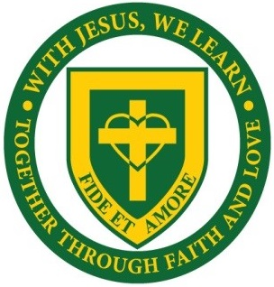

St Mary’s Catholic Primary School
Rockingham Close, Uxbridge, UB8 2UA
Tel: 01895 232814
http://www.st-marys.hillingdon.sch.uk/

1 CLASS TEACHER REQUIRED
Main Pay Scale Range
One permanent post required for September2021
St. Mary’s Catholic Primary School is near the centre of Uxbridge which has good transport links. St. Mary’s is a small school with a community feel. Staff are very supportive of each other and work closely as a team. The children are all very friendly and well behaved, the school has an inclusive environment and we have high expectations for all our children.
We are looking for:
- A teacher who is a practising Catholic or is empathetic to teachings of the Catholic faith
- Is committed to high standards and supporting school improvement
- Has excellent classroom management
- An enthusiastic and motivated class teacher
- A teacher who will work as part of our team
- A teacher who will be fully inclusive of all children
- An effective communicator with colleagues and parents
In return we can offer:
- A warm and welcoming School Community
- A dedicated team of staff who support each other
- A climate where everybody is committed to continuous improvement of the school.
- Supportive Parents and Governors
- Polite and happy children
- Excellent professional development opportunities

Safeguarding and promoting the welfare of all children is paramount and all staff are expected to share this commitment.
Any offer of employment is subject to two satisfactory professional references, an enhanced Disclosure and Barring Services check (DBS)

We strongly recommend that you visit our school, please telephone, Miss Shevlin on 01895 232814, to arrange a convenient time.
Closing Date: noon on Friday 14th May
Interviews are expected to be held during week commencing 17th of May

