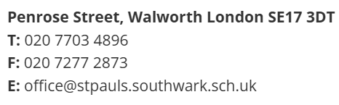
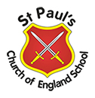
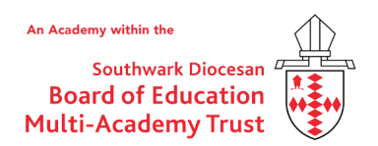
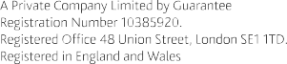

Job Advert - Class Teacher

St Paul's is looking for an enthusiastic class teacher to join our dedicated team.

Start date: | September 2026
Closing date: | 17th June 2026
Interview date: | 18th June 2026
Salary: | MPS/UPS
Hours: | Part-time and full-time applicants will be considered - Please indicate this in your application

At St Paul’s Church of England Primary, we are proud of our diverse and inclusive school where in all we do we aim high, encourage and have faith.

At St Paul’s:

- We are committed to high quality teaching and to excellent professional development opportunities for all our staff
- We have a resilient staff team from a wide range of backgrounds and experiences who work closely together to secure the best outcomes for our children

The successful applicant will:

- Be an excellent teacher who inspires and motivates pupils, parents and colleagues
- Have the drive and ability to secure excellent rates of progress & attainment for all children
- Develop a strong partnership with parents, other professionals and the wider community
- Contribute to the wider life of our church school
- Be a hardworking team member, committed to making a difference to children

If interested in joining our hard-working team, we can offer you:

- A well-resourced school set in extensive grounds
- Support and development from the SDBE MAT including a generous staff benefits scheme
- A school committed to wider education including a full extra-curricular programme
- Coaching and bespoke CPD opportunities
Thank you for your interest in this vacancy. We would be delighted to hear from you, arrange a visit to show you around our school, or simply have an informal discussion.
Applicants are expected to be sympathetic to the Christian ethos of the school.
St Pauls’s is committed to safeguarding and promoting the welfare of children and expects all staff and
volunteers to share this commitment.
All appointments are subject to a satisfactory enhanced DBS check and references.

