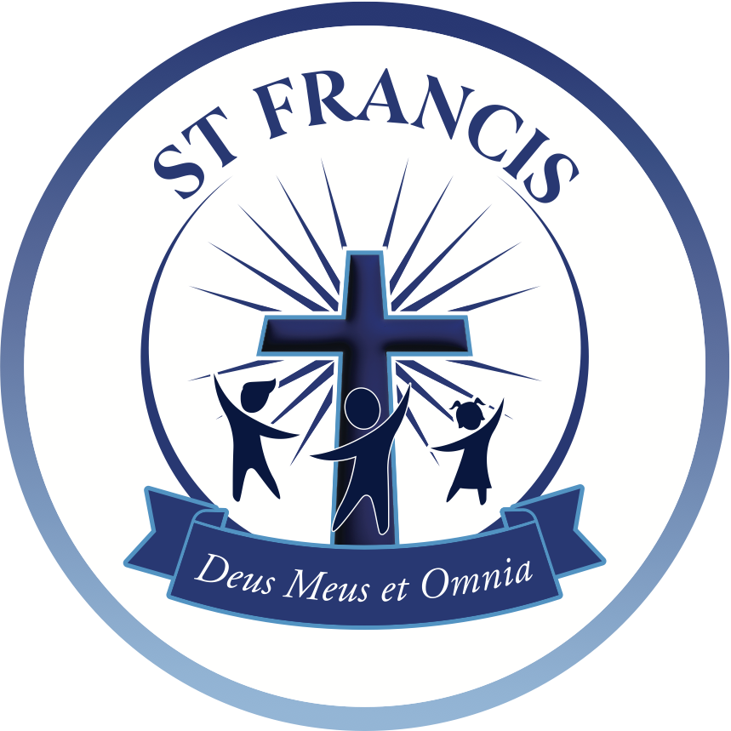





## Salary: MPS

## Hours of work: Full Time 32.5 hours per week

## Contract: Permanent

## Responsible to: Headteacher

## Start Date: September 2025

## Closing date: Monday 16th June 2025 @ 9am

## Shortlisting: Monday 16th June 2025

## Interviews: Monday 23rd June 2025

We are seeking to recruit an excellent class teacher from September 2025 to contribute to the school’s further success in the years ahead. Our successful candidate will be an enthusiastic and skilled teacher who will play a pivotal role in enhancing the educational experience of our pupils. They will have experience of working with pupils across the primary age range and will be able to have a significant impact on their academic progress and their personal development.

St. Peter’s is a caring and inclusive learning community, with a dedicated staff team and wonderful pupils. We are committed to improving outcomes for all our pupils, so that they are able to reach their full potential, both personally and academically. Through a rich curriculum, we aim to foster a love of learning and develop enquiring minds.

St. Peter’s is part of the St. Francis Catholic Multi Academy Trust, which currently comprises of 13 schools.

This is a wonderful opportunity for an exceptional individual to join a successful school and an expanding Trust. There will be scope to have significant impact and develop your career with the organisation.

All teachers must uphold the standards of personal and professional conduct at all times, ensuring honesty and integrity prevails in every situation. Teachers must maintain appropriate professional boundaries and respect the unique position of trust as a teacher at all times.

Informal Communication and visits to the school are welcome. To arrange a visit, please contact us on 01302 369143 or email Sharon Liddle, Finance & Operations Officer, on [admin@stpeter.doncaster.sch.uk](mailto:admin@stpeter.doncaster.sch.uk).

St. Peter’s Catholic Primary School

Sandy Lane

Doncaster

DN4 5EP

Tel: 01302 369143

www.stpeterdoncaster.co.uk

# Class Teacher

St Francis Multi-Academy Trust is committed to safeguarding and protecting the welfare of children, and expects all staff and volunteers to share this commitment. Safer recruitment practice and pre-employment checks will be undertaken before any appointment is confirmed.

This post involves working with children and therefore if successful you will be required to apply for a disclosure of criminal records check at an enhanced level and a barred list check. Further information about the Disclosure and Barring Service can be found at www.gov.uk/disclosure-barring-service-check

We are an equal opportunities employer committed to recruiting and retaining a diverse workforce.

**How to Apply**

Please visit https://stfcmat.com/vacancies/ to obtain the Teacher recruitment Pack.

Please complete all of the relevant documentation by the closing date of **Monday 16th June @ 9am** and send it to Sharon Liddle, Finance & Operations Officer via email to [admin@stpeter.doncaster.sch.uk](mailto:admin@stpeter.doncaster.sch.uk).

Please note that we are unable to accept CV’s in application for this role.