SS Philip and James C of E Primary School
With love we flourish

Class Teacher
Main Scale
Permanent, full time

We are looking to appoint a class teacher for KS2 to start in September 2021.
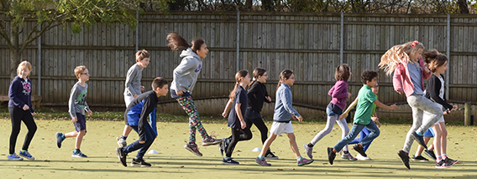
This is an exciting opportunity to join a vibrant and forward thinking setting. We are looking to appoint an inspiring teacher who is fully committed to doing the very best for the pupils in their care. We are a successful Local Authority maintained two-form entry primary school situated close to the centre of Oxford. Our Ofsted and SIAMS inspections in February 2018 confirmed that we are a good school with a strong and committed leadership team.

We are looking for someone who can:
- Demonstrate a clear understanding of what constitutes outstanding teaching and learning
- Inspire and motivate staff, parents, carers and children
- Demonstrate interpersonal and organisational skills
- Show commitment to ensuring equality of opportunity for all learners
- Be a dynamic and creative practitioner with high expectations

We offer you:
- A happy, supportive and friendly environment where we work effectively as a team
- Children who are eager to learn, committed staff, governors, parents and carers
- A commitment to a healthy work/life balance with blocked PPA time for all teaching staff
- Inspiring curriculum enrichment opportunities because of our exciting location in central Oxford
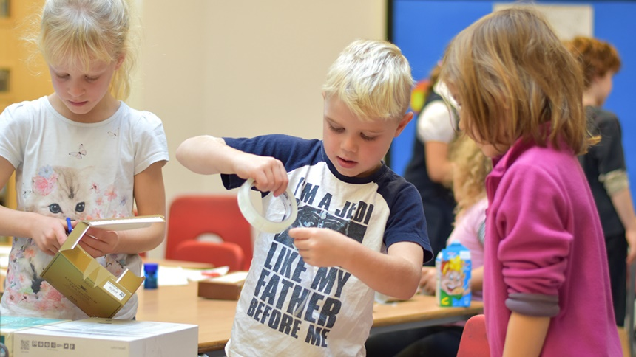
- Opportunities to develop your practice supported by a commitment to your continuous professional development

Benefits:
- Access to Oxfordshire County Council discounts
- Cycle to work scheme
- Ample parking and secure bike store
- Staff social events
- Free tea and coffee in the staff room
- Access to staff laptops and iPads

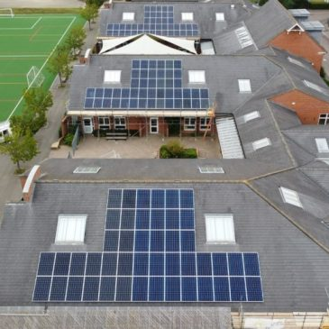
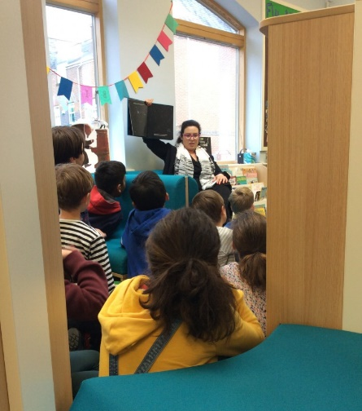
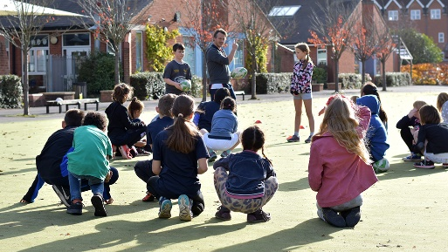
Our school has a new purpose built library, computer suite, two IPad trolleys, a large Astro turf pitch and we have recently had solar panels installed.

The school is committed to safeguarding and promoting the welfare of children and expects all staff and volunteers to share this commitment. The successful candidates will require an enhanced DBS clearance and appropriate references.

Visits to the school before applying are warmly encouraged and welcomed. Due to current Covid restrictions these will take place outside school hours.

How to apply:
- Please see the vacancy page on our website for job description, person specification and application form http://philandjim.org.uk/
- Completed applications can be emailed to Kirsty Underwood headpa@philandjim.org.uk

Closing date for applications: Thursday 20th May

Interviews will be held in school on: Monday 24th May

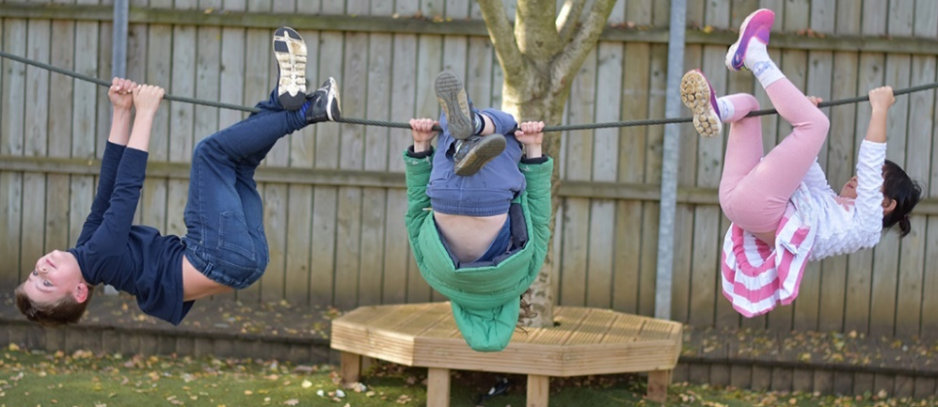
Applications will be considered on receipt with early opportunity for interview.

