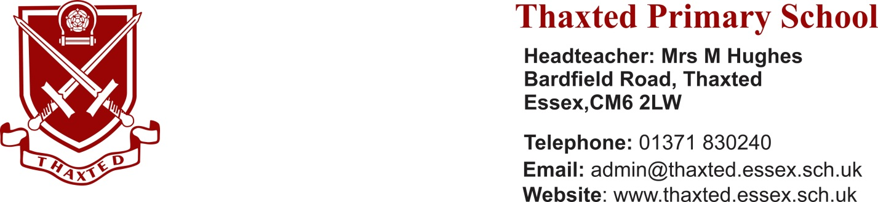

CLASS TEACHERS
Mainscale
Fixed Term until the 31/08/22
Required as soon as possible

Would you like to come and work in our amazing school?
Do you want to feel supported by a lovely and welcoming team?
Do you want to spend your days with enthusiastic children who love to learn?

A restructuring of our staffing structure has led to two fixed term opportunities, one teaching a Year 2 class for 2 days per week, and the other teaching in KS2, also for two days per week. We would be happy to appoint two individuals, or the roles could be combined. As ever with fixed terms, there may be opportunities for permanent employment in the 22/23 academic year.
We can offer you:
- A popular and aspiring school offering a rich and creative curriculum; In February 2017, Ofsted said, “There is a real ‘buzz’ of purposeful learning at Thaxted Primary. In every class visited, pupils were not only engaged in their learning, but also enjoying it”;
- A friendly and supportive staff;
- Well behaved and responsive children;
- An extremely stimulating environment;
- Many development opportunities

Successful applicants will:
- Be a fantastic, passionate teacher
- Be committed to help all children attain their full potential
- Be enthusiastic about learning and CPD
- Work well as part of a team
You are welcomed and encouraged to visit the school by prior arrangement. Please telephone for an appointment: Mrs Jackie Sweeting, email admin@thaxted.essex.sch.uk, or phone 01371 830240
Closing Date: 12pm Monday 18th October 2021
Interviews: Wednesday 20th October 2021
The school is committed to Safeguarding and promoting the welfare of children and young people. The successful candidate will be subject to an enhanced DBS check.

