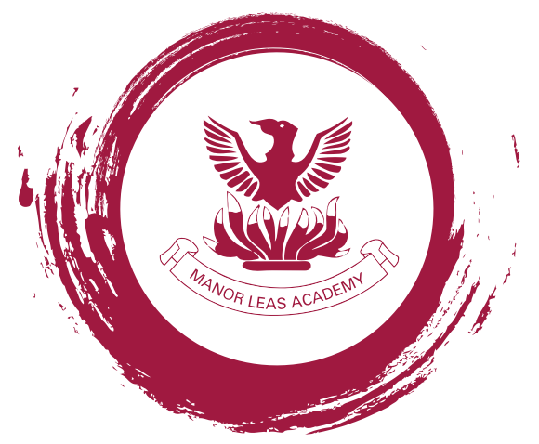

**Lincoln, Manor Leas Junior Academy, Hykeham Road, Lincoln LN6 8BE**

*“Staff have high expectations of pupils resulting in exceptionally strong learning, behaviour and conduct.” Challenge Partners*

*“This school is outward looking, enthusiastically sharing practice with schools locally and nationally” Challenge Partners*

Head teacher: Chelsea Sandbrook

Required for: September 2024/Main Pay scale

**Key Stage 2 Class Teachers:**

**Permanent and Temporary (1 year)**

Excellent Key Stage 2 class teachers are required who have the character to make a difference and be great team players.

Our school can offer you:

* An innovative environment with staff wellbeing at its heart;
* An assessment system that impacts on learning and reduces workload (‘No More Marking’);
* The chance to work with emotionally intelligent pupils who are extremely well-behaved;
* The opportunity to be part of a highly effective and supportive team;
* Fantastic resources, including iPads for each year group;
* The chance to work with an empathetic and highly supportive Senior Leadership Team;
* Outstanding professional development opportunities.
* Free tea/coffee
* Free family Friday meal
* No communications after 6pm policy
* Year group team PPA

**Visits to the school are welcomed, please contact the school office on 01522 881370 to arrange a visit - Available dates and times are: Friday 23rd February at 09.30, Monday 26th February at 15.30 and Monday 4th March at 15.30**

A wealth of information about our school and the application pack can be found on our website [www.manor-leas-junior.lincs.sch.uk](http://www.manor-leas-junior.lincs.sch.uk) on the ‘About Us’/’Working with us’ tab.

Manor Leas Junior Academy is committed to safeguarding and promoting the welfare of children. Consequently an Enhanced Disclosure & Barring Service check will be required for this post. All shortlisted candidates will need to verify their eligibility to work in the UK at interview. Please note that all references will be taken up before interview.

**Closing date for applications: 9am, Friday 8th March 2024**