
The Willows School and Early Years Centre
Fishermead Boulevard, Fishermead, Milton Keynes MK6
Tel: 01908 528803 Email: office@thewillowseyc.org.uk
Website: https://www.thewillowseyc.org.uk

To become honest, active citizens
and lifelong learners in a global society
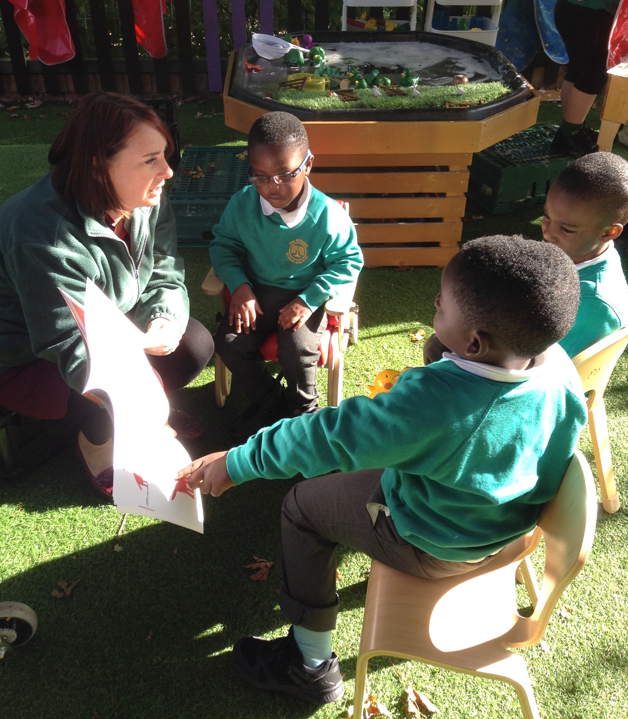


Class Teacher for Reception
To start January 2022
Permanent
Full time – Part time considered

Are you looking for something new where you can enjoy a challenge with each day being different? Then look no further! The Willows School and Early Years Centre is a thriving Infant School with a nursery. Through our culture of supporting the whole family, we work closely with our on-site children’s centre to support children from all backgrounds to make good progress. The school is judged “good” by Ofsted and we are now on our journey to “outstanding”.

We are looking for someone who:

- Has a passion for Early Years teaching.
- Is committed to and able to inspire lifelong learning.
- Is a creative and dynamic classroom teacher.
- Is able to secure high standards in all areas of the curriculum through the highest expectations of yourself and the children in our school.
- Is imaginative and able to plan relevant cross-curricular learning experiences.
- Is enthusiasic, energetic and willing to be involved in all aspects of school life.
We can offer you:
- A supportive leadership team, a friendly workplace and children who want to learn.
- An excellent working environment with fantastic opportunities for continuing professional development.
We encourage applicants to look round our school. Visits to the school are welcome - please contact the school office to book a time.

Application packs are available from the school office and our website. All applications must be made using the Milton Keynes Council application form. References may be taken up prior to interview.

Closing date for applications: 4pm Monday 4th October 2021
Interviews: week commencing Monday 11th October 2021

The Willows School and EYC is committed to safeguarding and promoting the welfare of children and vulnerable adults. All employees are expected to share this commitment, to follow the centre’s safeguarding policies and procedures and to behave appropriately towards children and vulnerable adults at all times, both in work and in their personal lives. The successful applicant will require an Enhanced DBS check.

