Role: Class Teacher + TLR (SEND Responsibility)
Class Teacher + TLR (Mainstream SEND)
Birley Spa Primary Academy
Candidate
Information Pack:

Salary: MPS + TLR

Location: Birley Spa Primary Academy, Jermyn Crescent, Sheffield, S12 4QE

Contract Type: Full Time

Contract Term: Fixed Term starting September 2022

Closing Date: 24th June 2022 @ 12:00pm

Birley Spa Primary Academy is seeking to recruit a talented class teacher with an additional TLR to lead on SEND developments and practice – in partnership with our SENCO. We are looking for an inspirational teacher to lead, coach and develop practices to deliver exceptional quality SEND provision across school. This exciting opportunity invites applications from leaders with a passion for working with SEND children. We seek an individual who can empower colleagues, as well as play a significant role in leading developmental approaches for high quality interventions that build our pupils’ level of curiosity, inquisitiveness to secure a love of life long learning.

We are looking for an inspiring teacher who can continue to develop our children’s love of learning and help them explore and understand the world around them. This is a fantastic opportunity to join a school that truly values the development of their staff. The successful candidate has the opportunity to benefit from our personalised coaching and CPD programme.
The successful candidate will be an outstanding practitioner who can contribute towards our passionate and committed journey to secure the greatest quality provision for our pupils at Birley Spa Primary Academy. The successful post holder will be responsible for SEN across our mainstream school.
If you have high expectations for yourself and all children, a passion and creativity for changing lives through learning and a desire to make a difference to young people, Birley Spa Primary Academy is the right place for you. We can offer you challenge and reward within this role, within an environment of continuous improvement and sharing of best practice and a commitment to your own CPD to support you in becoming the best you can be! Birley Spa Primary Academy and LEAD Academy Trust aims, through outstanding leadership, to provide the highest quality education to enable every pupil to realise their full potential. The L.E.A.D. Academy Trust is committed to safeguarding and promoting the welfare of children and young people and we expect all staff and volunteers to share this commitment. This post is subject to an enhanced DBS check.

We are looking for someone who:
- has a passion for working with primary age children and inspiring SEND practice;
- can build positive relationships with children, staff and all members of the community;
- is an inspirational teacher with a caring and adaptable approach to teaching children with all abilities;
- is dynamic and forward thinking;
- has high expectations of pupil progress;
- has a love of teaching both in the classroom and outside
- can offer creativity in leading planning and developmental learning across the curriculum

- has the skills to work collaboratively both within school and with colleagues within other L.E.A.D. Academies;
- shares a belief that motivated children can achieve whatever they set out to achieve;
- is willing to embrace or bring new ideas to the Academy;
- has an open and informed approach to developments in assessment and learning.

In return, the successful candidate will:
- work in an Academy with high aspirations for all of its children and staff;
- have access to the L.E.A.D. Academy Trust’s high quality training programmes;
- be part of a dynamic and forward thinking team of professionals;
- the opportunity to play a pivotal role within our team on our continued journey of improvement

Application Forms:
If you would like an application form or would like to arrange a visit, please contact Davinia Helliwell, on 0114 2399106 or via email, enquiries@birleyspaacademy.co.uk

Alternately please visit our website; https://www.birleyspaacademy.co.uk/about-us/vacancies/

L.E.A.D. Academy Trust

L.E.A.D. Academy Trust comprises of twenty five academies across Nottingham, Leicester, Derby, Lincoln and Sheffield. Our philosophy is to; lead, empower, achieve and drive.

At the heart of our Trust is the development of outstanding leaders. We empower individuals in our schools to provide the highest quality education, enabling every pupil to realise their full potential. We have also been recognised by Ofsted as a leading academy sponsor, securing rapid and sustainable improvement through the research and application of best practice across operational areas.

The combination of autonomy and collaboration across key areas of leadership and management underpinned by shared vision, values and best practice positions L.E.A.D. as a truly unique Academy Trust.

To view our ‘L.E.A.D. Family Brochure’ please visit:
www.leadacademytrust.co.uk

To see the wonderful achievements, proud moments and diverse events happening across our Trust please follow our twitter account: @LEADAcadTrust

Our Leaders

One of the core priorities for the L.E.A.D. Academy Trust is the development of outstanding school leaders. We are dedicated to providing an organisation which will:
• develop inspirational school leaders for the future through high quality recruitment, professional development and coaching;
• invest in joint training, peer coaching, sharing good practice and professional dialogue in a climate of trust;
• continually improve, exploring new ways of working, alternative curriculums and innovation;
• strategically plan to produce the next generation of high quality school leaders.

The L.E.A.D. Teaching School Alliance

The L.E.A.D. Teaching School Alliance is a dynamic, cross-phase collaboration of schools committed to harnessing, nurturing and sharing the specific skills and attributes required to teach and lead in areas with diverse pupil populations. Everything we do in our schools is about providing children with an outstanding, broad and balanced education.

Our innovative Initial Teaching Training (ITT) route aims to increase the number of quality teachers in our schools. In addition, we offer a range of high quality Continuing Professional Development (CPD) for staff at all levels and tailored school-to-school support. We are keen to nurture and grow staff across our alliance and offer a range of opportunities to develop the leaders of tomorrow. By working in partnership with The University of Nottingham and other regional Universities, we are also creating a research culture within our alliance that will impact positively on teaching, learning and the achievement of young people.

Our Support

We provide a range of high quality, professional services to schools in nine core areas:

Financial Management

Project Management

Procurement

ICT Management

Human Resources

Leadership Development

Legal Support

Governor Support

Education

How to Apply

Please send a completed application form and covering letter, with a supporting CV if you wish to:
Davinia Helliwell, Admin Manager, enquiries@birleyspaacademy.co.uk

Closing Date: 24th June 2022 at 12:00pm

Applications will be reviewed upon receipt therefore shortlisted candidates may be contracted in advance of the closing date.

The L.E.A.D. Academy Trust is committed to safeguarding and promoting the welfare of children and young people and we can expect all staff and volunteers to share this commitment. This post is subject to an enhanced DBS check.
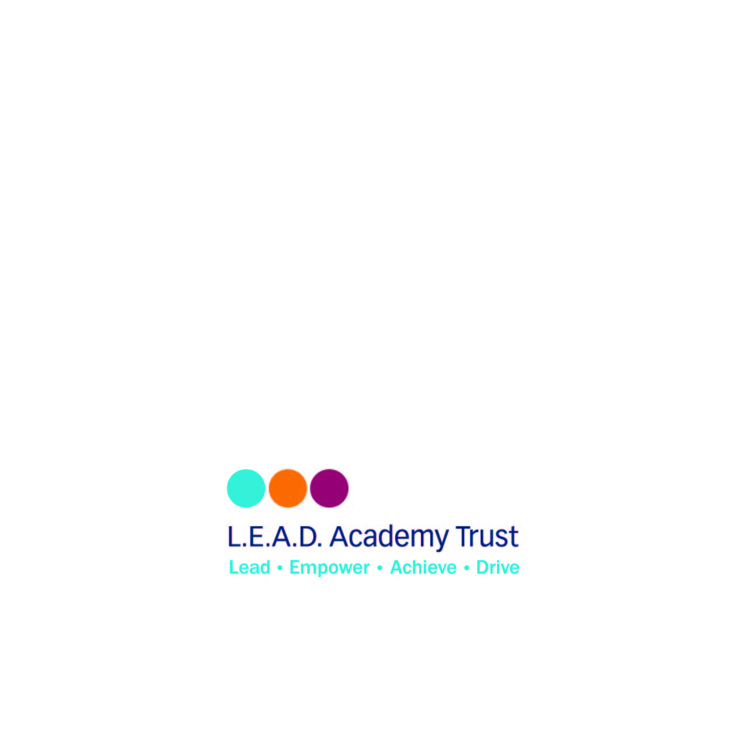
L.E.A.D. Academy Trust
5a The Ropewalk
Nottingham
NG1 5DU

Email: admin@leadacademytrust.co.uk

Telephone: 0115 822 5440

