ADVERT FOR A CLASS TEACHER 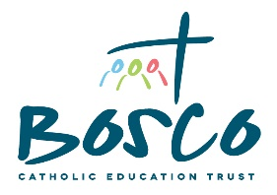PART TIME MATERNITY COVER

St Joseph’s Catholic Primary School
Hazelgrove Road, Haywards Heath, West Sussex, RH16 3PQ
N.O.R: 420
Age Range: 4-11
Post: Class Teacher
Grade: M1-M6

The Governing Body of St Joseph's Catholic Primary School are looking to appoint a highly motivated and exemplary Class Teacher for September 2021. This position is temporary to cover a maternity leave and will be for three days a week. The successful candidate will join our friendly, supportive and committed, professional team. Applications are welcome from existing Teachers and NQT’s.

The successful candidate will:

- be willing to support and promote the Catholic ethos of our school
- be a teacher committed to high standards in all areas
- recognise the uniqueness of each individual child
- have a secure understanding of the current curriculum and assessment expectations
- be an outstanding classroom practitioner
- be innovative and flexible, yet rigorous with an eye for detail
- have excellent organisational and time management skills
- work as part of a team
- be eager and confident to make your mark
- be willing to contribute to the wider life of our school

We can offer:
- hardworking, polite, responsive and well behaved children
- a real commitment to continue professional learning, development and improvement
- the opportunity to shape the school and make a real difference to our children
- a dedicated, friendly and supportive team of staff

Covid friendly informal visits to meet the Headteacher, Mrs Catherine Walker, and to view the school are strongly encouraged. Please telephone or email to make an appointment on 01444 452584 or email bursar@stjosephshh.org.uk

Closing date: 23rd April 2021
Interview date: 28th April 2021

St Joseph's Catholic Primary School is committed to safeguarding and protecting the welfare of our children and expects all staff and volunteers to share this commitment. An enhanced Disclosure and Barring Service Barring Service (DBS) check will be required for the successful candidate in accordance with Safeguarding Children and Safer Recruitment in Education legislation.

