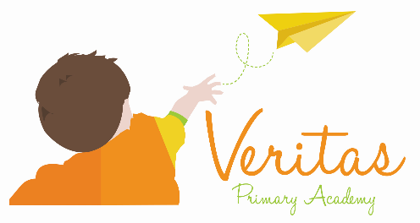

Aspiration, Enrichment, Opportunity
Inspirational Teacher required at Veritas Primary Academy
Post: Y3 (KS2) Job share Teacher required to start January 2022 for maternity cover
Hours: Part Time, 19.5 hours per week (Wednesday, Thursday, Friday inclusive of pro rata PPA time with job share)
Salary: Teachers Main Scale point 1 to 6.
Are you an inspirational teacher looking to work with an amazing group of children and colleagues? Are you looking to forge a career within a caring and values-driven family of schools? Do you want to belong to a national professional learning community, with real opportunities for growth, development and career progression? Are you driven to enable all children to succeed in all areas of the curriculum? If so, Veritas is the school for you!
Veritas Primary Academy is a bright and vibrant two form entry school for children aged 3 to 11 years old that opened its doors in September 2015 and achieved a ‘Good’ Ofsted rating in 2018. We are a very friendly school where we aim to provide exceptional learning opportunities for all children. We set high expectations for our children both behaviorally and academically and offer a wide range of creative, inspirational lessons through all areas of the curriculum. Our children are encouraged to become confident, caring and articulate and to use their abilities to the full. Teachers have curriculum support through the use of Cornerstones curriculum, White Rose Maths and RWInc Spelling.
We are part of the REAch2 Academy Trust family and foster close links with other schools throughout the Trust aiming to share resources, facilities and expertise to ensure the best teaching and learning possible.
We are seeking to appoint a new member of staff to join our dynamic teaching team of committed teachers on our remarkable journey in contributing to the achievement of our vision to ensuring all children reach their full potential. We would like to hear from anyone who feels they can motivate, inspire and challenge our pupils to achieve their very best and want to be a memorable chapter of a child’s learning story.
Candidates should:
- Have a flexible approach to working and be adaptable
- Have relevant experience of working in KS2
- Be a hardworking, team player who communicates well and thrives in working closely with others
- Display initiative and ability to work independently and as part of a team
- Be creative, enthusiastic and dynamic
- Be reliable with a sense of commitment
- An individual that is passionate and dedicated to the profession, who puts children’s learning at the heart of what they do
- Someone who is willing to contribute to an outstanding education for the community that you serve
- Have high standard of spelling, grammar, handwriting in order to be a good role model for KS2 pupils

In return we can offer:
- Excellent CPD with continuous training and development opportunities
- Excellent Leadership, Teaching and Support Staff within a friendly, supportive working environment
- A school that provides a strong culture of collaboration and support together with high expectations for staff and pupils alike
- A vibrant and dynamic workplace
- The chance to network and develop links with colleagues within the trust
We would like to hear from anyone who feels they can motivate, inspire and challenge pupils to achieve their very best and want to be a memorable chapter of the children’s learning story.
School Tour/Q&A session: Tuesday 16th November at 4pm (please call the school office on 01785 333400 to request a place).
How to apply: Application packs can be found on our school website- www.veritasprimaryacademy.com
Closing Date: Completed applications should be received by no later than 5pm Friday 26th November 2021
By Post to: Lucy Henderson, Veritas Primary Academy, Weston Road, Stafford, ST18 0FL
Or by Email: recruitment@veritasprimaryacademy.com
REAch2 Academy Trust has an Equal Opportunities Policy for selection and recruitment. Applicants are requested to complete an online Equal Opportunities Monitoring form.
Interview Date and Task Completion: Friday 3rd December 2021 (short listed candidates will be notified by email, no later than 6pm Monday 29th November 2021)
Veritas Primary Academy is committed to safeguarding and promoting the welfare of children and young people and expects all staff and volunteers to share this commitment.
This position is subject to an enhanced DBS Check and satisfactory written references.

