Come and join us as our new Class Teacher

- Have a positive impact on our children in school;
- Access high quality professional development opportunities;
- Have your ideas and aspirations nurtured.

Class Teacher
West Cliff Primary School

Required to start in September 2022
Recruitment Information Pack
West Cliff Primary School
Church Square, Whitby, YO21 3EG

Contents

Welcome from the Headteacher 3
Our vision and values 4
Context of the school 5
Our English Hub 6
Application process 7
Job Description and Person Specification 8-12

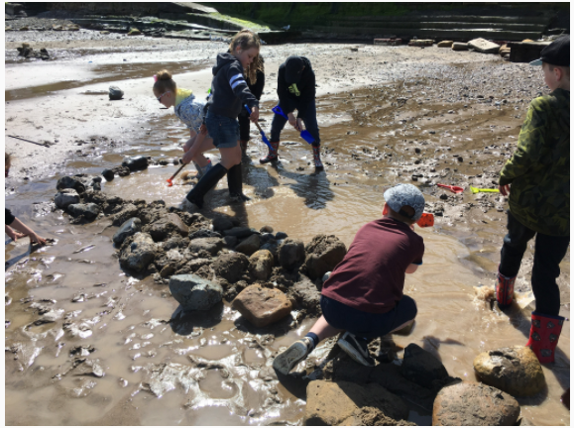
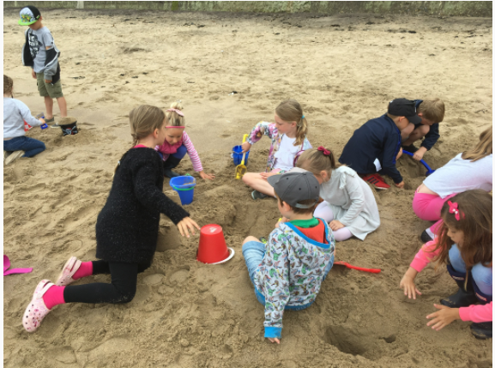

Dear applicant,

Allow me to extend a warm welcome from all governors, staff and children of West Cliff Primary School. I am delighted you have shown interest in joining us and I look forward to sharing with you what makes our schools very special places to work.

Our children are delightful, happy, confident and energetic. They are passionate about their learning and enjoy a wide curriculum, with access to 1:1 iPads, outdoor learning areas, excellent sports provision and lots and lots of books! Our children have many talents and we pride ourselves in providing lots of opportunities for every child to contribute to the wider school community. We dream big and tame our tigers, ensuring that every child has had the opportunity to achieve our ‘pledges’ before they leave the school. We have beach school status and are looking for someone who will support our love of outdoor learning!
We are working on the National Nurturing Schools Programme and have a truly inclusive ethos, with emotion coaching and restorative practice at the heart of all we do. In 2021, we opened the Rockpool, our targeted mainstream provision focussed on supporting social, emotional and mental health, and we are proud to have a staff team who fully embrace our child-centred culture.

This is an exciting time to join us, as our inspirational headteacher and CEO, Christina Zanelli, passes on the mantle of headship to our current associate headteacher, Kirsty Hird from September 2022. As part of the Yorkshire Endeavour Academy Trust, our team are working in partnership across the Whitby area to share, learn and inspire. Through our Trust we are able to access support, training and resources from the Yorkshire Endeavour English Hub and other YEAT schools, which means staff members have a wide range of colleagues, tools and resources to help them develop not just in the classroom but beyond.

I hope that you will take the time to find out more about our amazing school. Good luck with your application. I look forward to reading it.

Kirsty Hird, Associate Headteacher of West Cliff Primary School (headteacher from September 2022)

Yorkshire Endeavour Academy Trust
Our Vision and Values

Vision
- Ethical action for a world class education.
- Nurturing relationships at the heart of our communities.
- Brave leadership in a changing landscape.

Values
- Providing world-class education to all children through an ambitious curriculum.
- Encouraging curiosity and a lifelong love of learning.
- Wrapping around our community through an inclusive nurturing approach.
- Taking pride in local heritage whilst preparing our children to be global citizens.
- Collaborating with partners in education and universal services to support each child’s unique journey.
- Highlighting and sharing excellent educational practice for the benefit of all.
- Growing and developing people in all roles to be their very best.

Context of the school
West Cliff Primary School
West Cliff Primary School is a warm and friendly community school that provides education from children aged 2-11. It currently has 210 children on roll, divided into 8 classes (one for each year group). One of our classes is a nursery class that takes children from 2 years old. The school mainly takes children from the west side and the centre of Whitby - but is accessible from all parts of the town.
We pride ourselves on providing a warm and welcoming environment for children and adults alike, and we strive to provide the very best standard of education possible for our children. We are working closely with Nurture UK and were delighted to open the Rockpool, our targeted mainstream provision for pupils with SEMH needs, in 2021.
The school has a before and after school club (The Ocean Fun Club), offering wraparound care for children from 7.45 until 5.15. This is open to all children including our nursery children.
We are a Beach School as we believe that the beach is a fantastic resource that can be used, to both learn and have fun on. More details at Beach Schools - West Cliff Primary School (west-cliff.n-yorks.sch.uk).
Dorothy’s journey
In 2019, we purchased a double decker bus and were delighted when the previous owner drove it up to Whitby and parked ‘Dorothy’ on the school playground.
She was in reasonable condition but needed a full overhaul to meet our vision of being a bright, welcoming environment for children to access wellbeing sessions, phonic interventions and other activities.
With the support of local companies, staff members, parents and friends of the school, Dorothy was – over several months – transformed into a fantastic and inspiring place to learn, talk and feel safe.
Dorothy’s daily use
Dorothy is used on a daily basis by a variety of children from across the school. The space is used for a variety of activities, including phonic interventions, Compass Buzz sessions, art therapy, lunchtime clubs and much more besides.
Find out more about life at West Cliff by visiting our website: Home - West Cliff Primary School (west-cliff.n-yorks.sch.uk) or viewing our active Facebook page.

Yorkshire Endeavour English Hub
In September 2018, the DfE appointed 32 English Hub schools across England to support other schools to deliver excellent early language and phonics teaching in Reception and Key Stage 1.
The Yorkshire Endeavour English Hub is one of the chosen 32 schools working in Scarborough, Whitby, Ryedale, the East Riding, York and Hambleton.
We have supported a wide range of schools by organising open events to share good practice; providing bespoke training for new subject leaders; and undertaking audits of phonics and early reading provision.

OUR PRIORITIES
The hub focuses on three priority areas:

Early language development
Providing evidence-based approaches to early language development and closing the word gap in school-based early years settings.

Age-appropriate phonics provision
Encouraging best practice in systematic synthetic phonics teaching from school-based early years provision to the end of Key Stage 1, and as the primary reading strategy throughout the school. This includes:
- Encouraging fidelity to a single systematic synthetic phonics programme
- Supporting the effective use of decodable books in the early stages of learning to read, as a way of establishing phonic decoding;
- Supporting effective practice in formative assessment in relation to phonics/early reading.

Promoting a love of reading
Encouraging reading for enjoyment by supporting whole school reading approaches, reading to children at least once a day and encouraging reading at home, developing teacher knowledge of children’s literature.

To learn more about us please visit our website at https://www.yeat.co.uk

Application Process
Applications from early career teachers and more experienced teachers are encouraged.

The closing date for all applications is 9am on Thursday 19th May.

Interviews will be held as soon as possible after the closing date.

Completed applications must be returned to Garry Morrison at garry.morrison@northyorks.gov.uk

If you do not receive confirmation of receipt of your application within one working day please call Garry on 07814935700

If you think you are the person for the job, please complete the enclosed application form with a covering letter, no more than two sides of A4, and send to the email address above by the closing date.

An email will be sent to shortlisted candidates with details of the interview process. If you have not heard from us within a week of the closing date please assume your application has been unsuccessful.

Queries
Informal chats with our incoming Headteacher, Kirsty Hird, are welcomed. Please contact Garry to organise.

We actively welcome you to contact Garry at North Yorkshire County Council to chat through the role and talk informally about the school/post and how working here will make a real difference to the children and young people on the coast.

Job Description

JOB TITLE: Class Teacher

GRADE: MPS/UPS

RESPONSIBLE TO: Head teacher and Governors

RESPONSIBLE FOR: Deployment of support staff allocated (where relevant)

JOB PURPOSE: Promote effective learning, appropriate achievement and educational, social and personal progress of all pupils for whom the teacher is designated as being responsible, consistent with the aims of the school and the unique needs of each individual.

KEY RESPONSIBILITIES:

1. Develop and maintain an up-to-date knowledge and understanding of the areas of teaching and pupil support for which post-holder is responsible

2. Plan work to meet the learning needs of allocated pupils in a consistent and effective way

3. Use appropriate teaching and classroom management strategies to motivate pupils and enable each to progress

4. Monitor the progress of pupils for whom the potholder is responsible to set expectations and give constructive feedback

5. Maintain appropriate records to demonstrate progress made by pupils

- Participate fully in professional development activities to develop practice further, sharing the learning from these as appropriate

- Make an active contribution to the policies and aspirations of the school

To fulfil all of the requirements and duties set out in the current Pay and Conditions Documents relating to the conditions of employment of teachers

To fulfil all of the responsibilities and duties required by the School’s policies on teaching and learning.

To achieve any performance criteria or targets arising from the School’s Performance Management arrangements

This job description will be reviewed annually.

Person Specification

Attributes |  | Desirable/  Essential
 | Experience of teaching in primary schools  Able to evidence excellent pupil progress  Experience of working positively and closely with staff, parents and guardians  Effective experience in creating a positive climate and environment to secure accelerated learning | Essential  Essential  Essential  Essential
EDUCATION AND TRAINING | QTS  Thorough knowledge of teaching, learning and curriculum in primary schools  Commitment to continued professional development  Evidence of recent & relevant training  Safeguarding Awareness | Essential  Essential  Essential  Essential  Essential
PROFESSIONAL KNOWLEDGE AND SKILLS | An excellent classroom practitioner  Effective use of assessment data to plan sequence of learning that secures accelerated progress  Work effectively as part of a team, relating well to colleagues, pupils and parents  Excellent use of ICT to support learning  High expectations of all pupils  Detailed knowledge of the National Curriculum and its planning and delivery  Implications of the Code of Practice for Special Educational Needs for teaching and learning  Evidence of ability to maintain high standards of behaviour and develop attitudes of care, control and cooperation  Experience of curriculum planning as part of a team  Ability to self-motivate and lead a team of support staff  High level of oral and written communication skills and ability to communicate with a wide range of audiences  Able to offer subject expertise  High level of organisational and planning skills  Ability to use initiative, solve problems, make decisions and motivate others  Ability to relate to and empathise with pupils and to build trusting, nurturing relationships with them | Essential  Essential  Essential  Essential  Essential  Essential  Desirable  Essential  Essential  Essential  Desirable  Essential  Essential  Essential  Essential
ANY ADDITIONAL FACTORS | A commitment to abide by and promote equal opportunities, Health and Safety and Child Protection Policies  Commitment to an involvement in extra-curricular activities  Experience of nurturing approaches | Essential  Essential  Desirable
We are committed to safeguarding and promoting the welfare of children and young people and expects all staff and volunteers to share this commitment.
This post is exempt from the Rehabilitation of Offenders Act 1974 and the appointment is subject to a satisfactory enhanced level disclosure and S128 clearance from the Disclosure & Barring Service (DBS).

