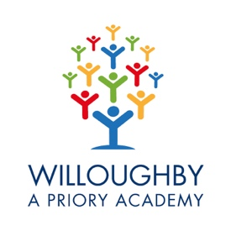
Willoughby

Priory Academy

Class Teacher Vacancy

Thank you for your interest in the Class Teacher vacancy here at Willoughby Academy.

Willoughby is an all need (2 – 19) Academy for pupils with moderate, severe, profound and complex learning needs. The school currently caters for 110 pupils and is extremely well supported in the local community. The staffing body consists of 4 Senior Leaders, 11 Teachers, 5 Instructors, 37 Teaching Assistants and 11 Support Staff. We are able to offer a detailed induction programme, continued CPD and excellent facilities to support pupils and staff in their education. Willoughby are part of the Priory Federation of Academies Trust, who support and challenge the school to be at the forefront of SEND development and practice.

I joined Willoughby in 2015 and am continually overwhelmed by the high levels of teaching, the pupil centred approach and genuinely warm welcome that everyone receives. Working at Willoughby is challenging, but more importantly hugely rewarding. Every single day, the staff of Willoughby have a positive impact on pupils’ lives.

Applications for the vacancy of Class Teacher are welcomed from all candidates. Self-confidence and enthusiasm combined with energy and perseverance are a perquisite, as is the desire to be involved in all aspects of school life. We offer a comprehensive, individualised curriculum that meets the needs of all pupils. Pupils join classes that are appropriate to their age range, ability and curriculum pathway. The successful candidate must be confident to teach in any Key Stage (1-5) or curriculum pathway and be able to offer enrichment opportunities to pupils. Class teachers currently teach the majority of subjects to their class. However, as we expand, specific subjects will be taught by specialist teachers, initially Food and Nutrition, Dance, Music and Performing Arts from September 2021.

Willoughby is currently undergoing a major expansion, which, when complete, will enable us to educate 148 pupils. This new build project is due to be completed in October 2021 and will provide state of the art Food and Nutrition, Art and Science rooms, along with a new dining hall, PMLD classrooms and further teaching spaces.

To apply for the post, please complete our online application form. Please note CVs are not accepted.
The Priory Federation of Academies Trust - Teacher Staff Application Form (prioryacademies.co.uk)

The closing date for completed applications is 12 noon on Thursday 4th March 2021, with interviews taking place the week commencing 8th March 2021.

Visits to the school prior to receiving applications are warmly welcomed but will need to take place after the school day, due to the current pandemic. I look forward to discussing the impact that you can have at Willoughby and what Willoughby is able to offer you.

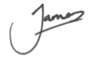
James Husbands
Headteacher

