**Class teachers**

**for September 2025**

* We are recruiting for a couple of positions
* 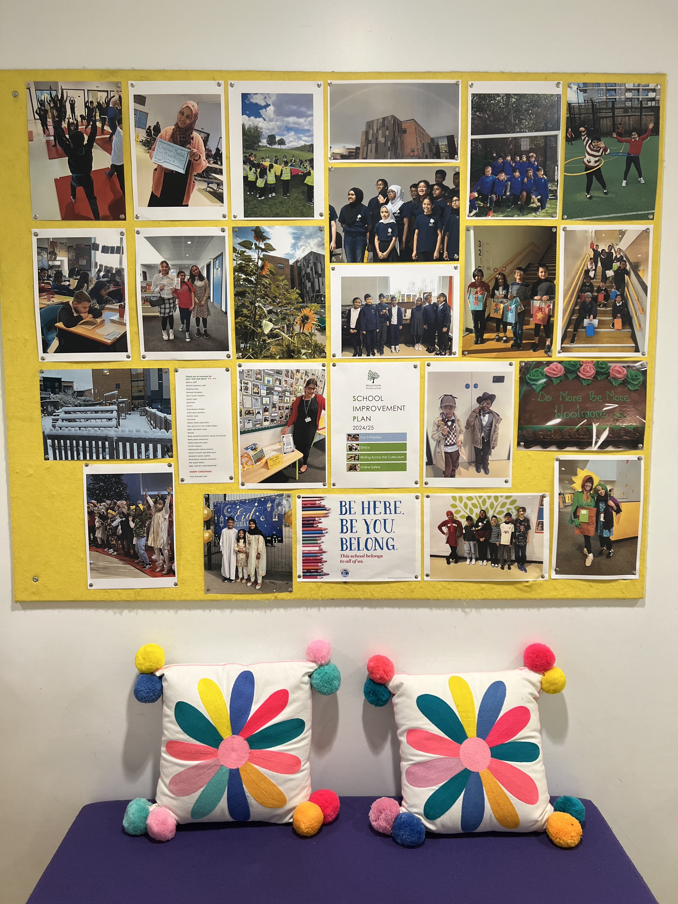Do you have what it takes to join our team next year?
* If so, take a look at our advert on the DfE website: <https://teaching-vacancies.service.gov.uk>
* Open to Early Career Teachers and teachers with experience.
* Closing date for applications: 4th June
* Interviews: week beginning 9th June
* We look forward to hearing from you



We are an equal opportunities employer, and we are committed to safeguarding and promoting the welfare of children and expect all staff to share this commitment. The post is subject to an enhanced DBS check.

Woolmore is committed to creating a diverse workforce. We’ll consider all qualified applicants for employment without regard to sex, race, religion, belief, sexual orientation, gender reassignment, pregnancy, maternity, age, disability, marriage or civil partnership.