

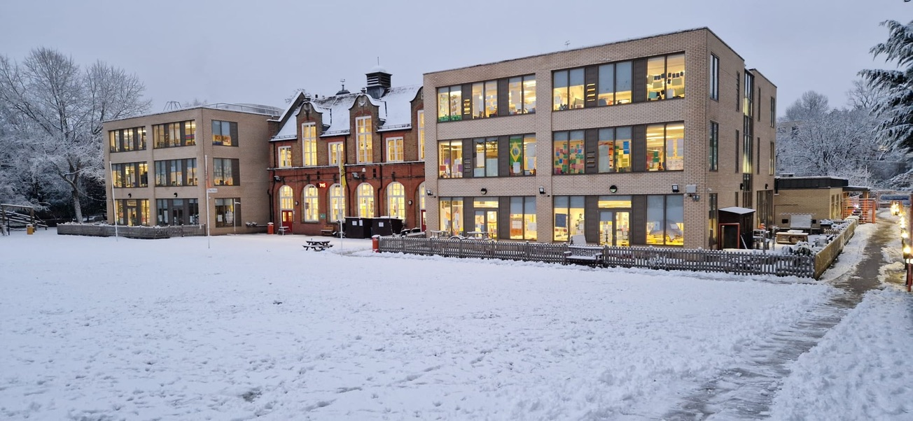

**Hitherfield**

**Primary School**

**INSPIRATIONAL TEACHERS REQUIRED**



**TO JOIN OUR SUCCESSFUL TEAM FROM 1st September 2024**

**We would like to appoint 2 Class Teachers**

**(Fixed Term – 1 Year Maternity / Sabbatical Cover**

**Main Scale or Early Career Teacher)**

Hitherfield is an excellent, popular and friendly London school close to transport links. We

genuinely believe in the development of the whole child and use our learning dispositions

to help children take ownership of their learning.

We are looking for teachers to make learning irresistible, inclusive and effective to ensure

our children continue to reach the highest standards. You will have a clear understanding

of effective learning and teaching and are willing to work in partnership with an excellent,

committed team of staff.

Experienced teachers and ECTs are welcome to apply for the post. Hitherfield has many opportunities for professional development and we are experienced in support and developing teachers at all stages of their careers. If you want to be part of a very happy, hardworking and committed team and you want to make a real difference to the life chances of our children, then Hitherfield is the school for you.

**Hitherfield can offer you:**

* **Bright, confident, well-behaved children who are eager to learn**
* **A forward thinking, research based and exciting school**
* **Motivated and happy colleagues who work closely as a team**
* **Stunning classrooms, excellent staff facilities, expansive play spaces, a field, a nature area and an Edible Playground.**
* **Supportive ICT technical staff and quality equipment across the school**
* **A commitment to your ongoing professional development**



We invite you to visit us, a warm welcome awaits you.

**For an application pack or to arrange a visit, please contact**

**Tammy Wallace on 020 8769 8428 or**

**email: recruitment@hitherfield.co.uk**

**Closing date: Friday 21st June 2024 at 9am**

**Lesson Observations and interviews w/c 24th June**

Headteacher: Mr Chris Ashley-Jones

Hitherfield Primary School

Leigham Vale, Streatham

London

SW16 2JQ

[www.hitherfield.co.uk](http://www.hitherfield.co.uk)

*We are committed to safeguarding and promoting the*

*welfare of children and expect all staff and volunteers to*

*share this commitment. This post is subject to an*

*enhanced DBS check.*