Consent to Obtain References Form
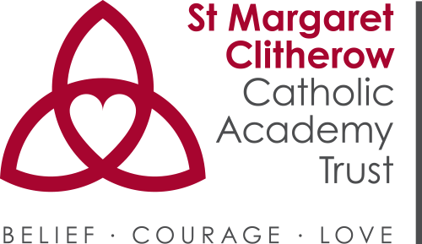

It is the responsibility of all Applicants to ensure that all named referees have consented to providing a reference. In accordance with Keeping Children Safe in Education (2018) we will obtain and scrutinise references prior to interview and referees will be contacted to provide clarification as appropriate. All information provided by referees will also be compared, for consistency, with the information Applicants have provided on their application form with the intention that questions will be asked during interview if there are discrepancies.
Referees will be asked to verify the contents of an Applicant’s application form (where they are relevant) and will also be asked for information about:
- All disciplinary offences (including those where the penalty is “time expired” if related to children; and
- All child protection allegations including the outcome of any child protection investigations.
We will also ask about an Applicant’s performance history including details of any capability concerns (including attendance issues).

Request for your consent
In compliance with the General Data Protection Regulation (GDPR), we wish to ensure you are aware of the purpose for which we are requesting your consent to collect and process the data we will be asking for when we contact your referees.

Important information regarding your consent
- We are St Margaret Clitherow Catholic Academy Trust the data controller.

- Being a Catholic education provider, we work closely with the school’s / academy’s Diocesan Authority, the school’s / academy’s Trustees, the Local Authorities, the Department for Education, and the Catholic Education Service with whom we may share the information you provide on this application form if we consider it is necessary in order to fulfil our functions.

- The person responsible for data protection within our organisation is the data protection officer and you can contact them with any questions relating to our handling of your data. You can contact them at hr@smccat.org.uk

- We require the information we have requested on this form in order to process your application for employment.

- To the extent that you have shared any special categories of personal data this will not be shared with any third party except as detailed in paragraph 2 above, unless a legal obligation should arise.

- If your application is successful, the information you have provided on this form will become part of your personnel file which shall be retained throughout the duration of your employment within our organisation and afterwards in accordance with our data retention policy.

- If you are unsuccessful, your application form and any documents you have submitted in support of your application will be destroyed after a period of 6 months.

- We will keep a record of your consent as evidence that we have obtained your consent to collect and process the data you have provided on this application form.

- You have the right to withdraw your consent at any time and can do so by informing our organisation’s Data Protection Officer (see paragraph 3 above) that you wish to withdraw your consent.

- To read about your individual rights you can refer to our fair processing notice and data protection policies.

- If you wish to complain about how we have collected and processed the information you have provided on this form, you can make a complaint to our organisation St Margaret Clitherow Catholic Academy Trust complaints procedure. If you are unhappy with how your complaint has been handled you can contact the Information Commissioner’s Office via their website at www.ico.org.uk.

Request for your consent
Please ensure that you read paragraphs 1-11 above and raise any relevant questions before providing your consent below:
- I confirm that I have read and understood paragraphs 1-11 above and that I have been offered the opportunity to raise any relevant questions: Yes ☐ No ☐
- Please check this box if you have any objection to our collecting and processing your personal information as described in paragraphs 1-11 above ☐
- I agree to my personal data being shared as stated in paragraphs 2 and 5 above: Yes ☐ No ☐

Name:
Click or tap here to enter text.

Signature: | Date:  Click or tap to enter a date.

Article 9(1) GDPR sets out the special categories of personal data as follows: “personal data revealing racial or ethnic origin, political opinions, religious or philosophical beliefs, or trade union membership, and the processing of genetic data, biometric data for the purpose of uniquely identifying a natural person, data concerning health or data concerning a natural person’s sex life or sexual orientation….”

