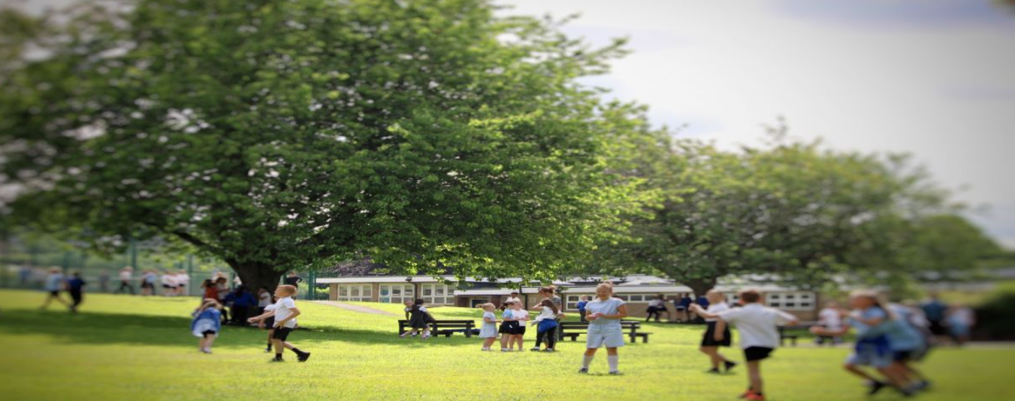
Job Application Pack

Beaufort Primary School

Year 3 Class Teacher
Start date: 1st January 2026
Part time or Full time Temporary contract until August 31st 2026
Salary: MPS1 – MPS6

Closing Date: Monday 20th October 2025
Interview Date: Thursday 23rd October 2025

Beaufort Primary School
‘BRAVE’
Brilliant Beaufort Minds, Respectful Relationships, Amazing Attitudes, Varying Vocabulary, Everyone is Equal

Welcome letter from Kate Beecroft, Head Teacher of Beaufort Primary School

Dear Candidate,
Thank you for showing an interest in the role of Year 3 Class Teacher at our school. An exciting opportunity has arisen for a strong candidate to make a difference to our pupils at Beaufort Primary School in Derby. We are looking for a creative teacher who is dynamic and can cope with the occasional bump in the road!

We are looking for a candidate who will strengthen the team, who has good communication skills and will have our children’s best interests at heart.

Our school is part of the Odyssey Collaborative Trust. Our Trust is committed to supporting and delivering education of the highest quality across the trust. Here at Odyssey, we share one vision; ‘Our Children Thrive - Our Colleagues Thrive - Our community Thrives.’

Each of our academies is unique and has their own values to provide our children with the opportunities they deserve. At Beaufort our values are based on our ‘BRAVE’ Curriculum: Brilliant Beaufort Minds, Respectful Relationships, Amazing Attitudes, Varying Vocabulary, Everyone is Equal.

This is a tremendous opportunity to make a difference and to be part of a dynamic and innovative staff team.

We look forward to receiving your application and working with you on your own professional journey to excellence.

Best regards,


Kate Beecroft
Headteacher
Beaufort Primary School

Beaufort Primary School
‘BRAVE’
Brilliant Beaufort Minds, Respectful Relationships, Amazing Attitudes, Varying Vocabulary, Everyone is Equal

About the school

At Beaufort Primary School our vision is for every child to become a successful, independent, resilient, lifelong learner and a responsible member of the community, who can achieve and grow in a nurturing and creative environment prepared for our ever-changing world.

The strong sense of a learning community; working together and caring about each other, is felt throughout the school and leads to a commitment by all members to recognise the importance of having a positive impact on their school, local community and beyond.

The aims provide the overall direction in which Beaufort Primary School wishes to move and provide the essential context within which our school vision can develop the curriculum and the ethos of the school can be achieved. They are built on the values and vision and summarise how the vision can be realised.

We develop positive learning relationships with our children and recognise the importance of this. We are proud of our children, staff and school.

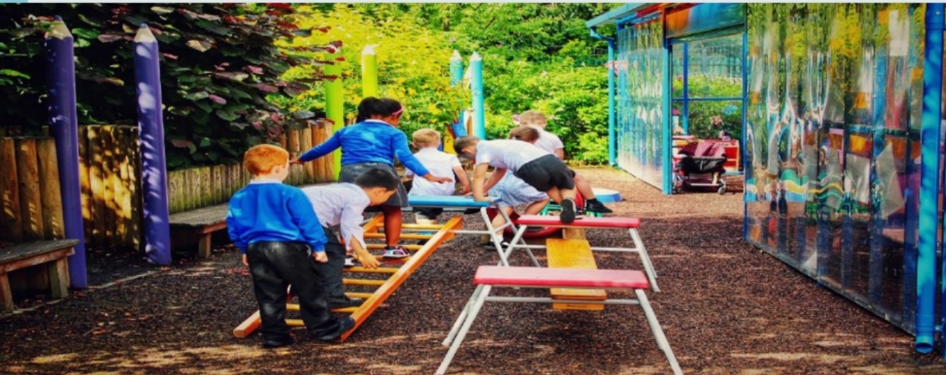

Job Description – Year 3 Class Teacher
Application Details
We are looking for an enthusiastic Year 3 Class Teacher to join our team here at Beaufort Primary School. We need ambitious and driven candidates with a passion for helping children learn effectively. Everyone who visits our school comments on the calm atmosphere, the enthusiasm our children have for learning and the great sense of team amongst staff and children alike.

At Beaufort we value every individual and put our children at the heart of everything we do. If you think this sounds like you then come and visit us to see for yourself. Visits are positively encouraged. Please phone or email to arrange a mutually convenient appointment. Find out if we’re right for you! Contact Ms. Stephanie Baird on 01332 347275 or email s.baird@beaufort.odysseyct.org.uk

Odyssey Collaborative Trust is committed to safeguarding and promoting the welfare of children. We follow safer recruitment procedures and will require an enhanced DBS clearance and references from current and past employers. Further details of this post, the school and the Trust are included in this pack and details of how to apply can be found below.

How to Apply
Should you wish to apply for the post, please complete and return an application form along with a covering letter addressed to Mrs. Kate Beecroft at Beaufort Primary School which clearly demonstrates your suitability for this role. Applications can be submitted via email to s.baird@beaufort.odysseyct.org.uk, or by post, for the attention of Stephanie Baird, to the following address: Beaufort Community Primary School, Hampshire Road, Chaddesden, Derby, DE21 6BT.

Wherever possible, please provide work email addresses for your referees.

Closing Date
Please ensure your application form arrives by 10.30am on Monday 20th October 2025.
Interviews for the role will be held Thursday 23rd October 2025.
Our privacy notice can be found at https://www.odysseyct.org.uk/gdpr/

Beaufort Primary School is committed to safeguarding and promoting the welfare of children and young people, and expects all staff and volunteers to share this commitment. As this post is regulated activity, successful appointments are subject to an enhanced Disclosure and Barring Service check and relevant recruitment checks that comply with guidance in the most recent version of Keeping Children Safe in Education.
We are committed to equality of opportunity in employment and services
Beaufort Primary School is part of the Odyssey Collaborative Trust

All members of staff will receive training in line with our Safeguarding and Child Protection Policy.

Equal Opportunities
Odyssey Collaborative Trust welcomes applications from everyone and values diversity in our workplace. A commitment to promoting diversity and developing a workplace environment where all staff are treated with dignity and respect is central to our recruitment process.

In addition to the current responsibilities as set out in the Conditions of Employment
of Teachers the successful candidate is to be responsible for the following:

Main Duties and Responsibilities
- Being a committed, enthusiastic, energetic and imaginative class teacher, organising and planning classroom practice to reflect the aims and objectives of the school
- Being familiar with the national curriculum and ensuring the continuity of a broad and balanced curriculum.
- Planning teaching to achieve progression in pupils’ learning through:
  - identifying clear teaching objectives and specifying how they will be taught and assessed;
  - setting tasks which challenge pupils and ensure high levels of interest;
  - setting appropriate and demanding expectations;
  - setting clear targets, building on prior attainment;
  - identifying SEND or very able pupils;
- Planning opportunities to contribute to pupils’ personal, spiritual, moral, social and cultural development.
- Providing clear structures for lessons, maintaining pace, motivation and challenge and evaluating their own teaching critically to improve effectiveness.
- Setting high expectations for pupils’ behaviour, establishing and maintaining a good standard of discipline through well-focused teaching and through positive and productive relationships.
- Establishing a secure environment which supports learning and in which pupils feel safe and confident.
- Providing a lively and stimulating environment and an attractive classroom setting, including displays of children’s work and informative materials.
- Ensuring there is a safe working and learning environment for all pupils in his/her class where risks are properly assessed.
- Using teaching methods which sustain the momentum of pupils’ work and keep all pupils engaged through:
  - stimulating intellectual curiosity, communicating enthusiasm for the subject being taught, fostering pupils’ enthusiasm and maintaining pupils’ motivation;
  - matching the approaches used to the subject matter and the pupils being taught;
  - effective questioning which matches the pace and direction of the lesson and ensures that pupils take part;
  - listening carefully to pupils, analysing their responses and responding constructively in order to take pupils’ learning forward;
  - selecting and making good use of learning resources which enable teaching objectives to be met;
  - setting high expectations for all pupils notwithstanding individual differences, including gender, and cultural and linguistic backgrounds;
  - encouraging pupils to communicate about and record their learning, develop self-control and independence, concentrate and persevere, and listen attentively;

- Make effective use of assessment to inform future planning for teaching and learning.
- Be able to effectively differentiate learning to meet the needs of all pupils
- Being actively involved, with the Headteacher and Deputy Headteacher, in the collection and analysis of data to support learning.
- Working with the SENCO to ensure that individual education plans are relevant and used effectively to support learners.
- Assessing how well learning objectives have been achieved and use them to improve specific aspects of teaching.
- Mark and monitor pupils work, give constructive feedback and share targets as required.
- Assess and record pupils progress systematically and keep records to check work is understood and completed, monitor strengths and weaknesses, inform planning and recognise the standard at which the pupil is achieving.
- Liaising with the other phase teachers, Teaching Assistants and other colleagues to ensure joint curriculum planning and implementation
- Lead on an area of the curriculum.
- Provide an extra-curricular club to be negotiated with Headteacher.
- Attending relevant CPD to ensure up to date knowledge.
- Being punctual for work and any supervisory duties.
- Attending to routine administrative matters promptly, and to be within time for agreed deadlines – e.g. class assemblies, reports, etc.
- In consultation with the Headteacher, being responsible for his/her own professional development and attending training in those areas identified at the annual Performance Management discussions.
- Operate at all times within the stated policies and practices of the school.
- Contribute to the corporate life of the school through effective participation in meetings and management systems necessary to coordinate the management of the school.
- Have a working knowledge of teachers’ professional duties and legal abilities.
- Take on any additional responsibilities which might from time to time be determined.

These above-mentioned duties are neither exclusive nor exhaustive, the post-holder maybe required to carry out other duties as required by the Trust.
As this job is designated as a ‘regulated activity’ an enhanced DBS with Barred list check is essential.

Person Specification

Post Title: Year 3 Class Teacher
Hours: Part time or Full time
Salary: MPS1 – MPS6

Person Specification – Class Teacher | Essential | Desirable
Qualifications & Experience
Proven ability as a good or outstanding classroom teacher | x
Experience in Primary Teaching | x
Qualified Teacher | x
Evidence of participation in professional development | x
Knowledge & Skills
A knowledge and understanding of a range of teaching styles. | x
An understanding of the importance of enhancing pupils’ self-esteem. | x
Knowledge and appreciation of current issues and developments in Education | x
Knowledge of what constitutes quality first teaching and learning | x
A clear understanding of behavior management | x
Communicate clearly both written and verbally | x
Praise and develop secure behavior management skills | x
Curriculum Skills
Very high expectations for the achievement of pupils, staff and themselves | x
The ability to monitor and evaluate the teaching and learning environment | x
A commitment to the improvement of educational standards and results within school | x
The ability to ensure tasks are completed on time and to seek advice when required | X
Be forward looking and be an effective member of the team | x
Appreciate the importance of extra-curricular activities |  | x
Specific Requirements
Demonstrate a well constructed high standard of application demonstrating grammar, spelling and punctuation | x
A clear understanding of primary learning and assessment | x
Ability to form positive relationship with pupils | x
Knowledge and experience in effective planning and use of assessment and recording | x
Evidence of engaging parents in the learning process |  | x
An understanding and positive attitude to children with SEND along with skills in making adaptations | X
Understanding the need to safeguard children and use robust procedures to protect and support them | X
Knowledge and commitment of Equal Opportunities | X
Have sensitivity to the diverse social and emotional needs of children | x
Personal qualities
Enthusiastic | X
Positive | X
Hardworking | X
Flexible | X
Decisive | X
Sensitive | X
Able to use their own initiative | X

