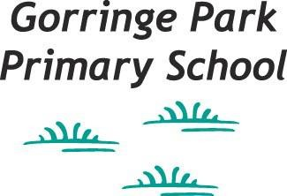

Person specification
Class Teacher Main Pay Scale
Candidates should provide evidence of the following.
Criteria | Qualities
Qualifications and experience | - Qualified teacher status and degree  - Successful primary teaching experience with good or outstanding in formal lesson observations  - Successful record of good to outstanding progress and attainment for all groups of children  - Recent relevant training
Skills and knowledge | - Thorough and up to date knowledge of all areas of the Primary Curriculum  - Detailed knowledge of effective teaching and learning strategies  - A deep understanding of how children learn  - Ability to adapt teaching to meet pupils’ needs  - Ability to build effective working relationships with pupils  - Knowledge of and familiarity with formative and summative assessment and record-keeping  - Experience of current tracking and assessment procedures  - Knowledge of guidance and requirements around safeguarding children  - Detailed knowledge of effective behaviour management strategies  - Experience of working with different educational resources including ICT equipment  - Knowledge and understanding of inclusion issues, including EAL, SEN, G&MA and gender issues etc.
Personal qualities | - A commitment to achieving the best outcomes for all pupils and promoting the ethos and values of the school  - High expectations for children’s attainment and progress  - Ability to work under pressure and prioritise effectively  - Commitment to maintaining confidentiality at all times  - Ability to work independently and within a team environment  - Commitment to safeguarding and equality  - The ability to reflect on professional practice and a commitment to personal professional development and supporting the development of a professional learning community within the school

