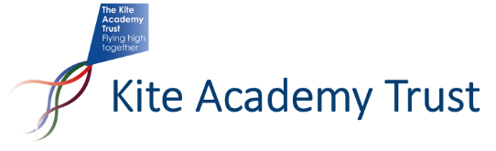
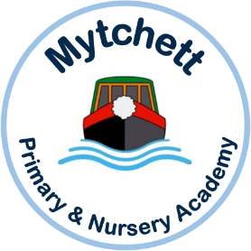
Mytchett Primary and Nursery Academy
is looking to recruit a permanent, part-time teacher, to be part of a dynamic job-share in Year 3.

Contract: 2.5 days/Permanent (Weds pm/Thurs/ Fri) – starting Jan 2023 or soon after.
At Mytchett you will find an amazing team of like-minded practitioners who believe in a pedagogy of learning through a creative, coherent curriculum, where key learning behaviours are nurtured and children flourish with opportunities to challenge themselves and learn from their mistakes. Our positive behaviour approach nurtures kindness and strong sense of community that form an umbrella overarching our Mytchett Heart Values. We have high expectations of everyone in TEAM Mytchett, adults and children alike and our inclusive philosophy means that everyone feels part of the team.

The Kite Academy Trust is a group of 10 Primary Academies, a mix of infant and through-primary, one and two-form entry. We have four nurseries and a specialist unit for children with Developmental Language Delay.
There are many benefits of working as teachers in a multi academy trust, including widely varied and quality CPD, team-working and greater opportunities for professional development and promotion within the organisation.
If you would like more information or would like to make an appointment to visit please contact the Headteacher, Mrs Sam Willans via email sam.willans@mytchett.kite.academy
Application packs are available via eteach or recruitment@kite.academy
Closing date for applications: Thursday 8th December 2022
Interviews to be held: Monday 12th December 2022

Suitable applicants may be interviewed sooner according to availability and the post filled prior to this date and so applicants are encouraged to apply as soon as possible.
The Kite Academy Trust is committed to safeguarding and promoting the welfare of children and expects all staff and volunteers to share this commitment. The successful candidate will be expected to undertake an enhanced DBS check.

