‘A happy school committed to excellence’

Class Teacher Y5 (maternity cover)
Required for February 2022
Recruitment Information Pack
Seamer and Irton Community Primary School
Denison Avenue, Seamer, Scarborough, YO12 4QX

Dear applicant,

Allow me to extend a warm welcome from all governors, staff and children of Seamer and Irton Community Primary School. I am delighted you have shown interest in joining us and hope to give you an insight into what an exciting and inspiring place our school is.

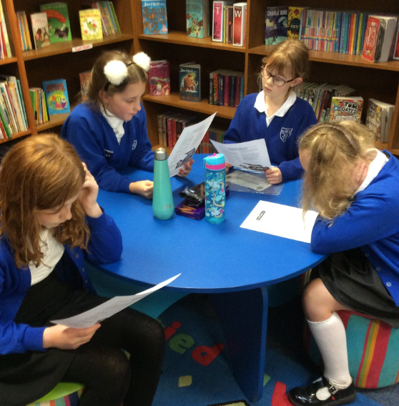
I am very proud of the pupils and the dedicated and enthusiastic staff who work so hard to provide a secure, happy and stimulating environment.

Considerable investment has gone into our learning environments and enrichment experiences, which include Forest Schools, Music, ICT and Sport.

All of this is driven by a desire to make our vision of a ‘happy school committed to excellence’ a reality, providing pupils with every opportunity to achieve their full potential and become confident, independent learners.

We are seeking to recruit a teacher to work as part of our Year 5 team and we are excited by the opportunity this appointment will bring to our school.

We are looking for a colleague who shares the same ethos and values, understands our community and can continue to provide the enthusiastic and inspirational teaching our pupils deserve.

I hope that you will take the time to come and see and experience for yourself the warm and welcoming atmosphere which makes our school such a special place to work.

Good luck with your application. I look forward to reading it.

Jonathan Wanless
Headteacher

Our aims and mission

Aims and Ethos: To create a happy school committed to excellence.
- We provide all pupils with every opportunity to achieve their full potential.
- We ensure a supportive, safe, friendly environment in which everyone is valued and respected.
- We expect the highest standards of work and behaviour.
- We offer every pupil full and equal access to all areas of the curriculum.
- We provide a broad and balanced curriculum for all our pupils, which values and celebrates their diverse backgrounds and needs.
- We promote pupil’s self-esteem and emotional wellbeing and help them to form and maintain worthwhile and satisfying relationships, based on respect for themselves and for others, at home, at school and in the wider world.
- We value all adults’ and pupils’ contributions to the school’s progress, and celebrate success and achievement in all areas of life
- We prepare each pupil for life beyond school, in a modern, global society.

Application Process

The closing date for all applications is 4pm on Monday 6 December 2021

Interviews will be held on Tuesday 14 December 2021

Completed applications must be returned to Mrs. Lisa More at lmore@seamerirton.n-yorks.sch.uk

If you think you’re the person for the job, please complete the North Yorkshire County Council application form with a covering letter, no more than two sides of A4, and send this back to Lisa (as above).

An email will be sent to shortlisted candidates with details of the interview process. If you have not heard from us within a week of the closing date, please assume your application has been unsuccessful.

Visits are warmly welcome. Please contact the school office to arrange.

For more information and to get an insight into our school please visit our website at www.seamerirtonprimary.co.uk and our twitter page @seamerirton

Job Description

Job title: KS2 class teacher
Salary: Teachers’ Pay and Conditions (MPS)
Hours: 1.0 FTE
Contract type: maternity cover

Duties and responsibilities
All teachers are required to carry out the duties of a school teacher as set out in the current School Teachers Pay and Conditions Document. Teachers should also have due regard to the Teacher Standards. Teachers’ performance will be assessed against the Teacher Standards as part of the appraisal process as relevant to their role in the school.

Teaching
• Plan and teach well-structured lessons to assigned classes, following the school’s plans, curriculum and schemes of work
• Assess, monitor, record and report on the learning needs, progress and achievements of assigned pupils, making accurate and productive use of assessment
• Adapt teaching to respond to the strengths and needs of pupils
• Set high expectations which inspire, motivate and challenge pupils
• Promote good progress and outcomes by pupils
• Demonstrate good subject and curriculum knowledge
• Participate in arrangements for preparing pupils for external tests (where applicable)

Safeguarding and promoting the welfare of the child
- Be responsible for promoting and safeguarding the welfare of children and young people that you are responsible for and come into contact with.
- Be aware of and comply with policies and procedures relating to child protection, health, safety and security.
- Be able to recognise when a child or young person is in danger or at risk of harm, and take action to protect them.
- Have an awareness and basic knowledge of the most recent legislation.

Professional development
• Take part in the school’s appraisal procedures
• Take part in further training and development in order to improve own teaching
• Where appropriate, take part in the appraisal and professional development of others

Communication
• Communicate effectively with pupils, parents and carers

Working with colleagues and other relevant professionals
• Collaborate and work with colleagues and other relevant professionals within and beyond the school
• Develop effective professional relationships with colleagues

Personal and professional conduct
• Uphold public trust in the profession and maintain high standards of ethics and behaviour, within and outside school
• Have proper and professional regard for the ethos, policies and practices of the school, and maintain high standards of attendance and punctuality

Management of staff and resources
• Direct and supervise support staff assigned to you, and where appropriate, other teachers
• Deploy resources delegated to you

Notes: This job description may be amended at any time in consultation with the post holder. The job description is illustrative of the general nature and level of responsibility of the role. It is not a comprehensive list of all tasks that the teacher will carry out. The post holder may be required to do other duties appropriate to the level of the role, as directed by the Headteacher or line manager.

We are committed to safeguarding and promoting the welfare of children and young people and expect all staff and volunteers to share this commitment.

This post is exempt from the Rehabilitation of Offenders Act (1974) and the appointment is subject to a satisfactory enhanced level disclosure and S128 clearance from the Disclosure & Barring Service (DBS).

Person Specification
Qualifications
- Qualified teacher status or recognised equivalent

Experience
- Recent experience of working successfully in KS2.
- Experience of working positively and closely with staff, parents and guardians

Professional Skills and Knowledge
- Excellent classroom practitioner
- Thorough knowledge of teaching, learning and curriculum in primary schools
- Detailed knowledge of the National Curriculum, including planning and delivery
- High level of oral and written communication skills and ability to communicate with a wide range of audiences
- Evidence of ability to maintain high standards of behaviour and develop attitudes of care, control and cooperation
- Ability to relate to and empathise with pupils and to build trusting relationships with them
- Secure understanding of effective safeguarding practices

Personal Qualities
- The ability to provide enthusiastic and inspirational class teaching
- The ability to work effectively as part of a team, relating well to colleagues, pupils and parents
- Ability to exercise discretion and judgement

Other Requirements
- To be committed to the school’s policies and ethos
- To be committed to continuing professional development
- Evidence of recent and relevant training
- Well-motivated to work with children and young people
- A commitment to abide by and promote equal opportunities, health and safety and child protection policies

