Class Teacher Application Pack
Contents
Letter from Catherine Paine, Chief Executive Designate 3
Our Cornerstones and Touchstones 4
The role 5
The application 6
The application process and timetable 6
Safeguarding, Safer Recruitment and Data Protection 7

Letter from Catherine Paine, Chief Executive Designate

Dear Candidate
Thank you for your interest in this role within the REAch2 Academy Trust.
This is a hugely exciting time for our family of schools. The Trust has been recognised by the Department for Education as being well placed to raise standards and achieve excellence for pupils in a growing number of schools nationwide. We are presented with a rare opportunity to make a real difference to the lives and life chances of so many primary school children – many of whom haven’t previously received the educational opportunities they deserve.
The Trust includes schools at all stages of development, from those requiring significant improvement through to existing outstanding schools. As a Trust we are clear about the importance of achieving long term sustainability for our schools. Our vision is to enable individual academies to flourish with real autonomy, whilst also ensuring a strong ethos of support and collaboration across our schools.
Employees within REAch2 belong to a national community of professionals, and benefit from a wide range of networks and development opportunities across the Trust. In time, our best teachers are able to work across schools, develop specialisms and step up to leadership roles within and beyond their own academy. The Trust provides a strong culture of collaboration and support, together with high expectations for staff and pupils alike.
Those we recruit are able to demonstrate that they share our values, are highly motivated to work with colleagues within and beyond their school to continuously develop their skills and pursue professional excellence and are committed to providing the highest standards of teaching for all children. If that is you then we would be delighted to receive your application.
Catherine Paine

Chief Executive Designate, REAch2 Academy Trust

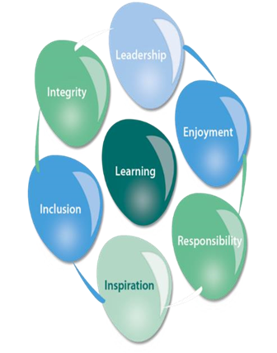
Our Cornerstones and Touchstones
REAch2 is the Cornerstone of the Trust: providing a strong, responsible foundation from which every academy develops and grows. A cornerstone provides a subtle yet paramount role in the construction of a building and ensures that REAch2 is a trustworthy, accountable and inspirational organisation, delivering the best possible learning experience.
REAch2 is defined by the values of excellence, quality, delivery and standards – these features give the Trust its enduring attributes and its inherent reliability.
However, what gives each REAch2 Academy its uniqueness are the Touchstones of the Trust (seen on the right). Just as 500 years ago touchstones were used to test the quality of the gold they marked, so too our touchstones find what is precious and set these things apart. They are used to express the values and ethos of the Trust and describe what the Trust wants to be known for and how it wishes to operate.
With good leadership, we aspire to develop children academically, emotionally, physically and spiritually. We notice talent and spot the ‘possible’ in people as well as the ‘actual’. Developing potential across our Trust becomes a realisation that there is a future worth pursuing for everyone.
Children deserve enjoyment in their learning and the pleasure that comes from absorption in a task and achieving their goals. Providing contexts for learning which are relevant, motivating and engaging, release in children their natural curiosity, fun and determination.
Inspiration breathes energy and intent into our schools: through influential experiences, children can believe that no mountain is too high and that nothing is impossible.
REAch2 serves a wide range of communities across the country and we celebrate the economic, social, cultural and religious diversity that this brings: embracing inclusion ensures that we are a Trust that serves all, believing that everyone can succeed.
We take our responsibility seriously. We act judiciously with control and care. We don’t make excuses, but mindfully answer for our actions and continually seek to make improvements.
REAch2 is a Trust that has a strong moral purpose, our integrity is paramount. Our mission is to change children's lives by providing the very best quality education we can. Through this, children can fulfil their potential, become happy, successful adults and contribute effectively and meaningfully to society. We welcome the fact that all our decisions and actions are open to scrutiny. You can learn more about REAch2 at our website: www.reach2.org

The role
Class Teacher at The Palmer Academy

The Palmer Academy is currently recruiting to the role of class teacher. Duties include:

- Be responsible for the quality of teaching and learning of all pupils who are assigned to the post-holder.
- Contribute to a positive ethos in which all pupils have access to a broad, balanced and relevant curriculum.
- Supervise the work of any support staff, including higher level teaching assistants and support teachers, who are assigned to work with the post-holder’s pupils.
- Provide leadership across the school in a designated subject or curriculum area (except Newly Qualified Teachers), which will include:
- monitoring quality and standards
- contributing to school planning and self-evaluation
- providing professional support to other teachers and support staff
- advising the headteacher on appropriate resources and materials
- leading appropriate professional development.

All teachers work within the statutory conditions of employment set out in the current School Teachers’ Pay and Conditions Document. The duties listed below are not, therefore, an exhaustive list of what is required.

The full job description is set out below.

The application

To arrange an informal discussion about this role and a virtual or on-site tour please contact the school office who will schedule a discussion with Miss Libby Thomassen (Deputy Headteacher).

Visits to The Palmer Academy are encouraged. You will be informed of risk protocols for on-site tours, but they include: wearing of a mask, washing and sanitising of hands and maintaining social distance.

You are invited to submit a completed application form to Mr Dom Prendergast (Headteacher) via recruitment@thepalmeracademy.com

In accordance with our Child Protection and Safeguarding Policy the successful candidate will be required to have an enhanced DBS check with Child Barred List check.

The application process and timetable
Application deadline: | Applications will be considered on submission
School visits: | Virtual or on site tour and informal discussion times:
Selection exercises: | These will take place the week commencing:  - Teaching element  - Tasks linked to the role of the teacher  - An interview
.Contract details: | Permanent
Salary: | Main Pay Scale or Upper Pay Scale
Start date: | ASAP

The candidates selected for interview will be informed after shortlisting and full details of the interview/selection programme will be provided.

Safeguarding, Safer Recruitment and Data Protection

At REAch2 we recognise that academies and academy personnel are in a unique position in their care of children. The responsibility for all staff to safeguard pupils and promote their welfare, as stated in Section 175 of the Education Act (2002) is one that is central to our ethos, our policies and our actions. All children are deserving of the highest levels of care and safeguarding, regardless of their individual characteristics or circumstances, and we are committed to applying our policies to ensure effective levels of safeguarding and care are afforded to all of our pupils.

We have a principle of open competition in our approach to recruitment and will seek to recruit the best applicant for the job. The recruitment and selection process aims to ensure the identification of the person best suited to the job based on the applicant’s abilities, qualifications, experience and merit as measured against the job description and person specification. The recruitment and selection of staff will be conducted in a professional, timely and responsive manner and in compliance with current employment legislation, and relevant safeguarding legislation and statutory guidance.

All information is stored securely and any information supplied by unsuccessful candidates will be destroyed through a confidential waste system after six months from notifying unsuccessful candidates, in accordance with our information and records retention policy.

The Trust ensures all applicant data is stored and processed appropriately. For further details on how your details will be managed during the recruitment process please refer to our Privacy Notice for Job Applications.

Class Teacher (EYFS/Key Stage 1/Key Stage 2)
Job Description
Pay Scale/Grade: | Main/Upper Pay Scale
Reports to: | Phase Leader/SLT
Liaison with: | Teaching Staff, Support Staff, Staff in other phases, Headteacher, Senior Leadership Team, Pupils, Parents/Carers

To deliver high quality teaching and learning to pupils who are assigned to the post-holder.
2. ACCOUNTABILITY
Class teachers are directly responsible and accountable to the Headteacher and the Deputy Headteacher.
3. MAIN DUTIES
All teachers work within the statutory conditions of employment set out in the current School Teachers’ Pay and Conditions Document. The duties listed below are not, therefore, an exhaustive list of what is required.
- Be responsible for the quality of teaching and learning of all pupils who are assigned to the post-holder.
- Contribute to a positive ethos in which all pupils have access to a broad, balanced and relevant curriculum.
- Supervise the work of any support staff, including higher level teaching assistants and support teachers, who are assigned to work with the post-holder’s pupils.
- Provide leadership across the school in a designated subject or curriculum area (except Newly Qualified Teachers), which will include:
- monitoring quality and standards
- contributing to school planning and self-evaluation
- providing professional support to other teachers and support staff
- advising the headteacher on appropriate resources and materials
- leading appropriate professional development.

4. ESSENTIAL ACTIVITIES
- To plan, prepare, organise, monitor and evaluate programmes of work and methods of record keeping.
- To provide an exciting, challenging, welcoming, secure and varied learning environment with opportunities to engage in individual and group problem-solving wherever appropriate, in a cross-curricular way, using a variety of teaching approaches and activities to suit learner’s different learning styles.
- To teach the children according to their individual educational and developmental needs.
- To have regard for children with learning difficulties, working closely with the academy’s SENCo and Designated Safeguarding Lead and Deputy Designated Safeguarding Leads.
- To promote the diversity of our academy community.
- To assess and report on the development, progress and attainment of learners.
- Analyse and interpret relevant school, local and national data relating to their own class and advise the SLT on the level of resources required to maximise achievement.
- To support and promote continuity and experience in learning.
- To be responsible for the welfare of the children in your own class in particular and the whole school generally.
- To encourage children to be self-motivated and take a pride in themselves, their achievements, and those of their peers.
- To support the academy’s Behaviour Policy at all times.
- To be familiar with new initiatives.
- To ensure files and records are available at all times in school and submitted for monitoring when required.
- To work as part of a cohesive team.
- To direct and monitor the work of other adults within the classroom team.
- To bear constantly in mind our agreed aims, Academy Development Plan, policies and classroom code of practice in all planning and activities.
- To keep a tidy and well-organised classroom environment.
- To welcome visitors into your classroom.
- To ensure that your physical areas of responsibility are well cared for, and well maintained.
- To take part in regular INSET and continuing professional development (as necessary)
- To attend weekly staff professional development meetings (PDMs) and, when required, year group or key stage/phase meetings.
- To take part in Performance Appraisal according to academy policy.
- To be responsible for curriculum areas throughout the academy as necessary depending on experience.
- To carry out any other reasonable duties which may be required by the Headteacher which are within the terms of the contract.

5. ORGANISATION CHART
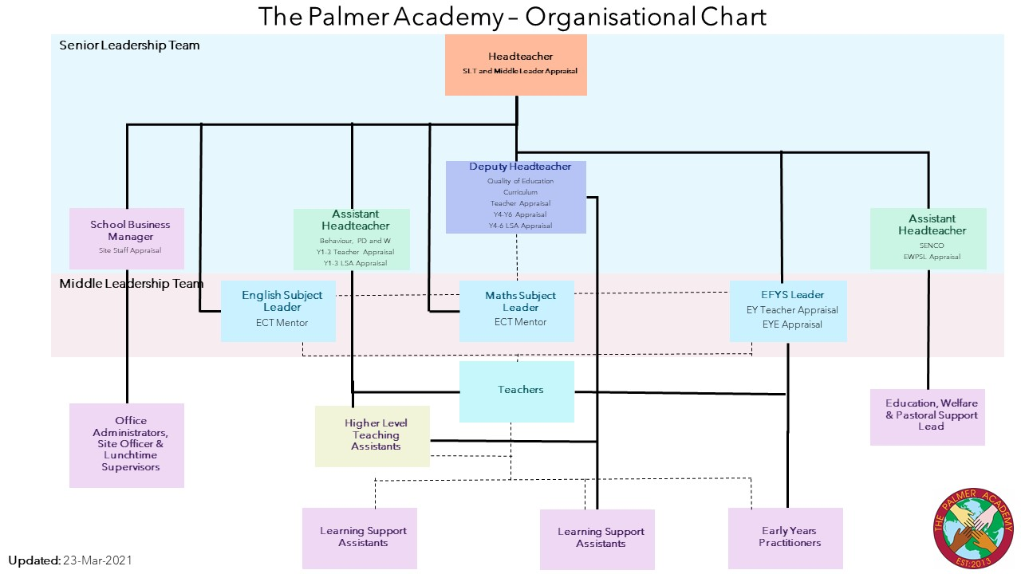
6. SUPERVISION
The jobholder is managed by the SLT for their key stage/phase.
The jobholder oversees the day-to-day direction and management of support staff that they work with.

7. JOB CONTEXT
The school welcomes teachers of high professional standard and shares the responsibility with each teacher for continual review and the development of expertise.
All teachers make a valuable contribution to the school’s development and, therefore, to the progress of all pupils. All teachers except those who are newly qualified, will have a lead responsibility for a curriculum area across the whole school and will be supported in that role by their line manager.
For newly qualified teachers, subject leadership will be taken by his/her line manager during the first year of employment at the school.
Teachers in the upper pay scale can be expected to make a particular contribution to building team commitment in line with the statutory requirement to meet threshold standards.
In particular, teachers at UP1-3 will:
- provide a role model for professional practice in the school
- make a distinctive contribution compared with other teachers
- contribute effectively to the wider team.

8. COMMUNICATION
- Headteacher
- SLT and Phase Leaders
- Governors
- All staff within academy
- Parents, children and families
- Visiting professionals
- Members of the local community

9. JOB ENTITLEMENTS
- 10% release time for Planning, Preparation and Assessment.
- Access to training and staff development according to personal development needs and the needs of the academy
- High quality whole-school INSET
- Annual Performance Appraisal and reviews

10. ADDITIONAL INFORMATION
The jobholder is required to contribute to and support the overall aims and ethos of the academy.
All staff are required to participate in training and other learning activities, and in performance management and development, as required by the school's policies and practice.
11. REVIEW OF DUTIES
The specific duties attached to any member of staff are subject to annual review and may, after discussion, be changed. The post-holder is expected to perform reasonable duties requested by the Headteacher or Deputy Headteacher from time to time, commensurate with experience, role and salary.

Signed colleague ……………………………………………………………. Date ……………………………..

Signed Headteacher ………………………………………………………….. Date …………………………….

Class Teacher (EYFS/Key Stage 1/Key Stage 2)
Person Specification
Pay Scale/Grade: | Main/Upper Pay Scale
Reports to: | Phase Leader/SLT
Liaison with: | Teaching Staff, Support Staff, Staff in other phases, Headteacher, Senior Leadership Team, Pupils, Parents/Carers

The selection decisions will be based on the criteria outlined below. At each stage of the process, an assessment will be made by the appointment panel to determine the extent to which the criteria have been met.

When completing your covering letter, application form and person specification form, you should ensure that you address each of the selection criteria and provide supporting evidence of how you meet the criteria through reference to work or other relevant experience.
 |  | Essential | Desirable
Qualifications | Qualified Teacher Status (QTS) – may be pending | ü
 | Degree or equivalent | ü
 | Evidence of additional qualifications suitable to teaching role |  | ü
Experience | Teaching or placements within the primary age phase | ü
 | Experience of teaching or placements in different phases |  | ü
 | Subject Leadership experience in the primary phase |  | ü
 | Experience of communicating effectively with parents and carers |  | ü
 | The willingness and ability to move between key stages EYFS/KS1/KS2 if required |  | ü
Knowledge and understanding | The monitoring, assessment for learning, recording and reporting of pupils’ progress | ü
 | The theory and practice of providing effectively for the individual needs of all children (e.g. classroom organisation and learning strategies) | ü
 | The National Curriculum and/or Early Years Foundation Stage Curriculum | ü
 | Knowledge of the statutory requirements of legislation concerning Equal Opportunities, Health & Safety, SEND and Child Protection | ü
 | The positive links necessary within school and with all its stakeholders | ü
 | A range of effective teaching and learning styles | ü
 | Experience of implementing creative cross curricular teaching |  | ü
Skills and abilities | Be able to demonstrate good or outstanding classroom practice and articulate what constitutes effective teaching and learning | ü
 | Promote the school’s aims positively, and use effective strategies to monitor motivation and morale | ü
 | Good communication | ü
 | Ability to work effectively as part of a team of staff. | ü
 | Ability to inspire, lead and motivate children and staff | ü
 | Good organisational and time-management skill | ü
 | Demonstrate a positive and professional attitude at all times | ü
 | Commitment to extra-curricular activities |  | ü
 | Establish and develop close relationships with parents, governors and the community | ü
 | Experience of using an interactive whiteboard and ICT applications to enhance learning | ü
 | Create a happy, challenging and effective learning environment |  | ü
 | Knowledge of the use of iPads and other wireless technology to enhance learning |  | ü
 | Be able to lead a core subject area of the curriculum across the school through subject leadership |  | ü
 | Promote and deliver the academy’s values and ethos | ü
Personal qualities | A team player | ü
 | Approachable | ü
 | Committed | ü
 | Good interpersonal skills | ü
Safeguarding | Evidence of being proactive in child protection issues and having strong commitment to protecting children | ü
 | Understands legislation and guidance on keeping children and members of the school community safe |  | ü
Note to applicants:
This school is committed to safeguarding and promoting the welfare of children and young people and expects all staff to share this commitment.

