

Moordown St John’s CE Primary School

Policy for
Equality

“A Christian community where commitment to
educational excellence changes lives”

The Board of Directors of Moordown St. Johns CE Primary School ratified this policy on 19 January 2023

Review Date: January 2027

A copy of this policy in an alternative format, such as large print or different language,
may be provided on request from the school office.

POLICY FOR EQUALITY


Our Ethos and Vision
‘A Christian Community where commitment to educational excellence changes lives’
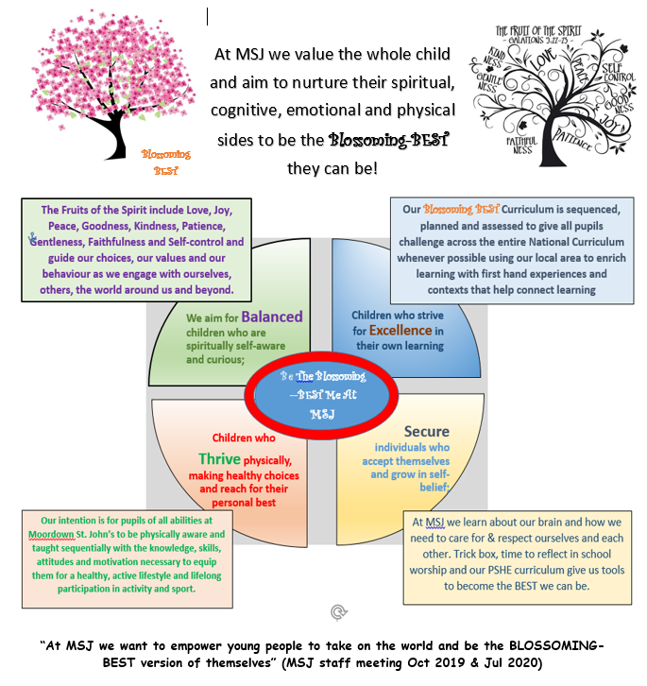

This policy supports these important aims.

Introduction
This policy is closely linked to the school’s Inclusion Policy. It has been informed by the current relevant legislation, including the Equality Act 2010, and by the school’s aims, and in turn, it informs all other policies and should therefore be read in conjunction with these policies.
The Equality Act 2010 replaces nine major acts of parliament and almost one hundred sets of legislation. It provides a single, consolidated source of discrimination law. It simplifies the law and it extends protection from discrimination in some areas. The act defines four kinds of unlawful behaviour – direct discrimination, indirect discrimination, harassment and victimisation. As a school, we welcome our duties under the Equality Act 2010. The general duties are to eliminate discrimination; to advance equality of opportunity and to foster good relationships.
Moordown St Johns is an inclusive school where we focus on the well being and progress of every child and where all members of our community are of equal worth. We endeavour to make the school a welcoming place and show acceptance of others. As a Church of England School we recognise this policy is set within the context of Christian belief and practice. This means that all people within our school community are treated with respect as children of God.
Principles
Our approach to equality is based on the following 8 key principles

1.All learners are of equal value. We value all learners whether or not they are disabled, whatever their ethnicity, culture, national origin or national status, whatever their gender and gender identity, whatever their religious or non-religious affiliation or faith background and whatever their sexual orientation.
2.We recognise, respect and value difference and understand that diversity is a strength. We take account of differences and strive to remove existing inequalities and barriers and disadvantages which people may face, in relation to age, disability, ethnicity, gender, religion, belief or faith, marriage/civil partnership status and sexual orientation. We believe that diversity is a strength, which should be respected and celebrated by all those who learn, teach and visit our school.
3.We foster positive attitudes and relationships. We actively promote positive attitudes and mutual respect between groups and communities different from each other.
4.We foster a shared sense of cohesion and belonging. We want all members of our school community to feel a sense of belonging within the school and wider community and to feel that they are respected and able to participate fully in school life.
5.We observe good equalities practice for our staff. We ensure that policies and procedures benefit all employees and potential employees in all aspects of their work, including in recruitment and promotion, and in continuing professional development
6.We have the highest expectations of all our children. We expect that all pupils can make good progress and achieve to their highest potential
7.We work to raise standards for all pupils, but especially for the most vulnerable. We believe that improving the quality of education for the most vulnerable groups of pupils raises standards across the whole school.

Celebrating Diversity
Admissions to the school are governed by the school’s admissions policy which is applied impartially.
It is the right of all pupils to receive the best education that the school can provide, with access to all educational or recreational activities organised by the school.
This school will not tolerate any harassment or victimisation related to a protected characteristic. This is true whether it relates to the child themselves or another person with whom the child is associated. The protected characteristics as outlined in the Equality Act 2010 are:
- Sex/gender
- Race (includes colour, nationality and ethnic or national origins)
- Disability*
- Religion or belief
- Sexual orientation
- Pregnancy or maternity
(*definition – when a person has a physical or mental impairment which has a substantial and long term adverse effect on that person’s ability to carry out normal everyday activities.)
Staff are additionally protected from discrimination under these protected characteristics - age, marriage/civil partnership and those undergoing gender reassignment.
Should an incident of discrimination occur we will act immediately to prevent any repetition of the incident. Any act of discrimination will be dealt with through application of the school’s behaviour policy or anti bullying policy - recorded and copied, retained in the school and by the Local Authority. Graffiti or other displays of a discriminatory nature will be removed immediately and the perpetrator, if known, will be disciplined.
We actively promote an understanding of, and respect for, diversity through the curriculum topics studied by the children, which are often reflected in the displays and work shown throughout the school.
Although the content of the curriculum is not caught by discrimination law, we aim to ensure that our curriculum reflects the attitudes, values and respect that we have for minority ethnic groups. For example:
- History and Geography lessons give due emphasis to differing traditions and cultures
- Religious Education curriculum gives children a sensitive appreciation of other faiths and people of no faith
- Disability is a theme explored through class and school worship and in PSHE lessons, providing an awareness of the impact of prejudice
- Children are invited to attend collective worship, which will focus on the Christian faith in line with our Church of England school status. Parents can opt for their children not to attend this collective worship
Should any member of the school community consider themselves to be a victim of discrimination, we will do all that we can to support that person in overcoming any difficulties they may have.
This school will ensure that all employees abide by the public sector Equality Duty. This means eliminating discrimination, advancing equality of opportunity and promoting good relations between people with different protected characteristics.

Data Collection
In order to meet our duties under the Equality Act 2010 we publish equality information and analyse data at a level that allows us to compare the performance of different groups. However, we do not publish any information that allows any individual children to be identified. Additionally, we prepare and publish equality objectives.
In order to fulfil our duties, we may collect data related to the protected characteristics. We then analyse the data to determine our focus for the equality objectives. This data may include information from
- Admissions
- Attendance
- Attainment
- Exclusions
- Prejudice related incidents

The role of the board of directors
The directors of Moordown St Johns are ultimately responsible and accountable for this policy and its implementation.
They will do this by –
- Monitoring the progress of pupils of all vulnerable groups to ensure that they are receiving equal provision and opportunities
- Monitoring the staff appointments process to ensure that no applicant applying for a position at the school is discriminated against on grounds of a protected characteristic
- Monitoring progression of staff within the school and access to training to ensure that no member of staff is discriminated against on grounds of a protected characteristic
- Ensuring all children have access to the full range of the curriculum
- Requiring the head teacher to report to directors on an annual basis on the effectiveness of this policy
- Taking into serious consideration any complaints regarding discriminatory issues from parents, staff and pupils.
- Reviewing this policy at four year intervals
The role of the Headteacher
The Headteacher -
- will implement this policy by delegating responsibility of the policy and its implementation to the assistant head teachers/inclusion leaders who will report to the directors
- is responsible for ensuring that all staff are aware of the school’s policy on equality and that teachers have the skills to apply these guidelines fairly in all situations
- promotes the principle of equality when developing the curriculum and promotes respect for other people in all aspects of school life
- will treat all incidents of discrimination with due seriousness and report to the directors and the Local Authority
- will ensure that all staff are aware of their responsibilities to record and report prejudice related incidents
The role of the Equality Officers (Assistant Head Teachers/Inclusion Leaders)
The equality officer will -
- identify development objectives which support the principles set out above and include them in relevant school development plans
- implement actions identified through the school’s established termly school improvement planning process which will promote and support the principles
- monitor policy and principles
- report to directors
The role of the class teacher
The class teacher will –
- Ensure that all pupils, parents/carers and members of staff are treated fairly and with respect
- Pay due regard to the sensitivities of all children when selecting classroom materials and ensure classroom materials are not discriminatory in nature
- Strive to provide materials that give positive images of the diversity of the local community and challenge stereotyped perceptions of minority groups
- Challenge any incidents of a discriminatory nature, record serious incidents in line with the school policy and draw them to the attention of the head teacher

EQUALITY OBJECTIVES
Equality objective 1 | Why we have chosen this objective | To achieve this objective we plan to
To reduce the gap in attendance data between different sections of the school community. | Monitoring of attendance data shows that some groups of pupils are susceptible to poorer attendance than others. Some pupils in receipt of Free School Meals have poorer attendance than our school average or have a higher incidence of lateness than average. Some of our children with EHCPs have attendance that is below school average. | Continue to hold half termly attendance meetings with SLT, director and office manager.  Ensure that attendance is monitored monthly across the school and individuals of concern are identified.  Involve the Parent Support Worker to support parents of pupils with lower attendance and to maintain a focus on these individuals.  Work with outside agencies involved (eg Early Help).  Class teachers to make initial contact about attendance concerns.  Arrange meetings with families where attendance does not improve.  Explore other support strategies for families in need.
Equality Objective 2 | Why we have chosen this objective | To achieve this objective we plan to
To further develop cultural awareness. | To develop the children’s knowledge and understanding of cultural diversity. | Make use of opportunities in foundation subjects (eg History, Geography , PSHE) to explore issues of race and culture.  Promote the understanding of diversity through multi denominational worship sessions.  To explore different faiths and cultures through the RE curriculum.  Build on our Global Neighbours Bronze award, work towards silver.

Complaints
Complaints relating to this policy will be dealt with using the school’s complaints policy

Policy Review and Ratification
Monitoring of this policy will be done through regular school self-evaluation and lesson observations.
This policy has been carefully considered and ratified by the Board of Directors at its meeting on 19 January 2023.
The Equality Policy will be reviewed on an annual basis, with the next review taking place during January 2024.
The Equality Objectives will be reviewed on a 4 yearly basis, with the next full review taking place during January 2027.
The reviews will be brought forward should changes in protocol be recommended by either the Department for Education or the Local Authority

Signed: Date: 19 January 2023

Chair, Board of Directors

