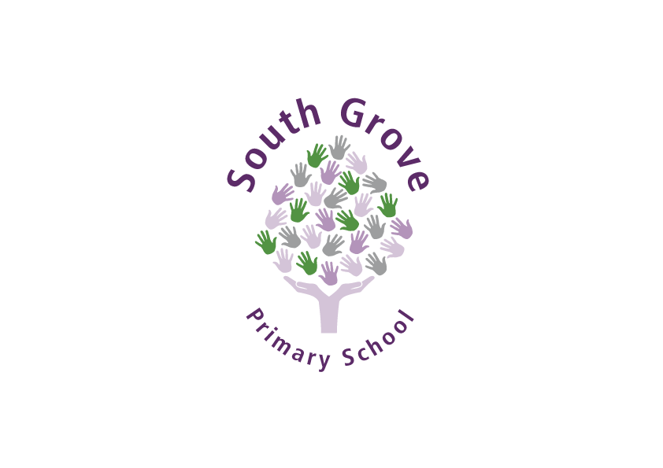

**SOUTH GROVE PRIMARY SCHOOL**

**MAIN SCALE CLASS TEACHERS OFFERING EARLY YEARS NURSERY AND RECEPTION, KEY STAGE 1**

**Dates:** Apply by Wednesday 19th May 2021 at 12:00pm **Job start**: September 2021

**Salary:**  NQT - Main Scale (1-3)

**Contract Type**: Full-time

**Contract term**: Full-time Temporary position (1-year contract)

South Grove is rated Outstanding in all areas by Ofsted in January 2019 and is a larger than average primary school with a large nursery and a designated Special Resourced Provision for children with autism and global delay, serving a vibrant and diverse community.

The Governors are seeking to appoint an enthusiastic, creative EYFS teacher,(with the flexibility and willingness to teach in KS1 Year 1 at some point) to join our committed and dedicated team of staff. This is an excellent opportunity for anyone relocating to the area near Walthamstow to join a friendly, supportive school.

**Are you looking for an exciting challenge?**

**Are you inspired by helping children make rapid progress?**

**Are you passionate about providing creative and challenging experiences for children?**

**Ideal candidates will:**

* Have the resolve to make a real difference to the lives of children
* Have the expertise to give our youngest children an excellent start to their education
* Be committed to the school’s ethos of high expectations for all
* Enjoy working as part of a team and be a team player

**We will offer you:**

* Opportunity to work in an attractive stimulating school setting conducive to team teaching and a supportive working atmosphere
* The support and expertise of our experienced and established leadership team and team of staff
* A school committed to your continuing professional development
* All the advice and training you need to be an excellent practitioner

**South Grove Primary School is committed to safeguarding and promoting the welfare of children and young people and expects all staff and volunteers to share this commitment. All posts are subject to pre-employment checks. References will be sought ad successful candidates will need to undertake an enhanced Disclosure and Barring Service (DBS) check.**

Further information and applications forms are available from the School Business Manager, Jazz Ali.

A virtual Teams Meeting can be arranged with the Head Teacher will be warmly welcomed.

**Closing date**: By 12:00 pm Wednesday 19th May 2021

**Short-Listing**: Wednesday 19th May 2021

**Interviews:** Friday 21st May or W/C Monday 24th May 2021