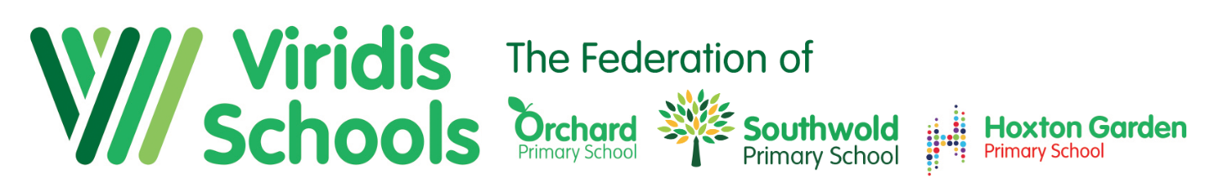

The Viridis Federation of Orchard, Southwold and Hoxton Garden Primary Schools Hackney, London.

We are looking for:
Class Teachers

(MPS/UPS/LP/Full Time/Permanent)

We are a happy family of three schools working in partnership looking for Experienced or Newly Qualified Class Teachers to join our team in January 2021, April 2021 or September 2021!

Why work with us?

- We are a professional, friendly and happy team of teachers and support staff
- We offer a dynamic and exciting environment with the chance to make a real difference
- We are an organisation that is keen to nurture and develop the expertise of its staff
- We have children who are shown how to learn from the very start
- We serve communities that deserve the best
- We offer opportunities for leadership and leadership development

So if you are…

- Self-reflective and seeking to be the best at your profession
- Have a professional outlook and thrive on challenge
- A hard worker who has a passion for teaching and is ambitious for children and making a difference
- Someone who genuinely enjoys the company of children and can see the fun as well as the serious side of teaching
- Someone who enjoys working with other people and being part of a team

…….please download our application pack!
.
Visits are warmly welcomed. To arrange this, or for an informal discussion, please call Ms Beverley Shore to 020 8806 5201. Alternatively, to request an application pack or to find out more about what we can offer visit our website:

https://viridis-schools.co.uk/

www.orchard.hackney.sch.uk | www.southwold.hackney.sch.uk | www.hoxtongarden.hackney.sch.uk
@OrchardPrimary  @primary_orchard | @ Southwold School  @Southwold School | @ Hoxton Garden Primary School  @HoxtonGardenSchool

Interviews will be held in the following weeks:

Friday 20th November 2020
Tuesday 2nd February 2021
Friday 21st May 2021

Successful candidates will be asked to apply for an Enhanced Disclosure from the disclosure & barring service. Further information about the disclosure can be found at www.dbs.gov.uk and in the application pack.

All three schools are based in the London Borough of Hackney, close to central London with easy transport links

