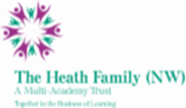
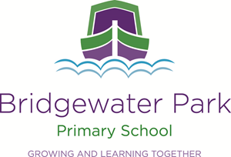

Bridgewater Park Primary School

Fixed Term for one year - Classroom Assistants to support pupils with additional needs

Hours: 30 hours, Term Time Only - 8:30-3:30 Monday to Friday
Fixed term for one academic year, start date: 1st September 2022

Bridgewater Park School is a delightful Primary school nestled in the heart of Castlefields, Runcorn. We offer an exciting and enriched curriculum and all learning is engaging and fun to ensure that all our children will achieve their full potential and become life-long learners. Bridgewater Park is part of The Heath Family (NW) Multi Academy Trust which operates 8 schools across Merseyside and Cheshire.

We are looking to secure 3 classroom assistants to work supporting pupils with additional needs.

We are after caring, friendly and efficient candidates with a strength in special needs who have the ability to work alongside the class teacher/ SENDCO and the Nurture Teaching Assistant to provide strategies following a support plan and behaviour plan.

The Heath Family (NW) is committed to safeguarding and promoting the safety and welfare of children and young people and expects all staff and volunteers to share this commitment. This post is subject to an Enhanced DBS check and pre-employment checks.

If you would like to visit the school on the 4th July at 4:00pm then please email head.bridgewaterpark@halton.gov.uk

An application pack is available from Miss Karen Murphy, Principal via email.
Completed application forms and supporting letters should be emailed to head.bridgewaterpark@halton.gov.uk

Closing date for applications: Wednesday 6th July at 9am
Interview: 14th July 2022

