RECRUITMENT PACK
Class Teacher
MPR/UPR
Start Date: With immediate effect

Introduction from the Headteacher

Queen Emma's Primary School sits at the heart of our local community. We prioritise personal, social development and wellbeing alongside our irresistible knowledge curriculum. We are truly inclusive, no child held back, no child left behind. We ensure our children's needs are met whilst developing their independence and resilience.

Our school site is magical! We have an outdoor gym, the daily mile, netball courts, football pitches, a vast outdoor space for our children in Early Years, vegetables patches and our very own forest. Our staff are an amazing team who are relentlessly bothered about our children.

Our Ofsted Report of 2024, recognises the excellent work of our school in providing high quality education. The bar has been raised significantly since our last inspection and so we are so delighted that our strengths were recognised.

“Pupils are thriving at this kind, nurturing and caring school. One pupil represented the views of many when they stated, ‘The school helps me to become the best I can be.’ There is a strong sense of community, which results in pupils feeling happy, safe and well looked after. Pupils know there is always someone to talk to if they need help.”

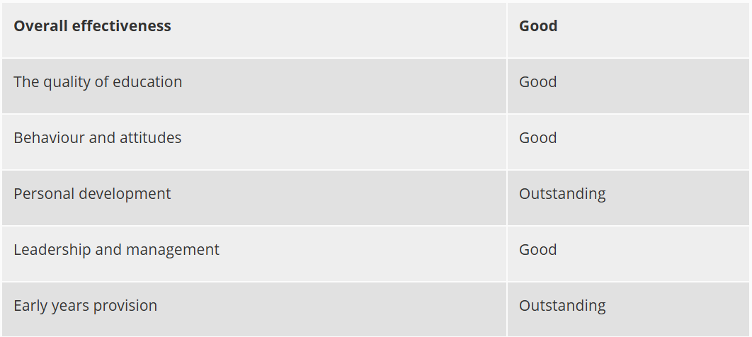

Our approach

This is a hugely exciting time for our family of schools as we are presented with a rare opportunity to make a real difference to the lives and life chances of so many children and young people. Our vision is to enable individual schools to flourish whilst remaining integral to the communities they serve.

Here we think deeply about how we can have the biggest impact on pupils. In a world where the algorithms of life give us more of the same, we believe education has the role to give children something different. We continually ask ourselves the following five questions:
- Are we securing equity?
- Is our leadership driving school improvement?
- Is our curriculum irresistible?
- Are we research informed?
- Are we deploying resources effectively?

All schools in our Trust have a culture of compassion underpinned by high expectations and understanding. We have three rules: ready, respectful and safe. We are a truly inclusive organization and passionately believe that every child has a right to mainstream education.

Our curriculum principles

We use Read, Write, Inc to teach children how to read. This approach ensures every child learns how to read accurately and fluently to enable them to comprehend. We teach writing using the 'Write Stuff' principles. These principles guarantee that all children develop their vocabulary and confidence with a range of sentence structures. We teach Maths using 'Inspire Maths'. Children a in small, flexible groups to ensure prerequisites are embedded and gaps are closed. Using this concrete, pictorial and abstract methods to teach mathematical concepts enables all children to make incredible progress.

Here at Queen Emma's Primary School we provide a broad and balanced curriculum based around the Cornerstones Curriculum, a nationally recognised approach for delivering outstanding learning opportunities for children. What is the Cornerstones Curriculum? The Cornerstones Curriculum is a creative and thematic approach to learning that is mapped to the 2014 primary national curriculum to ensure comprehensive coverage of national expectations. It is based on a child-centred pedagogy called The Four Cornerstones and is delivered through Imaginative Learning Projects (ILPs) and Knowledge Rich Projects (KRPs), which provide a rich menu of exciting and motivating learning activities that make creative links between all aspects of children’s learning. We believe children learn better when they are encouraged to use their imagination and apply their learning to engaging contexts. Our curriculum provides many learning challenges throughout the academic year that require children to solve problems, apply themselves creatively and express their knowledge and understanding effectively. Cornerstones also provide a rigorous skills and knowledge framework that outlines the end of year expectations in all subjects. These skills and knowledge are tied to activities and are age-related so that staff can track children’s progress and identify their individual learning needs.

Queen Emma’s Primary School is committed to promoting the welfare of children and young people and expects all staff and volunteers to share this commitment.

Leanne Dixon
Headteacher

The opportunity
Position: Class Teacher
Working Hours: Full time
Required: ASAP

We are seeking to appoint an energetic, enthusiastic and skilled Class Teacher to a permanent full-time vacancy at Queen Emma’s Primary School.

We are looking for candidates who are committed to the learning and development of our pupils, inspiring and motivating them in their learning, as well as successfully working as part of our friendly school team and the wider Trust team.

Applications are welcome from new or experienced teachers. Ideally, we are looking for candidates wanting a full-time role, but we may also open to applications from candidates wanting to job share or part time hours if we could make a number of part time appointments to make up the full-time role. This could be a fantastic opportunity for teachers with leadership aspirations as our CPD programme is gold standard and we offer leadership training opportunities as part of our OLEVI programmes, as well as networking opportunities with colleagues in our family of schools.

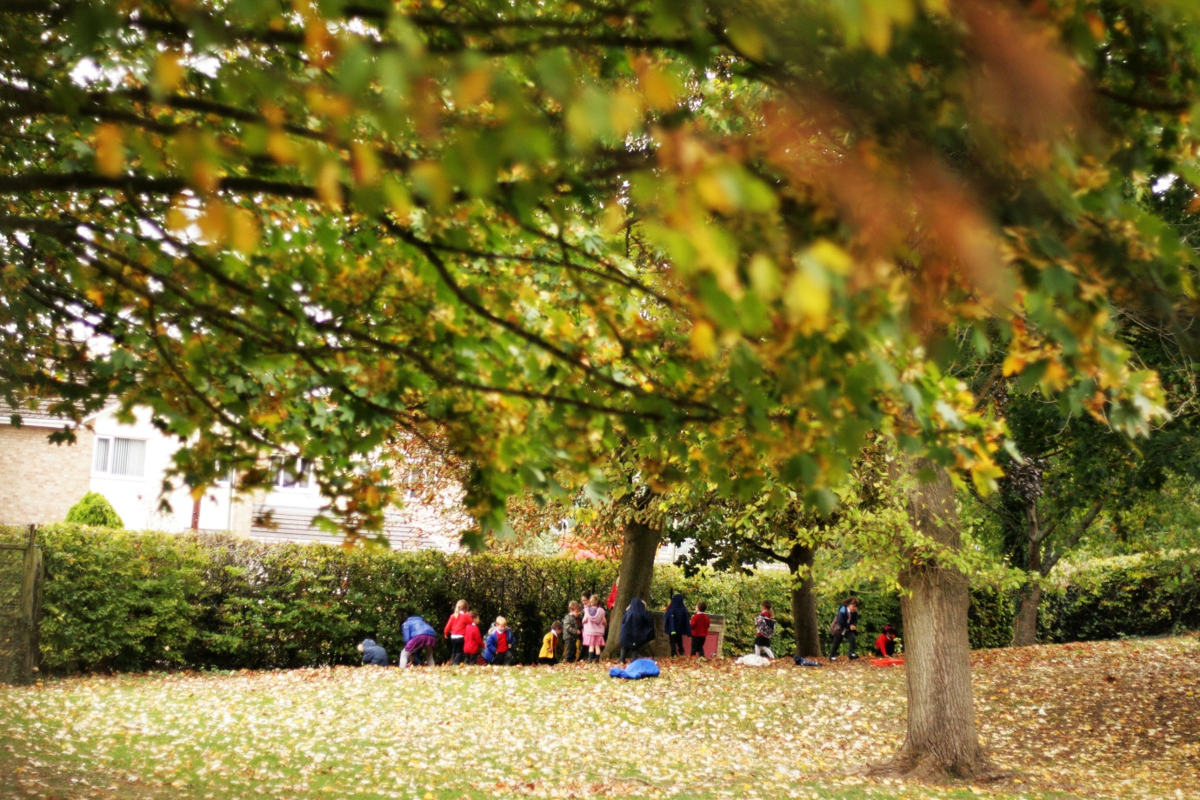

Selection Criteria

Essential
- Qualified Teacher Status
- Ability to work as part of a team
- Knowledge of planning, assessment and record-keeping
- Commitment to further training and development
- Conscientious, enthusiastic and positive
- The ability to relate well to pupils, staff and parents

Desirable
- Willingness to contribute to extra-curricular activities
- Evidence of improving practice by identifying and meeting CPD needs

Job Description: Class Teacher (MPR and UPR)

This job description should be read in conjunction with the current School Teachers’ Pay and Conditions Document and the provisions of that document will apply to the post holder. You will be expected to carry out the professional duties of a teacher as outlined in the School Teachers’ Pay and Conditions Document currently in operation, or any subsequent legislation.

Set high expectations which inspire, motivate and challenge pupils
- establish a safe and stimulating environment for pupils, rooted in mutual respect;
- set goals that stretch and challenge pupils of all backgrounds, abilities and dispositions;
- demonstrate consistently the positive attitudes, values and behaviour which are expected of pupils.

Promote good progress and outcomes by pupils
- be accountable for pupils’ attainment, progress and outcomes;
- be aware of pupils’ capabilities and their prior knowledge, and plan teaching to build on these;
- guide pupils to reflect on the progress they have made and their emerging needs;
- demonstrate knowledge and understanding of how pupils learn and how this impacts on teaching;
- encourage pupils to take a responsible and conscientious attitude to their own work and study.

Demonstrate good subject and curriculum knowledge
- have a secure knowledge of the relevant subject(s) and curriculum areas, foster and maintain pupils’ interest in the subject, and address misunderstandings;
- demonstrate a critical understanding of developments in the subject and curriculum areas, and promote the value of scholarship;
- demonstrate an understanding of and take responsibility for promoting high standards of literacy, articulacy and the correct use of standard English, whatever the teacher’s specialist subject;
- demonstrate a clear understanding of systematic synthetic phonics;
- demonstrate a clear understanding of appropriate teaching strategies.
Plan and teach well-structured lessons
- plan sequences of lessons to extend knowledge and build on prior knowledge;
- use the “principles of instruction” to plan sequences on lessons;
- be evidence informed;
- be diagnostic in identifying gaps and relentless in closing them;
- Use feedback and assessment to inform the next stage of learning.
Adapt teaching to respond to the strengths and needs of all pupils
- know when and how to differentiate appropriately, using approaches which enable pupils to be taught effectively;
- have a secure understanding of how a range of factors can inhibit pupils’ ability to learn, and how best to overcome these;
- demonstrate an awareness of the physical, social and intellectual development of children, and know how to adapt teaching to support pupils’ education at different stages of development;
- have a clear understanding of the needs of all pupils, including those with special educational needs; those of high ability; those with English as an additional language; those with disabilities and be able to use and evaluate distinctive teaching approaches to engage and support them.

Make accurate and productive use of assessment
- know and understand how to assess the relevant subject and curriculum areas, including statutory assessment requirements;
- make use of formative and summative assessment to secure pupils’ progress;
- use your professional judgement to report data and have professional conversations;
- use regular feedback in the moment and to inform your planning.
Manage behaviour effectively to ensure a good and safe learning environment
- have clear rules and routines for behaviour in classrooms, and take responsibility for promoting good and courteous behaviour both in classrooms and around the school, in accordance with the school’s behaviour blueprint;
- have high expectations of behaviour, and establish a framework for discipline with a range of strategies, using praise, recognition, postcards, positive phone calls home and restorative conversations;
- maintain good relationships with pupils, exercise appropriate authority, and act decisively when necessary.

Fulfil wider professional responsibilities
- make a positive contribution to the wider life and ethos of the school;
- develop effective professional relationships with colleagues, knowing how and when to draw on advice and specialist support;
- deploy support staff effectively;
- take responsibility for improving teaching through appropriate professional development, responding to advice and feedback from colleagues;
- communicate effectively with parents with regard to pupils’ achievements and well-being.

For all staff - You have specific responsibilities under Health & Safety / Child Protection legislation to ensure that you:
- take reasonable care for your own health and safety, and that of others affected by what you do, or do not do.
- cooperate on all issues involving health and safety.
- use work items provided for you correctly, in accordance with training and instructions.
- do not interfere with or misuse anything provided for your health, safety or welfare.
- report any health and safety concerns to your line manager as soon as practicable.
- report any safeguarding children / child protection concerns to a senior member of staff.
- attend safeguarding training as requested.

This job description is current at the date shown, but, in consultation with you, may be changed by the Headteacher to reflect or anticipate changes in job commensurate with the grade or job title.

Working with Children and Safeguarding

The MILL Academy is committed to safeguarding children and promoting the welfare of children and young people and expects all staff and volunteers to share this commitment. All successful candidates are required to have enhanced DBS clearance and will need to undertake the DBS check with our organisation. Other relevant pre-employment checks will also be carried our including references from present and previous employers, a confidential health check and internet/social media checks.

What we can offer you:
- A hard working and committed team of colleagues
- Competitive salary with upper pay scales above the usual national levels
- Regular programmes of professional development to Teacher Development Trust Gold Standard
- Support for and commitment to your future training and development needs
- On-site free car parking
- Cycle to work salary sacrifice scheme
- Annual free flu vaccination
- 24/7 employee assistance wellbeing scheme

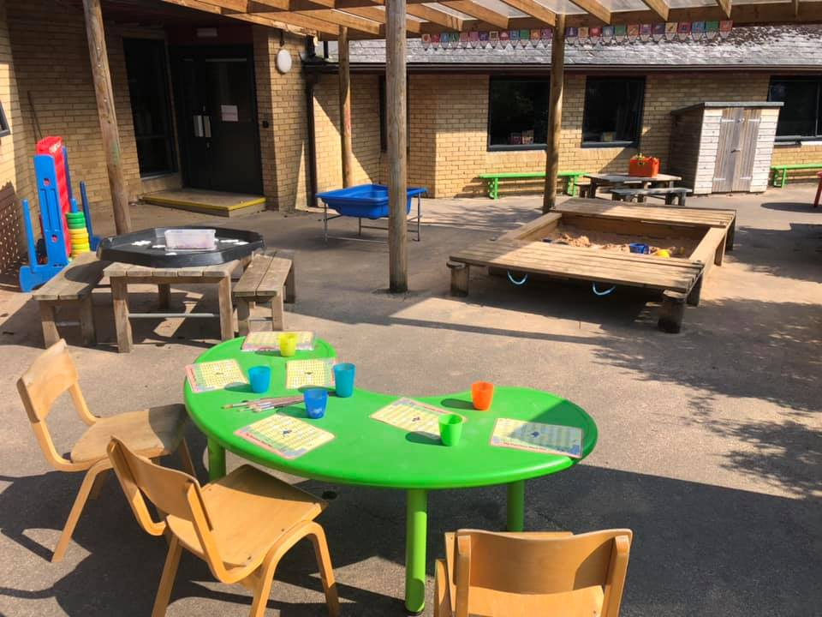
The Application Process

We are seeking to appoint the best possible candidate and our recruitment process will reflect our desire to undertake all possible measures to achieve this.

Applicants should download and complete the teaching staff application form from our website or complete the online application form on one of our partner recruitment sites. You should also submit an accompanying letter of application, addressed to the Headteacher, that is no more than two sides of A4. Applications should be returned to jobs@millacademy.co.uk please or via the online portal on the partner recruitment site.

Visits to the school prior to interview are also encouraged and warmly welcomed and can be arranged with the HR Team or the School Office. If you have any queries about this role, please do not hesitate to contact the HR Team on 01993 848166 or email jobs@millacademy.co.uk.

The closing date for applications is Monday 2nd December 2024 at 9am. Shortlisting will take place during that week and candidates will only be notified if they are successful in being called for interview. Applications may be considered as soon as they are received, and the Trust reserves the right to withdraw the vacancy at an earlier date if a suitable applicant is found.

If you decide you want to be part of our amazing team, we look forward to hearing from you and to receiving your completed application form.

