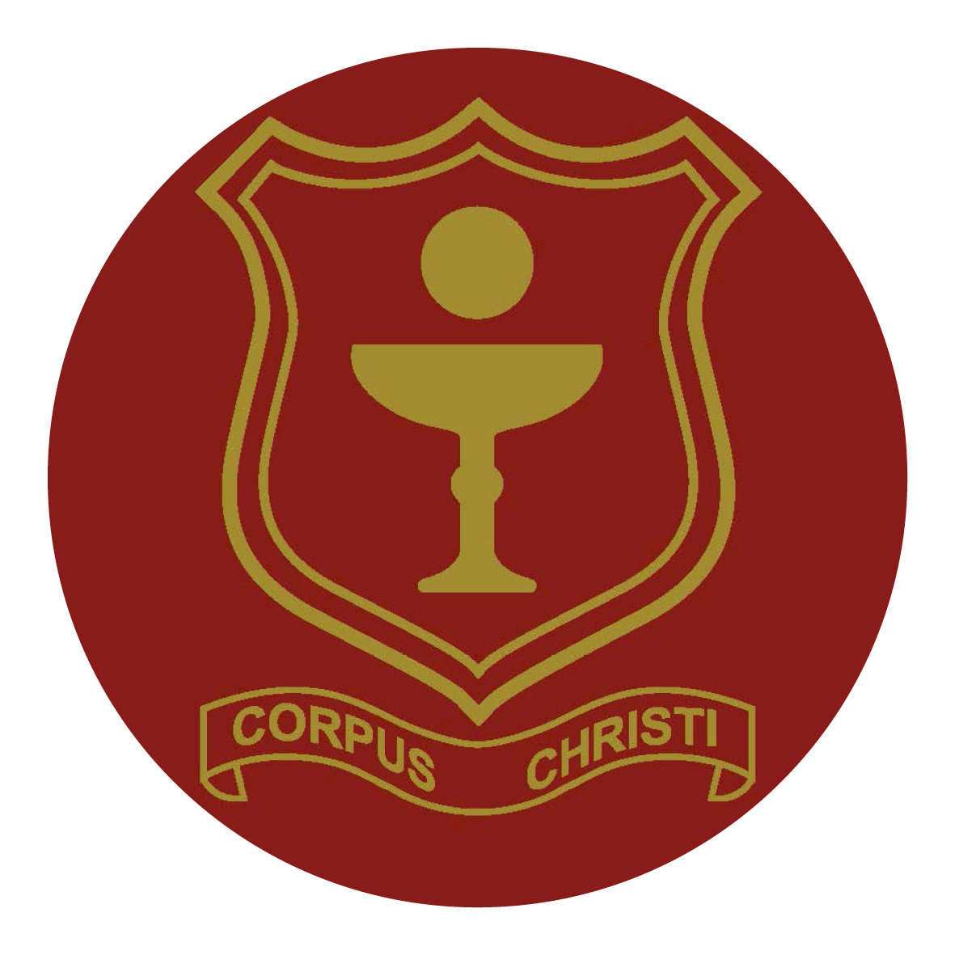

Corpus Christi Catholic Primary School
St. James’s Square, Boscombe,
Bournemouth, BH5 2BX
Tel. 01202 427544
Email: office@cccpschool.com

Classroom Teacher
Fixed Term to 31st August 2027
For the right candidate a permanent position could be available.
Main Scale

The governors of Corpus Christi wish to appoint a Fixed Term classroom teacher who is passionate, highly motivated, enthusiastic and hardworking and who will support the future development of our much loved school. This role begins as a fixed term contract position with the potential to become permanent.

We are looking for a teacher who
- Will be an excellent classroom practitioner or aspiring to be an excellent classroom practitioner;
- Will inspire and challenge children, staff and parents to ensure high expectations of behaviour and achievement for all pupils;
- Has a desire to build upon high standards of pastoral care;
- Can communicate effectively with all stakeholders and outside agencies.

We can offer:
- A welcoming community with a strong Christian ethos
- Enthusiastic and friendly children who are willing and eager to learn
- A commitment to professional and personal development
- Supportive governors, parents and Parish community

An informal meeting with a member of SLT is warmly welcomed and encouraged. Please email susan.solly@cccpschool.com from to arrange a meeting. Application forms, job description and person specification are available on the school website www.cccpschool.co.uk or you can request an application pack from the school office. We regret to advise that CV’s are not accepted as a form of application.
The closing date for applications is midday Monday 30th November 2026
Please email your application to susan.solly@cccpschool.com or send to the above address.
Selection morning Thursday 3rd December 2026

Corpus Christi Catholic Primary School is committed to safeguarding and promoting the welfare of children and young people and expects all staff and volunteers to share this commitment. The successful applicant will require an enhanced DBS.
Corpus Christi Catholic Primary School is an equal opportunity employer. We celebrate diversity and are committed to creating an inclusive environment for all employees.

