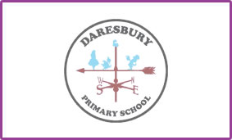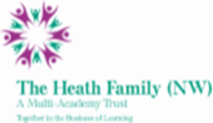

Dear Potential Candidate,

Thank you for showing interest in our current vacancy for a fixed term (Autumn term 2022) teacher post at our lovely school. This vacancy is to cover a Year 3 class up until the appointment of a new Deputy Head of School to hopefully start in January 2023.

Daresbury Primary School is a growing school with 185 children currently on roll, organised into 6 classes but anticipated to be 194 and in 7 classes in September 2022. The long term plans over the next 2 years have us increasing our numbers annually until we reach 210 on roll. These plans also include some new building at the school, so there are exciting times ahead. The school currently has 4 children with Education Health & Care plans.

You would be joining a staff of over 20 who all work together to help make Daresbury Primary School a happy and positive environment for all of our children, parents and wider community. Your role would involve taking responsibility for a class (year group to be confirmed at a later date).

We very much hope, having read all the information provided, that you decide to apply to become part of the staff team at Daresbury Primary School. If you require any further information please do not hesitate to get in touch via email or by telephone.

Kind regards



Carolyn Roberts

Principal

