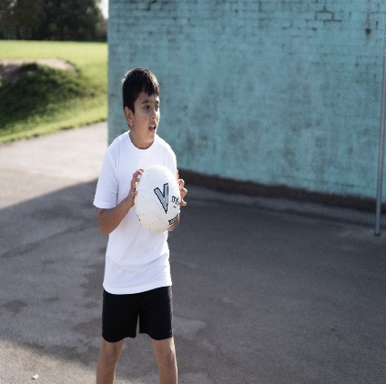
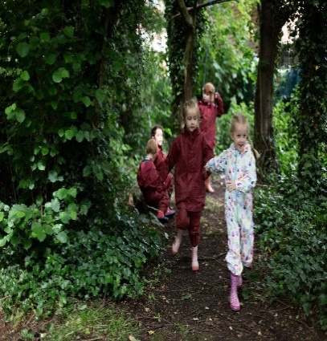
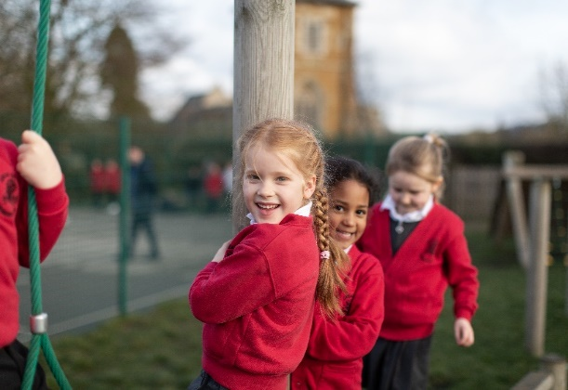
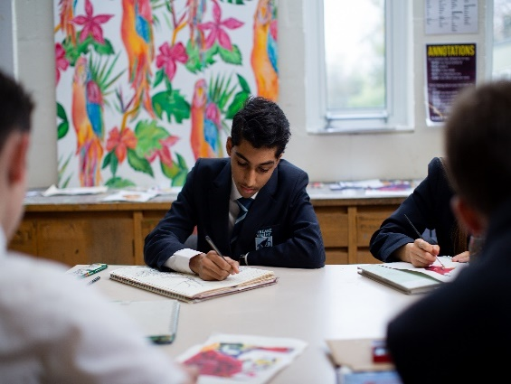
Classroom Teacher
Gaddesby Primary School
Fixed Term Contract
Contracted Hrs: 100%
Salary: MPS
Start Date: 23rd August 2022

An exciting opportunity has arisen for someone to join Gaddesby Primary School as a Classroom Teacher. The Classroom Teacher will be responsible for creating a learning experience that enables and challenges our pupils to be the best that they can be. We seek to ensure that children have the best possible experiences during their time with us and therefore aspirational and exciting teaching is encouraged.

The role of Classroom Teacher is a rewarding one with the opportunity for professional autonomy within the role to create the classroom environment that enables development. We are heavily focussed on trying to ensure that work life balance for teachers is manageable, this is under regular review. The ideal candidate will:

- Hold QTS status
- Possess the ability to teach high quality lessons and consistently provide learning opportunities that progresses pupils’ learning and achievements
- Be an excellent communicator and able to build positive working relationships with pupils, parents/carers and stakeholders
- Be a team player – whilst it is important as a Classroom Teacher to work independently, there are regular points of the working day and week where working alongside support staff and other teaching colleagues is vital, therefore working as part of a team that is supportive and effective is paramount to the role

In return we offer:
- Opportunity to work within a supportive team
- Access to the Bradgate Learning Alliance to share best practice, learn and network with other colleagues
- Opportunities for career development with access to professional development, apprenticeships and training schemes
- Access to a generous Teachers Pension Scheme
- Employee Support Service (counselling) for employees and close family members (24/7 support)
- Employee Discount and Benefit Scheme
- Opportunity for an annual flu vaccination

Applications
If you would like to discuss this post or arrange a visit to the school to meet the Head Teacher, Leigh Fox prior to applying please contact:
Email: office@gaddesby.bepschools.org

To apply for one of the positions:
- Visit our careers website: www.eteach.com/careers/bepschools and search for the vacancy
- Apply using the online application form
- Submit a supporting statement outlining the reasons why you are applying and your suitability for the position

Application Closing Date: 9am, Thursday 19th May 2022
Provisional Interview Date: WC 23rd May 2022

We look forward to receiving your application!

SAFEGUARDING…
Bradgate Education Partnership is committed to safeguarding and promoting the welfare of children and young people. All staff and volunteers are therefore expected to be-have in such a way that supports this commitment. Appointment to this post will be subject to satisfactory pre-employment checks.

WE ARE ALL UNIQUE…
At our Trust inclusion means everyone is welcome. Everyone is treated fairly and with respect. We value individuality and uniqueness and aim to create a sense of belonging. We want an inclusive workplace that helps build the success of our pupils and reflects the diversity of the communities we serve.

