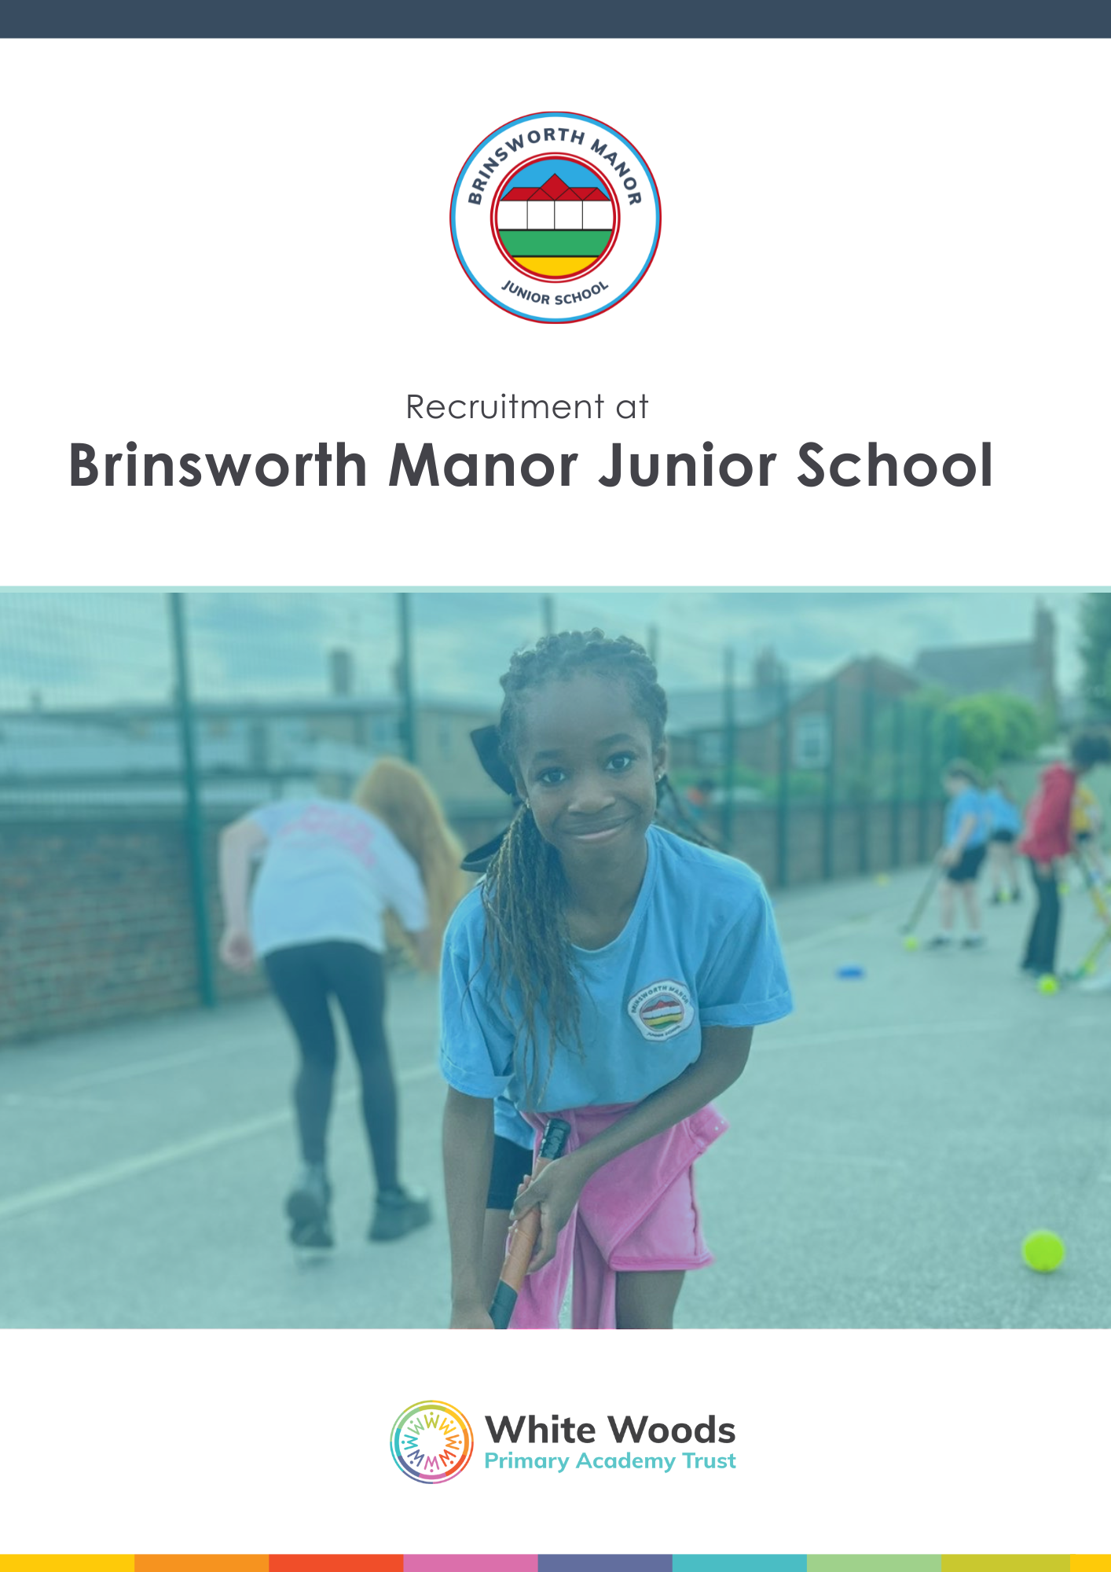

Job Advert
Job Title: Classroom Teacher (KS2)
Salary: Main Scale (1-6)
Appointment: (Full time/Fixed Term 1 year)
Responsible to: Headteacher
Start Date: 13/04/2026
White Woods Primary Academy Trust was established in 2013 and is now a family of 16 primary schools within the borough of Rotherham.
Our vision is simple: all children, whatever their background, will be supported to thrive both academically and socially, developing the skills of lifelong learners. We believe in keeping the main thing the main thing — excellent teaching and learning — within a culture that is curious, collaborative, child-centred and challenging in all the right ways.
Our mission is to make every school an exceptional place to learn and work. We want children and adults to experience a breadth of exciting opportunities that spark curiosity, broaden horizons and build ambition. We believe that the best outcomes come when we combine high challenge with high support, and when joy, wellbeing and professional growth are woven into daily school life.
We are also proud to host a successful DfE English Hub and have a strong track record in developing effective approaches to reading.
We are now looking to appoint a classroom teacher who shares our values and can bring expertise, energy and commitment to our team at Brinsworth Manor Junior School. The successful candidate will:
- Has the potential to be an exceptional teacher.
- Is creative and energetic with high expectations for all learners.
- Believes in the power of relationships and can demonstrate positive, high quality interactions with young children.
- Is hard working, resilient and determined.
- Has excellent communication skills and has the desire to work as a proactive member of our excellent team.

We can offer you:
- Membership of the Local Government Pension Scheme.
- Access to workplace and wellbeing support services.
- A genuine sense of belonging in a family of schools rooted in strong values.
- A comprehensive induction and support programme.
- A culture where curiosity, collaboration, joy and challenge drive professional growth.
- A real commitment to work–life balance: your wellbeing matters to us. We want you to thrive, both at work and beyond it.

Key dates:
Recruitment Opens: Friday 13th February 2026
Recruitment Closes: Monday 2nd March 2026
Interview Day: w/c Monday 9th March 2026

How to apply?
Applications should be completed on our online application form:
https://forms.wwpat.org/wwpat/form/WWPATApplicationFormTeachingVacancies/formperma/Xpn_4zosUlBoZfBYW239ScO-bJdRVPcqKelsU-4P-H4
* Please note, for Job Location / Department, please select: Anston Brook Primary School.

This post involves working with children and therefore if successful you will be required to apply for a disclosure of criminal records check at an enhanced level. Further information about the Disclosure Scheme can be found at: www.gov.uk/disclosure-barring-service-check.

White Woods Primary Academy Trust is committed to safeguarding and promoting the welfare of children and young people and expects all staff and volunteers to share this commitment.

Our Recruitment Privacy Notice can be viewed here.

