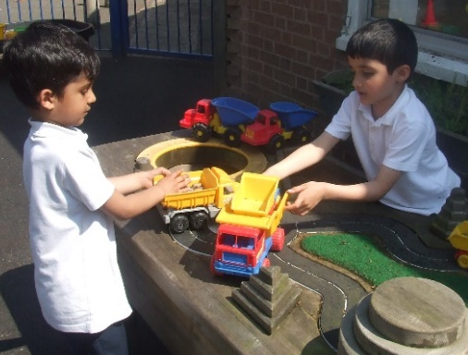

LAUNDE PRIMARY SCHOOL

JOB DESCRIPTION - CLASS TEACHER

According to the most recent School Teachers' Pay and Condition Document as applied to Launde Primary School, the teacher will be expected to:

- Teach pupils in the age range 4 - 11 years.

- Provide a stimulating and caring environment appropriate to the needs of the children, enabling them to form positive relationships with each other and adults.

- Show a high standard of teaching ability at all times, believing in and encouraging each child to achieve his/her potential.

- To ensure the school’s safeguarding policy and practices are adhered to in everyday practice.

- Run a well-organised classroom in which children are given a wide variety of experiences and opportunities for practical learning to maintain the continuity and progression of learning.

- Plan, organise, present and assess a curriculum appropriate to the needs of the children within the guidelines set out by the school and the National Curriculum.

- Co-operate and collaborate with other members of staff in order to contribute personal knowledge, skills and insights to the School Curriculum.

- Monitor and evaluate classroom practice to enhance the children's learning.

- Promote the involvement of parents as co-educators.

- Promote the Equality policy in everyday practice

- Work with colleagues in order to secure continuity and progression in teaching and learning throughout the school.

- Contribute to internal staff development programmes and school improvement projects.

- To report to parents as required by the school.

- Take part in normal school duties.

- Uphold high standards of discipline.

- Participate in the school appraisal procedures as agreed in the school’s Performance Management Policy.

- Seek professional development through INSET, in relation to the priorities identified in the school.

- Take all appropriate steps to ensure the well-being and the health and safety of the children, including safeguarding procedures

- Promote the personal, social, moral, cultural and spiritual development of children.

- Maintain the ethos, aims and practices of the school as set out in school policies and other school documentation.

- Be responsible for the work of teaching assistants or other adults working with children.

- Contribute to the development of a curriculum area.

- Undertake other reasonable duties agreed by negotiation with the Headteacher / Head of School.

Health and Safety

The post holder must at all times carry out his/her responsibilities with due regard to the Trust's policy, organisation and arrangements for Health and Safety at Work.

Safer Recruitment Statement:

Scholars Academy Trust is committed to safeguarding and promoting the welfare of children and expects all staff and volunteers to share this commitment. Successful applicants will need to undertake an enhanced Disclosure via the Disclosure Barring Service (DBS).

We have a number of policies and procedures in place that contribute to our safeguarding commitment, including our Child Protection Policy which can be viewed in the Policies section of our website.

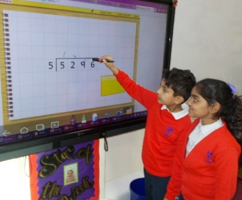

“Every child’s academic, artistic, physical and social potential
will be developed to the full within the Launde family.”

LAUNDE PRIMARY SCHOOL

PERSON SPECIFICATION - CLASS TEACHER

 | Essential | Desirable
Qualifications | Teaching qualification as required by the DFE for England and Wales | High degree or evidence of further  higher education studies
Experience | Class teacher
Application | Well constructed and neat application showing personal philosophy and clear evidence of the thinking of a primary class teacher | Creative ideas to meet and extend beyond the requirements of the post
Classroom Management | Evidence of good classroom planning and management strategies using a variety of strategies, including group work and whole class teaching  Evidence of recent experience of long, medium and short term planning  Evidence of working in collaboration with colleagues  Evidence of maintaining high standards of behaviour and develop attitudes of care, control and co-operation  To be able to provide a well ordered and stimulating learning environment  To meet the statutory requirements of legislation concerning equal opportunities, Health and Safety, SEN and Child Protection | Evidence of ability to create attractive displays of children’s work  To be aware and use a range of classroom strategies to motivate children to learn
Curriculum | Demonstrate knowledge of the National Curriculum and other current educational issues  Evidence of ability to offer each child a broad, balanced differentiated curriculum  Evidence of knowledge of the Special Needs | Experience of leading or supporting a subject area  Involvement in extra-curricular activities to promote out of school hours learning
Assessment | Evidence of ability to identify individual children’s needs and make provision for them  Evidence of the use of target setting to aid learning  Evidence of analysis of pupil tracking and data to plan future learning | Evidence of involvement in whole school target setting
Parents | To welcome parents as co-partners in the education of children | Be able to work with parents and governors to the advantage of children in the class and school as a whole
Equal Opportunities | To promote equal opportunities in line with the school’s policies
Communication | Be able to communicate children’s progress in both written and verbal forms.
Professional Development | Evidence of involvement in INSET Training  To illustrate understanding of the National Standards for teachers and their application | Evidence of attendance at courses  Evidence of keeping up to date with current educational thinking  Ability to contribute to whole school development
Personal Qualities | Ability to be organised, flexible, adaptable and enthusiastic  Evidence of ability to relate well to others with kindness and a sense of humour

